Liet International, Oldenburg, Germany, 12 December 2014
On 12 December 2014, the 10th edition of Liet International, the song contest for musicians from different regions across Europe who sing in a regional or minority language, took place in the north German city of Oldenburg. This year's winner was Marina Iori, a 19 year-old musician from Val di Fassa in the north of Italy, who sang in Ladin, a minority language spoken in South Tyrol, Trentino and Belluno. The Musicians’ Award was won by the Aila-duo from Finland, singing in Aanaar Sámi, a language estimated to be spoken by less than 400 speakers. Organised for the first time in the capital of Friesland, Ljouwert/Leeuwarden, in 2002, it has travelled around Europe since 2006 and since 2008, it has been under the patronage of the Secretary General of the Council of Europe and is this year supported by a grant from the Council of Europe’s Charter for Regional or Minority Languages. The Charter is an international treaty that aims to protect and promote the use of regional and minority languages all over Europe.

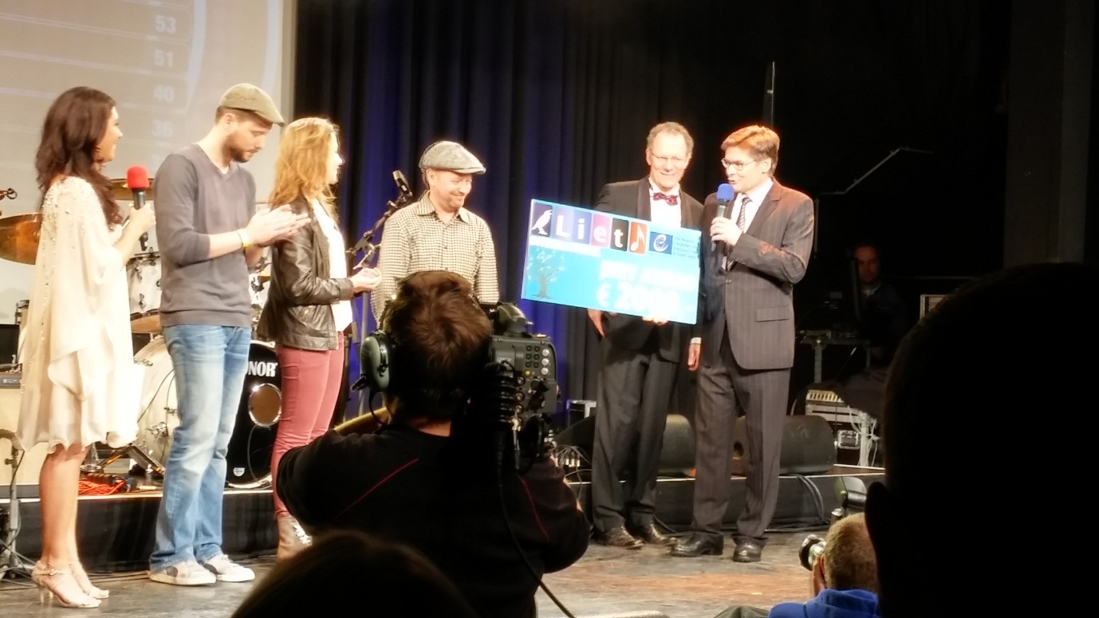

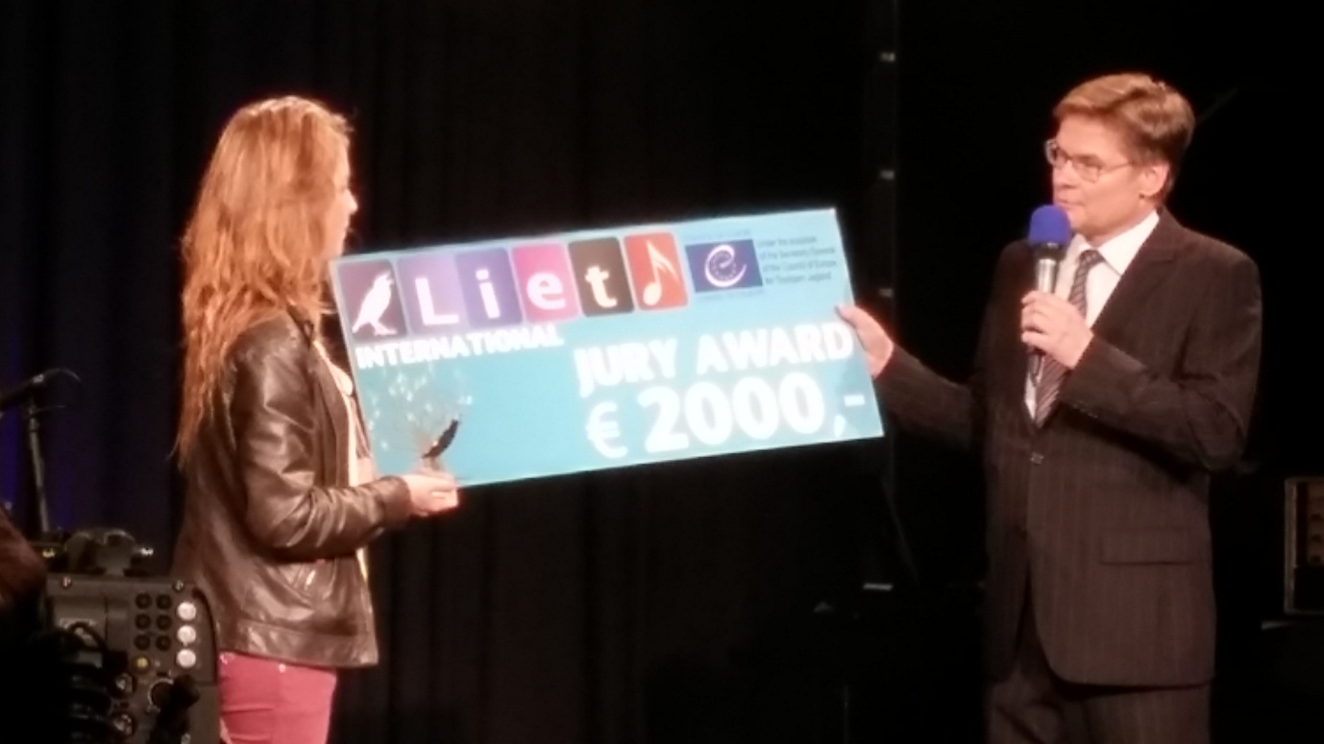
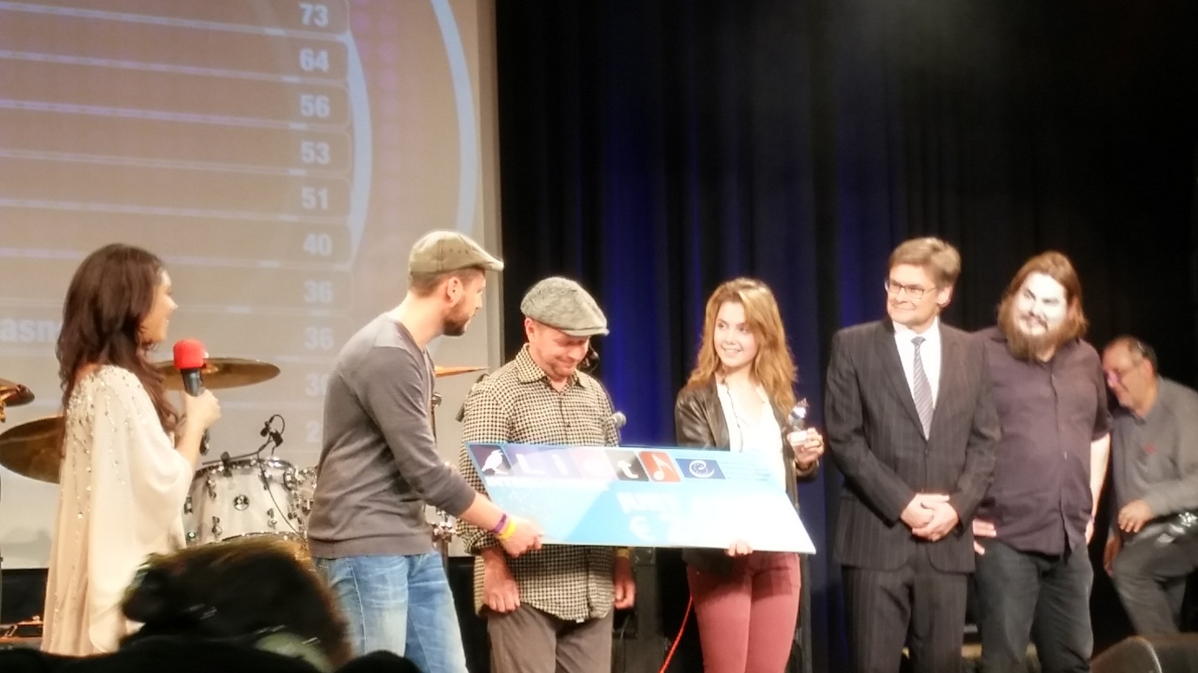

Liet International, Oldenburg, Germany, 12 December 2014
On 12 December 2014, the 10th edition of Liet International, the song contest for musicians from different regions across Europe who sing in a regional or minority language, will take place in the north German city of Oldenburg. Organised for the first time in the capital of Friesland, Ljouwert/Leeuwarden, in 2002, it has travelled around Europe since 2006 and since 2008, it has been under the patronage of the Secretary General of the Council of Europe and is this year supported by a grant from the Council of Europe’s Charter for Regional or Minority Languages. The Charter is an international treaty that aims to protect and promote the use of regional and minority languages all over Europe. As a prelude to the festival on Friday evening, on Thursday 11 December 2014 a conference on regional or minority languages is organised by the University of Oldenburg, where several language experts from institutes in both Germany and the Netherlands will share their knowledge.

“Sami – the People, their Culture and Languages and the Council of Europe”
27-29 November 2014 - Members of the European Commission against Racism and Intolerance (ECRI), the Advisory Committee on the Framework Convention for the Protection of National Minorities (FCNM) and the Committee of Experts of the European Charter for Regional or Minority Languages (ECRML) brought their expertise together in Inari (Finland) to discuss, together with Sami representatives from Finland, Norway and Sweden, how the Council of Europe human rights monitoring mechanisms can address the issue of “Sami – the People, their Culture and Languages and the Council of Europe”. Read more
See Video:
http://www.google.fr/url?sa=t&rct=j&q=&esrc=s&frm=1&source=web&cd=2&cad=rja&uact=8&ved=0CCgQtwIwAQ&url=http%3A%2F%2Fwww.youtube.com%2Fwatch%3Fv%3DB-15PLPV674&ei=uRgtVcmbMoTmapelgdgK&usg=AFQjCNHaAXioG9KukHUFxvLlu2xUgsJ5GQ&bvm=bv.90790515,d.d2s

Committee of Ministers publishes report on minority languages in Cyprus
Strasbourg, 30.10.2014 - The Charter is the European convention for the protection and promotion of traditionally used minority languages and applies in Cyprus to Armenian and Cypriot Maronite Arabic. The report has been drawn up by a committee of independent experts, which monitors the application of the Charter. The report acknowledges the goodwill and openness of the Cypriot authorities in matters related to Armenian and Cypriot Maronite Arabic. Nevertheless, on the basis of the report, the Council of Europe calls upon Cyprus to strengthen the use of both languages in the broadcast media. Furthermore, Cyprus should take measures to extend the teaching of Armenian and Cypriot Maronite Arabic.

Committee of Ministers publishes report on minority languages in Denmark
The Charter is the European convention for the protection and promotion of traditionally used minority languages and applies in Denmark to the German language. The report has been drawn up by a committee of independent experts, which monitors the application of the Charter. The experts commend Denmark for its continued commitment to the protection and promotion of the German language. In their view, the provision of German-language education through the private schools of the German minority remains exemplary. However, the experts consider the presence of German in the Danish broadcasting media as very weak. The Council of Europe therefore calls upon Denmark to increase the level of radio broadcasting and provide television broadcasts in German, in co-operation with the German speakers. In addition, the Council of Europe finds that measures to increase awareness and appreciation of German as a minority language of Denmark should be taken. Globally, the Council of Europe recommends Denmark to apply a more proactive and structured approach in the implementation of its undertakings under the Charter.

Council of Europe publishes report on minority languages in Germany

Strasbourg, 02.06.2014 - Released today by the Council of Europe’s Committee of Ministers, a new report calls on Germany to step up efforts in favour of regional and minority languages.

The evaluation report, drafted by a committee of independent experts, recommends Germany to continue and step up measures to teach North Frisian in Schleswig-Holstein and Sater Frisian in Lower Saxony.

It invites Germany to provide adequate radio and television broadcasting in regional and minority languages. Although public service broadcasting "continues to be good for some regional or minority languages, in particular for Upper Sorbian", according to the report, other languages are “insufficiently offered” including Danish, North Frisian, Sater Frisian and Romani.

German authorities are encouraged to adopt a strategy to promote and preserve Lower Sorbian in Brandenburg.

Furthermore, Brandenburg, Bremen, Mecklenburg-Western Pomerania, Lower Saxony, North Rhine-Westphalia and Saxony need to develop an adequate educational offer for Low German.

Overall, the report praises Germany for its “transparent approach” in implementing the European Charter for Regional or Minority Languages. In assessing policies in the country’s 16 Länder, the report takes note of positive initiatives in Saxony for Upper Sorbian, in Hamburg for Low German and in Schleswig-Holstein for Danish, Low German and North Frisian.

The report commends German authorities for their dialogue with representatives of regional or minority languages on the Charter and the measures taken to inform the public about the regional or minority languages in the country.

The Charter is the Council of Europe’s convention for the protection and promotion of traditionally used minority languages. A committee of independent experts monitors the application of the Charter and drafted this report.

For Germany, the Charter applies to Danish, Upper Sorbian, Lower Sorbian, North Frisian, Sater Frisian, Low German and Romani.

Statement by the Committee of Experts of the European Charter for Regional or Minority Languages (ECRML) on the situation in Ukraine
(unanimously adopted by the Committee at its 47th meeting, Strasbourg, 13-16 May 2014)
The Committee of Experts of the European Charter for Regional or Minority Languages (ECRML) recalls that the Charter is designed for pluralist and multilingual societies and reiterates that “the protection and promotion of regional or minority languages in the different countries and regions of Europe represent an important contribution to the building of a Europe based on the principles of democracy and cultural diversity within the framework of national sovereignty and territorial integrity” (Preamble of the Charter). Referring to its evaluation report on the application of the Charter in Ukraine of 15 November 2012 and its reassessment report of 25 March 2014, the Committee recalls that in respect of the Russian language, it had found that most undertakings chosen by Ukraine under the Charter were fulfilled or partly fulfilled. However, as far as the other minority languages are concerned, several of the Charter undertakings still needed to be implemented. This was also the case in Crimea. Particularly in the current situation in Ukraine, the protection granted by the Charter constitutes an additional European safeguard for minority languages. The Committee of Experts expresses its deep concern for the situation of the minority languages and their users in Crimea. Under the present conditions, Ukraine cannot implement the Charter and consequently the Committee of Experts cannot monitor the application of the Charter to Bulgarian, Crimean Tatar, German, Greek, Krimchak and Karaim in Crimea. With reference to the Secretary General’s report on the State of democracy, human rights and the rule of law in Europe (May 2014), the Committee of Experts offers its expertise on regional or minority languages and their users to the Committee of Ministers and the Secretary General of the Council of Europe as well as the Ukrainian authorities, also on an ad hoc basis.
Focus on Ukraine
Strasbourg, 31 March 2014. The protection of national minorities and their languages continues to enjoy a high level of legal recognition in Ukraine, says the Committee of Experts of the European Charter for Regional or Minority Languages. In respect of the Russian language, most undertakings chosen by Ukraine under the Charter are fulfilled or partly fulfilled. However, several of the Charter undertakings still need to be implemented for the Belarusian, Bulgarian, Crimean Tatar, Gagauz, German, Greek, Hungarian, Moldovan, Polish, Romanian, Slovak and Yiddish languages.
Find out more

16/04/2014 The Council of Europe Committee of Ministers today made public an evaluation report on the application of the European Charter for Regional or Minority Languages in Slovenia. The Charter is the European convention for the protection and promotion of languages of traditional national minorities. The report has been drawn up by a committee of independent experts, which monitors the application of the Charter.
The Council of Europe asks the Slovenian authorities to reduce the gap between legislation and practice regarding the use of Hungarian and Italian in the provision of public services, in economic and social activities, and in relations with the State administration.
The Council of Europe also calls upon Slovenia to recognise German, Croatian and Serbian as traditional minority languages of Slovenia and to apply the Charter to these languages, in co-operation with the minorities.
While Slovenia continues to make efforts to protect Romani, it is urged to develop the teaching of the Romani language and Roma culture at all appropriate stages.
The Council of Europe also urges Slovenia to intensify measures to raise public awareness of the minority languages in education and in the mass media.
In Slovenia, the Charter applies to the Croatian, German, Hungarian, Italian, Romani and Serbian languages.

15.01.2014 The Council of Europe Committee of Ministers today made public evaluation reports on the application of the European Charter for Regional or Minority Languages in Ukraine. The Charter is the European convention for the protection and promotion of traditionally used languages. The reports have been drawn up by a committee of independent experts, which monitors the application of the Charter.

With regards to Ukraine, the Council of Europe calls on the authorities to implement all their undertakings under the Charter. A comprehensive policy for teaching in or of minority languages at all levels of education, as well as an extended offer of radio and television broadcasting in minority languages are needed. The Council of Europe further calls on Ukraine to ensure that minority languages can be used in practice in administration.

The languages covered by the Charter in Ukraine are Belarusian, Bulgarian, Crimean Tatar, Gagauz, German, Greek, Hungarian, Krimchak, Karaim, Moldovan, Polish, Romani, Romanian, Russian, Ruthenian, Slovak and Yiddish. (link to the report)

Congress Declaration on “Regional and minority languages in Europe today”
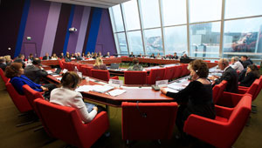
The Congress Bureau adopted a Declaration on ''Regional and minority languages in Europe today''. ''The Bureau welcomed the fact that a large majority of the French National Assembly voted, on 28 January 2014, in favour of a constitutional amendment permitting the ratification of the European Charter for Regional or Minority Languages by France, 15 years after its signature. It calls on Iceland, Italy and Malta, which have also signed the Charter but not yet ratified it, to follow France’s positive example. In addition, it invites the authorities of Albania, Azerbaijan, Georgia, Moldova, the Russian Federation and “the former Yugoslav Republic of Macedonia” to ratify the Charter, something which they committed to doing when they joined the Council of Europe. The Congress – and in particular its Chamber of Regions – will continue to follow up on this issue, in close cooperation with the relevant monitoring bodies of the Council of Europe.''

15.01.2014 The Council of Europe Committee of Ministers today made public evaluation reports on the application of the European Charter for Regional or Minority Languages in Armenia and the United Kingdom. The Charter is the European convention for the protection and promotion of traditionally used languages. The reports have been drawn up by a committee of independent experts, which monitors the application of the Charter.

With regards to Armenia, the Council of Europe recommends the authorities to promote the use of Assyrian, Greek, Kurdish and Yezidi languages in education. The Council of Europe also calls on Armenia to broadcast television programmes in Assyrian, Greek, Kurdish and Yezidi and improve the presence of the Assyrian, Greek, Kurdish, Russian and Yezidi on the radio. Armenia is also encouraged to develop a clear legal basis for the use of minority languages before courts. Finally, adequate funding to the national minority associations so as to ensure the promotion of the minority languages needs to be ensured.

The languages covered by the Charter in Armenia are Assyrian, German, Greek, Kurdish, Russian, Ukrainian and Yezidi. (link to the report)

In the United Kingdom, the authorities are commended for the promotion of Welsh, Scottish Gaelic, Scots, Cornish and Manx. However, the Council of Europe calls on the United Kingdom to continue taking measures to strengthen Scottish Gaelic education, and to adopt and implement a comprehensive Irish language policy, preferably through the adoption of legislation providing statutory rights for the Irish speakers. The Council of Europe also recommends the United Kingdom to take concrete steps to further increase the use of Welsh in health and social care. Finally, the United Kingdom is also encouraged to ensure that the present cuts in public spending do not have a disproportionate effect on the protection and promotion of minority languages.

The languages covered by the Charter in the United Kingdom are Cornish, Irish, Manx Gaelic, Scots, Scottish-Gaelic, Ulster-Scots, and Welsh. (link to the report)

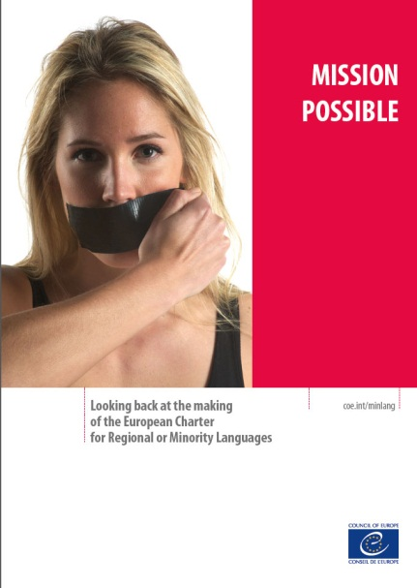
No regrets - mission possible The European Charter for Regional or Minority Languages was adopted, as a convention, for signature on 5 November 1992. On the occasion of the 20th anniversary of this, the Secretariat of the Charter conducted interviews in December 2012 with the authors of the first draft of the Charter - Piero Ardizzone, Yvo Peeters, Mervyn Phillips, Lluís Maria de Puig and Jean-Marie Woehrling. When looking back at the making of the treaty, what its impact has been since, and the challenges that still lie ahead, the original authors emphasised that they would still do it the same way again. Indeed, the objectives and principles of the Charter have remained as topical as they were in the 1980s. The Charter Secretariat now publishes these interviews in the present Festschrift.

