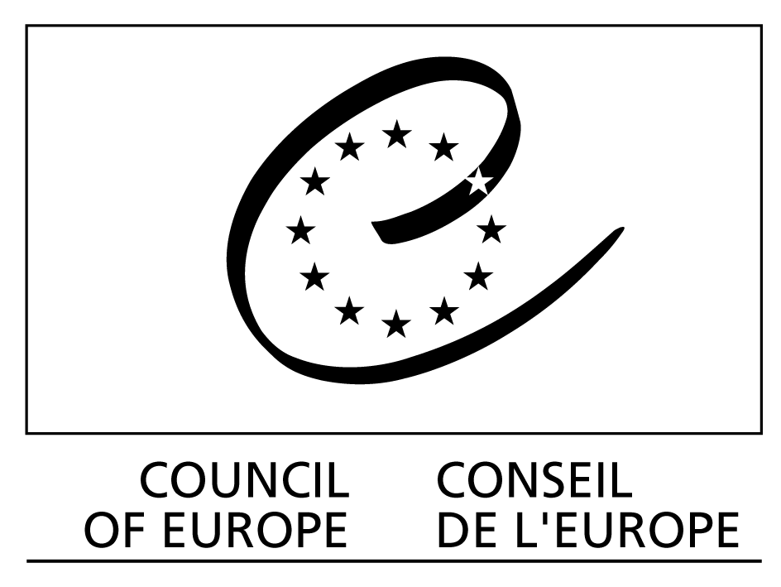

Strasbourg, 27 April 2010

Workshop for guidelines

on the certification of e-voting systems

Council of Europe Headquarters
Palais de l’Europe, Strasbourg
Room 8

Monday 31 May 2010 (2 pm to 6 pm)
Tuesday 1 June 2010 (9.30 am to 1 pm)

Programme

Monday 31 May

2 pm Opening of the meeting
Introduction of participants

Mr Michael Remmert, Project Manager, “Good Governance in the Information Society”: Introduction and aims of the meeting

Mr Jordi Barrat, University of Alicante, Spain, Rapporteur: Results of the workshop on the certification of e-voting systems in November 2009

Ms Susanne Caarls, Secretariat: Some initial draft guidelines on the certification of e-voting systems

Ms Melanie Volkamer, Center for Advanced Security Research, Technical University of Darmstadt, Germany: Discussion paper on the technical aspects of the certification of e-voting systems

6 pm End of the first part of the meeting

Tuesday 1 June

9.30 am General discussion:

- structure and scope of guidelines on the certification of e-voting systems;

- drafting suggestions;
- how to proceed towards the 3rd review meeting in November 2010 on developments with regard to
CM Recommendation (2004)11 on e-voting.

Conclusions

1 pm End of the meeting

