Secretariat general

Directorate General of Democracy and

Political Affairs
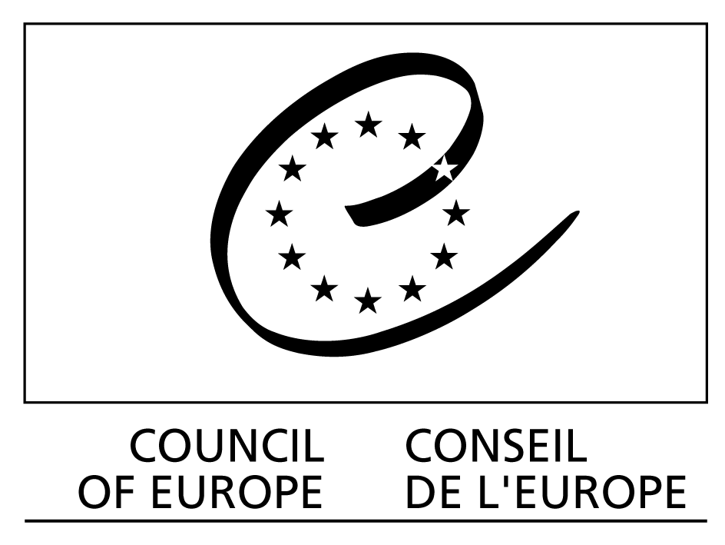
DIRECTORATE OF DEMOCRATIC INSTITUTIONS

GOOD GOVERNANCE IN THE INFORMATION SOCIETY

GGIS (2010) 2

Strasbourg, 24 February 2010

Workshop on the observation of e-enabled elections

18-19 March 2010
Building R-4,
Einar Gerhardsens plass 1
Oslo, Norway

DISCUSSION PAPER

prepared by
Jonathan Stonestreet

I. What is election observation?

Election observation may be conducted by a variety of organisations, including international bodies, political parties, candidate representatives, and civil society associations / NGOs. In some countries, individual citizens have the right to observe aspects of the election process, particularly election day proceedings. Each category of observer pursues different objectives through observation and may utilise different methods. However, the common function of all observer groups is to provide transparency in an election process, thereby contributing to its integrity, to accountability of electoral officials, and to public confidence.

Election observation under the auspices of an international organisation is conducted at the invitation of national authorities and follows a defined mandate. In general, the purpose of international observation is to assess the entire election process, including legislation and practice, against relevant international standards and commitments. International election observation missions identify good electoral practice as well as any shortcomings, and make recommendations regarding elements of the electoral process which could benefit from further improvement. Although international observation has historically taken place in transition democracies, such activities are increasingly taking place in longer-standing democracies, especially in the CoE / OSCE region. This is in recognition that election standards and commitments apply equally to all countries.

Domestic election observation varies according to the legislation and traditions of each country. In many countries, political parties or candidates have the right to nominate representatives to observe the process. Such partisan observers ensure that the rights and interests of their party/candidate are respected and that their opponents do not have an unfair advantage. In many CoE countries, civil society organisations may observe elections, providing for active political participation of citizens and for independent citizen control over elections.

Notwithstanding election oversight mechanisms established by the State, meaningful election observation is essentially the ability to verify independently that electoral and other authorities are adhering to the law and/or international standards and that claims made by the authorities are true. Election observation is therefore the practical exercise of the principle of transparency implicit in the conduct of democratic elections.

In general, observers must not interfere in the election, although domestic observers may be empowered to file complaints. With regard to e-voting, it is important to note that observers do not audit or certify e-voting systems.

II. Election Observation and the Council of Europe Recommendation on Legal, Operational and Technical Standards for E-Voting (2004)

The 2004 Recommendation by the Committee of Ministers does not explicitly mention observation, but it places the core idea of observation – verification of election integrity through transparency – at the foundation of considerations of electronic voting. The Recommendation enumerates a list of international obligations for democratic elections in the CoE area and goes on to state that “i. e-voting shall respect all the principles of democratic elections and referendums. E-voting shall be as reliable and secure as democratic elections and referendums which do not involve the use of electronic means. This general principle encompasses all electoral matters, whether mentioned or not in the appendices”.

Among the obligations for democratic elections, there are two which are especially relevant for discussion of electronic voting: 1) respect for secrecy of the vote; and 2) honest counting and reporting of votes. In addition, the OSCE Copenhagen commitments of 1990, and the Venice Commission’s Code of Good Practice in Electoral Matters (2002), recognise the importance of international and domestic observation in enhancing electoral integrity. Taken together, these obligations contain an implicit requirement for sufficient transparency in ensuring a genuine election process. It must be possible to verify in any voting system that principles and obligations are adhered to; otherwise, the basic integrity of the election process may be called into question.

Both the standards contained in the appendices to the 2004 Recommendation and the explanatory memorandum explicitly reference observation. For instance, standard 23 states that “Any observers, to the extent permitted by law, shall be able to be present to observe and comment on the e-elections, including the establishing of the results.” According to the explanatory memorandum (para 60), this means that “Observers should be able to verify that the e-voting system itself is designed and operated in a way which respects the fundamental principles of democratic elections and referendums. Therefore, member states should have clear legal provisions on observers’ access to the e-voting system documentation and audit data.” Para 59 recalls the commitment of OSCE States to permit and facilitate election observation.

Similarly, standard 108 states that “The audit system shall provide the ability to verify that an e-election or e-referendum has complied with the applicable legal provisions, the aim being to verify that the results are an accurate representation of the authentic votes.” The explanatory memorandum clarifies that the audit system must include interfaces to facilitate observation (subject only to restrictions to protect the secrecy of the vote) (para 183); that it be publicly verifiable (para 184); and that it have the ability to prove that the results are an accurate representation of votes cast (para 185).

These standards establish a basis for observation of electronic voting and appear to intend an expanded rather than limited scope of transparency. However, the standards and the explanatory memorandum provide limited guidance to election officials and other authorities as to how to facilitate meaningful observation. For instance, standard 56 (regarding access to counting) has no explanatory paragraphs to assist in interpretation.

III. Observation and electronic voting – what do observers need to consider?

Some aspects of electronic voting are in principle observable. Observers can assess without excessive difficulty the legal framework, the background for the introduction of electronic voting, transparency, and overall public confidence. System management procedures, physical security of e-voting machines, accessibility/usability, ballot design, voter education, training of election officials, election complaints, and set up of machines and other election day procedures can also be directly observed. Some of these elements can be observed through testing, and the explanatory memorandum states that observers should have ability to “inspect and test certified devices” (para 61).

Nevertheless, as the 2004 Recommendation notes, electronic voting presents special, inherent challenges to election observers. This is due in part to the need for observer groups to have e-voting experts, since many aspects of the process are not easily understandable to persons without technical expertise. Yet there are also significant challenges due to the fact that crucial aspects of e-voting cannot be directly observed. The secrecy of the vote, the casting of the ballot, and the counting of the votes can be directly controlled by observers in paper-based elections but can only be indirectly observed when e-voting is used.

In lieu of direct observation, observers need evidence that these aspects of the process have upheld fundamental democratic principles and domestic law, and that they have not been corrupted due to design problems, operator error, device malfunction, external or internal manipulation, or other threats identified in the 2004 Recommendation. Access to documentation regarding the system and to certification, testing, and audit reports will assist observers in assessing design and security mechanisms that protect against these threats and in drawing conclusions about those aspects of the process which they cannot directly observe.

While access to documentation and reports is a necessary requirement for meaningful observation, it may not be a sufficient condition for ensuring the transparency of certain aspects of the e-voting process. A particular issue arises when considering whether votes are in fact counted as cast. At present, there does not appear to be a solely electronic means that could “verify that the results are an accurate representation of the authentic votes”, as stated in the CoE standards.

Although public confidence is an important consideration, from the point of view of election observation the integrity of the vote counting process and confidence in that process derives from the possibility of verification, not from trust. If no means of verification exists, meaningful observation is not possible, and observers can at best say that they cannot draw conclusions about the vote count. In the worst case, gaps in transparency could be used by political parties or others to call the integrity of the process into question. This is true in e-voting processes as well as paper-based voting.

In a controlled voting environment, the use of a voter-verified paper audit trail (VVPAT), together with effective audits of the results, could be a solution to this issue by providing a means of verifying that votes were indeed counted as cast. Nevertheless, a VVPAT presents additional complexities for legislators and election officials, as well as voters. There is no consensus in the CoE area as to whether electronic voting machines must produce a VVPAT, and the 2004 Recommendation does not address the issue.

Whether source codes should be open is another area where consensus has not been reached. The explanatory memorandum (para 61) states only that they should have access to “relevant software information”. It is unlikely that international observers would have the resources to review source code in a comprehensive manner, but this possibility may be of greater utility to domestic observers. Even if source codes are open, establishing that the code used in the device is the same as the reviewed code may be difficult.

Another consideration in observation of electronic voting is the role and oversight of private vendors, and the accountability of vendors and election officials. This can create obstacles for observation unless the legal framework, tenders and contracts are clear regarding access of observers.

Remote electronic voting creates additional complexities for observation. Similar to paper-based remote voting, observers have no means to verify that voters are who they purport to be and that they are voting in secret. Full access for observers to documentation, reports and to those persons responsible for conducting remote electronic voting may contribute to building confidence in such systems. However, this does not address difficulties in knowing whether the device used by the voter is secure from malware which would identify the voter or alter the content of the vote, nor does it fully address the threat of internal manipulation of the content of the vote.

IV. How can Member States facilitate observation of electronic voting?

CoE Member States could consider taking a number of steps to facilitate observation of electronic voting and thereby enhance transparency. For States considering the introduction of e-voting or modification of existing e-voting systems, the key point is to make transparency/observability a fundamental principle of the system:

- Legal. Not all states have adequate legal provision for observation of elections (whether involving e-voting or not), although a number of States have recently taken steps in this regard. For observation of e-voting, legislation should address not only presence in polling stations and central server sites, but also access to documentation and reports; testing; and observation of audits. In some countries, this access could be defined through regulation rather than law.

At the same time as they provide for access for observers, states may also wish to regulate such access in order to manage the impact on election officials and others during the pre-election period. Accreditation is a common means of regulating observer access. This could include requiring observer groups to adhere to a code of conduct similar to that contained in the 2005 Declaration of Principles for International Election Observation and to have a publicly available methodology.

- Access to documentation and reports. Meaningful observation of e-voting requires access to documentation about the system, including certification and audit reports. For domestic observers, the review of such documentation may take place well before the immediate pre-election period. If accreditation is required in order to access e-voting documentation, it should be possible for groups to obtain accreditation well in advance.

Potential vendors should be made aware during the tender process that observers will have full access to documentation. Non-disclosure agreements which prevent observers from publishing assessments and the facts on which assessments are based render observation meaningless.

- Tests. Accredited observer groups could be given the possibility to check how the e-voting devices/system work. Such tests/audits must not interfere with the conduct of the election. Therefore it would be legitimate to allow such activities only in a controlled environment or to require that the persons conducting the tests/audits have attended a training session. However, observer groups should be allowed to test/audit as they wish; the process should be open enough to allow observers to have full insight into the operation of the device.

- Observer training. Developing training programmes for domestic observer groups could ensure common understanding and build public confidence.

- VVPAT and audits. Unless it becomes possible to verify solely by electronic means that votes have been counted as cast, the introduction of a VVPAT and effective audits of the paper trail would appear to be the only mechanism for making this part of the e-voting process observable. In accordance with the standards, any post-election audits – including VVPAT audits – should be observable.
Bibliography

Code of Good Practice in Electoral Matters, Venice Commission, 2002
http://www.venice.coe.int/docs/2002/CDL-AD%282002%29023-e.pdf

Declaration of Principles for International Election Observation, United Nations, 2005
http://ec.europa.eu/europeaid/observer/declaration_of_principles_code_of_conduct_en.pdf

Discussion Paper in Preparation of Guidelines for the Observation of Electronic Voting, OSCE/ODIHR, 2008
http://www.osce.org/documents/odihr/2008/10/34647_en.pdf

Document of the Copenhagen meeting of the conference on the human dimension of the CSCE , OSCE, 1990
http://www.osce.org/documents/odihr/1990/06/13992_en.pdf

Monitoring Electronic Technologies in Electoral Processes, National Democratic Institute, 2007
http://www.ndi.org/node/14616

Recommendation on Legal, Operational and Technical Standards for E-Voting (2004)11, Council of Europe, 2004
http://www.coe.int/t/dgap/democracy/Activities/GGIS/E-voting/Key_Documents/Rec%282004%2911_Eng_Evoting_and_Expl_Memo_en.pdf

This group may be further subdivided into institutions of international organisations, such as the OSCE Office for Democratic Institutions and Human Rights (OSCE/ODIHR), European Commission, and the CoE Congress of Local and Regional Authorities; international parliamentary assemblies, such as the Parliamentary Assembly of the Council of Europe; and international NGOs, such as the Carter Center. In addition, it is possible for States to observe elections in other States on a bilateral basis.
“…only those e-voting systems which are secure, reliable, efficient, technically robust, open to independent verification and easily accessible to voters will build the public confidence which is a pre-requisite for holding e-voting…”
Para 7.4 of the OSCE Copenhagen Document, 1990.
Standards 33, 56, 83, and 84 also specifically reference observation.
“56. When counting the votes, representatives of the competent electoral authority shall be able to participate in, and any observers able to observe, the count.” 2004 Recommendations, appendix 1.
These issues are addressed in a much more comprehensive manner in the OSCE/ODIHR Discussion Paper in Preparation of Guidelines for the Observation of Electronic Voting, 2008. See also the National Democratic Institute’s (NDI) Monitoring Electronic Technologies in Electoral Processes, 2007.
Please see: http://ec.europa.eu/europeaid/observer/declaration_of_principles_code_of_conduct_en.pdf

