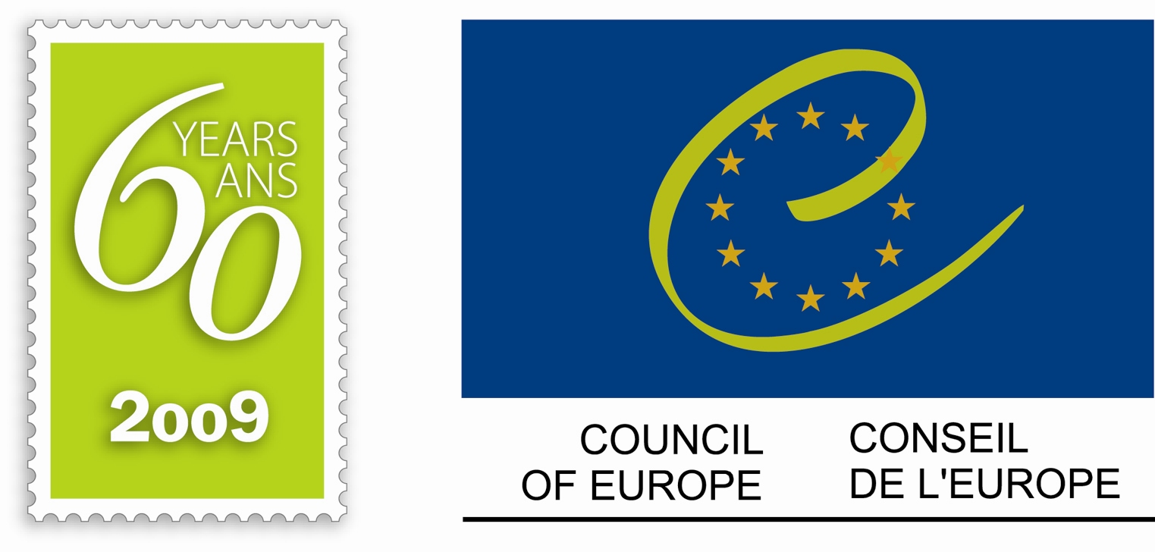

Strasbourg, 23 November 2009

Workshop on the certification of e-voting systems

Council of Europe
Palais de l’Europe, Strasbourg, Room 8

Thursday 26 November 2009 (2 pm to 6 pm)
Friday 27 November 2009 (9 am to 1 pm)

Programme
Thursday 26 November

2.00 pm Opening of the meeting
Introduction of participants

Introduction by the Secretariat

Presentation discussion paper by Mr. Jordi Barrat, Spain

Mr. Patrick Trouveroy
Expert informatician to the Local Authorities Administration
Ministry of the Brussels Capital Region, Belgium

Ms. Ülle Madise
Member of the National Electoral Committee of Estonia

Break

Mr. Michel Marti
State of Geneva, Switzerland

Mr. Daniel Konrad
IT-Security Expert, A-SIT Secure Information Technology Center Austria

First general discussion

6.00 pm End of first part

Friday 27 November

9:00 am Ms Melanie Volkamer
University of Passau, Germany

Ingo Boltz
Technical Consultant for Electronic Voting Systems and Biometric Voter Registration in Latin America

Break

Discussion on how to come to standards for certification of e-voting systems

Conclusions and how to proceed

1:00 pm End of the meeting

