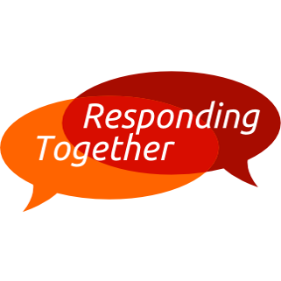
Responding Together
Citizens engagement
in reducing poverty and inequalities
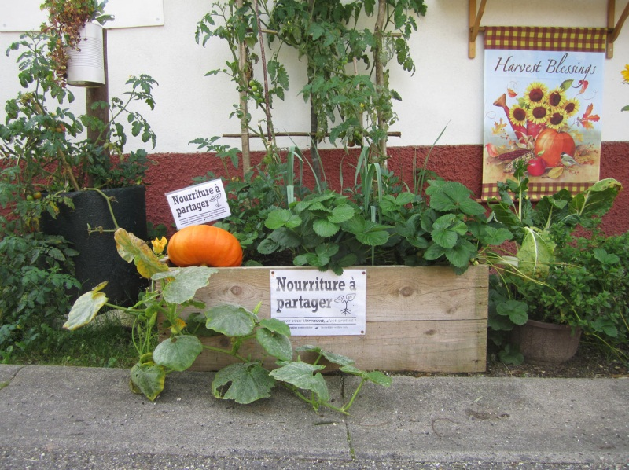
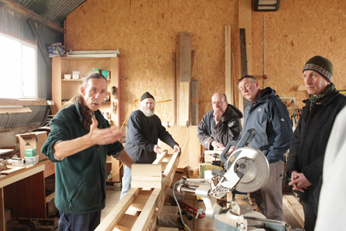

Programme
Conference
Strasbourg, 4 – 6 November 2013
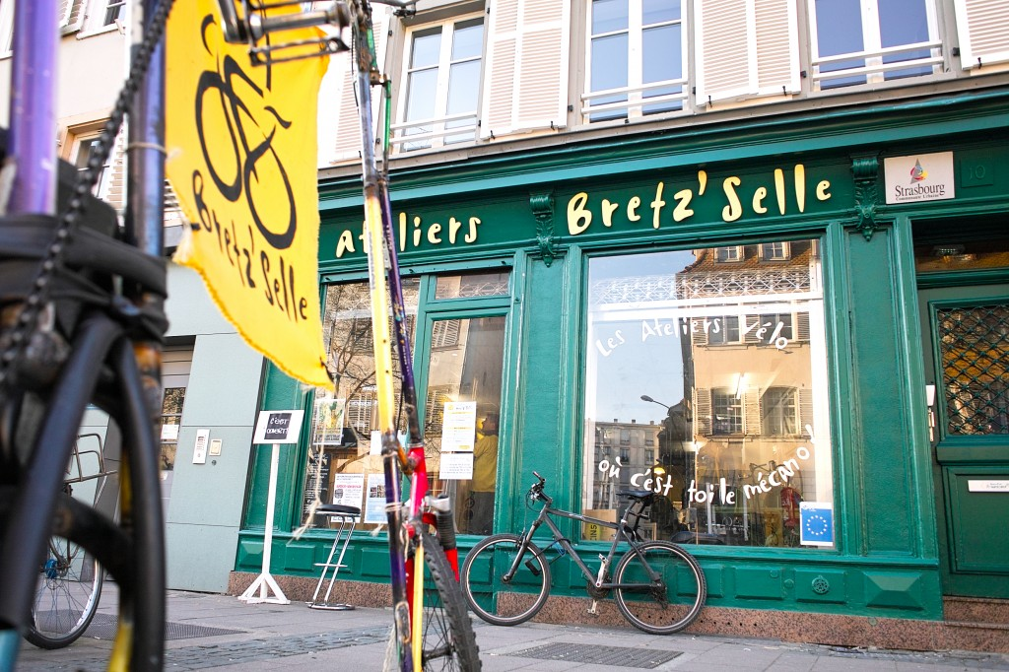
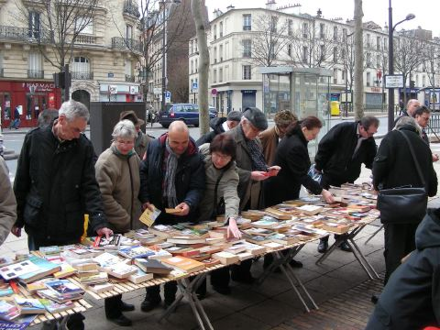

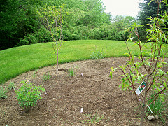
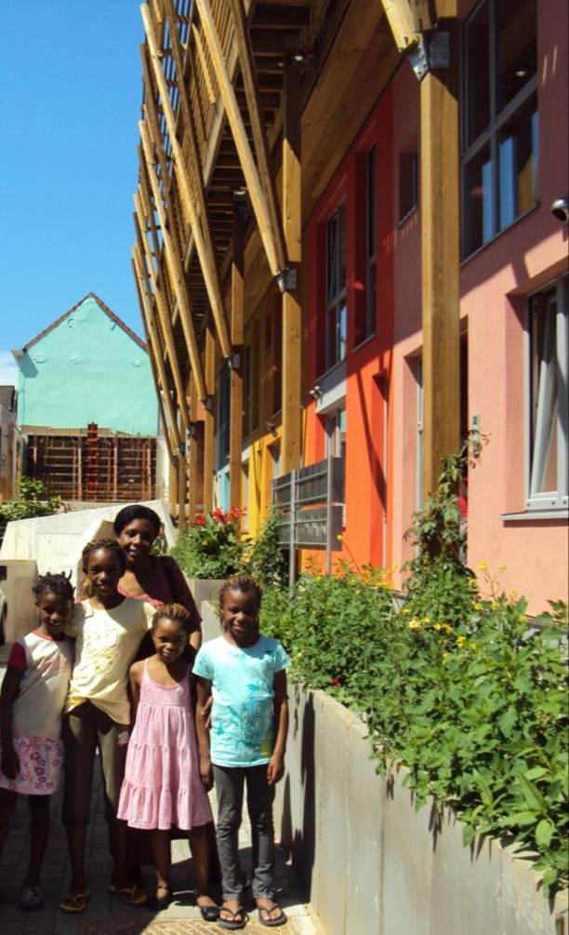
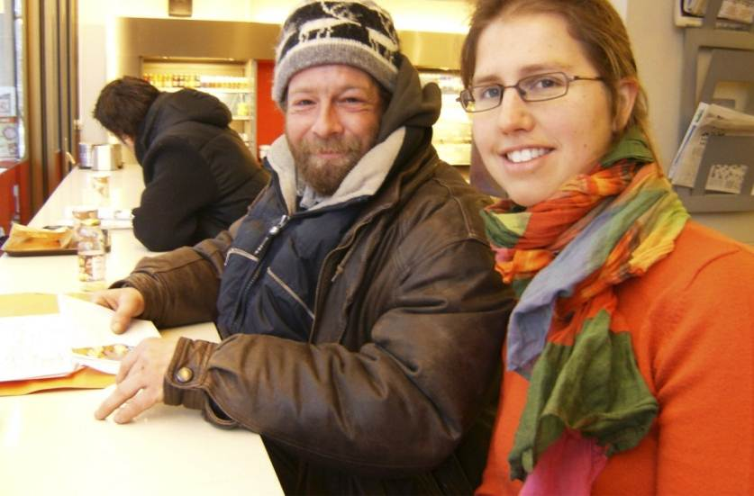

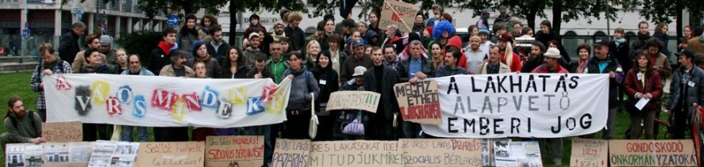
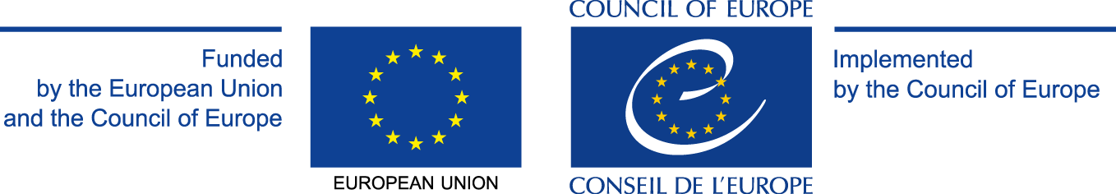

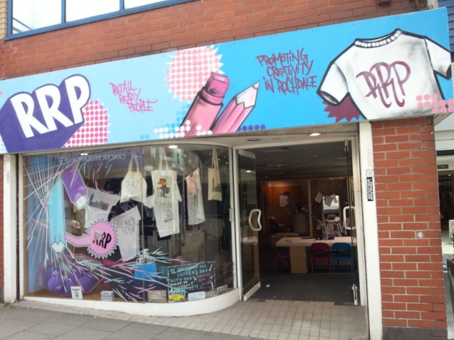

All the pictures of the front page are courtesy of projects presented in the Responding Together platform: Living Architecture, Incredible Edible, Circul’livre, Bretz’selle, Community Land Trust Bruxelles, Infirmiers de rue, A Varos Mindenkie
« Responding Together »
Engaging Citizens in Reducing Poverty and Inequalities
- Final conference of the Joint Programme -

Strasbourg, 4 - 6 November 2013
Council of Europe, Palais de l’Europe

* Draft Programme

Monday 4th of November 2013
ACTING TOGETHER TO REDUCE POVERTY AND PRECARIOUSNESS
How are citizens creating innovative paths to broaden access to resources, both through sharing and by avoiding waste?

8.30 Registration

9:00 – 9:45 OPENING SESSION

9:00 The challenges of reducing poverty and precariousness in Europe today

- Snežana Samardžić-Marković, Director General for Democracy (DGII), Council of Europe
- Luisella Pavan-Woolfe, Ambassador, Head of the Delegation of the European Union to the Council of Europe

9:30 The outcomes of the project “Responding Together”

- Reducing poverty and precariousness by enhancing local, participatory and bottom-up approaches
Gilda Farrell, Head of Division, Social Cohesion, Research and Early Warning, Council of Europe

9:45 – 10:15 THE VARIETY AND POTENTIAL OF CITIZENS’ INITIATIVES

- Resources, strategies and legal frameworks to address poverty and precariousness in times of crisis
Flore Berlingen, Ouishare, France

10:15 Coffee break

10:30 – 12:45 STRATEGIC GUIDELINES OF THE PROJECT « Responding Together »

Moderator:
Samuel Thirion, Council of Europe

10:30 Presentation of the Strategic Guidelines
- Alessandra Sciurba, University of Palermo, Italy

10:45 Roundtable
Practices that respond to the challenges of reducing poverty and precariousness in an innovative way, while facilitating access to resources

- Promoting a better use of resources: Avoiding waste
Matteo Guidi, Last minute market, Italy

- Involving communities in transformation processes: An inclusive approach to sharing
Alain Philippe, Macif Foundation – Presentation of L’accorderie, Paris, France

- Developing methods and processes of co-responsibility: Combining public incentives with citizens’ initiatives
Thomas Dawance, Community Land Trust Brussels, Belgium

- De-stigmatising actions to reduce poverty and precariousness: Enhancing people’s potential and support networks
Marco Clausen, Prinzessinnengarten, Berlin, Germany

11:45 Debate: questions & answers

12:45 – 13:00 MORNING CONCLUSIONS
BY THE EUROPEAN COMMISSION

- Emma Toledano-Laredo, Head of Unit, Social Inclusion and Poverty Reduction, European Commission

13:00 Lunch

13:45 – 14:30 Living library of projects
Meet project enablers

14:30 – 16:30 WORKSHOPS: DISCOVERING & VALUING CITIZENS’ INITIATIVES

a) Avoiding waste and reusing resources
- Repairing resources: Borko Magazin, BicycleRepairShop, Croatia
- Reusing resources to create objects: Paula Policarpo, DariAcordar, Portugal
- Reusing resources to create instruments: Mélissa Azaïche, Lutherie Urbaine, France

Moderator: Kath Rosen, London Orchard Project, UK

b) Sharing and providing access to resources
- Sharing bikes: Graham Pope and Olga Andreeva, BikeSurf Berlin, Germany
- Sharing time: Christine Papadopoulos, Time bank Athens, Greece
- Providing access to health: Laetitia Cloostermans, Infirmiers de Rue, Belgium

Moderator: Anne-Iris Romens, Tous ensemble jeunes et engagés (TEJE), France

c) Creating employment and building community
- Creating employment while avoiding waste: Thomas Fletcher, Rejuce, UK
- Innovative job creation: Rui Elpas de Sa-Carneiro, associação social de Caxias, Portugal
- Strengthening social ties: Georgi Georgiev, Association St. Martyr. George - Lukovit, Bulgaria

Moderator: Denis Stokkink, Think Tank “Pour la solidarité”

16:30 Coffee break

17:00 – 18:30 ENHANCING IMPACT: REPRODUCING & ENLARGING THE IMPACT OF CITIZENS’ INITIATIVES

Moderator:
Arte, génération solidarité*

17:00 Roundtable

- Involving communities
Mary Clear, Incredible Edible, UK

- Toolkits for action
Martine Postma, Repair café, the Netherlands

- Crowdfunding
Charlotte Rautureau, GOTEO, France

18:00 Debate: questions & answers

18:30 End of working day

20:00 Dinner

Tuesday 5th of November 2013
LEARNING TOGETHER TO REDUCE POVERTY AND PRECARIOUSNESS:
Developing enabler policies for citizens’ action
What are the frameworks and incentives to ensure the enlargement and reproduction of citizens’ initiatives?

9:00 – 10:45 IDENTIFYING THE RIGHT INCENTIVES AND FRAMEWORKS

Moderator:
Gilda Farrell, Head of Division, Social Cohesion, Research and Early Warning, Council of Europe

9:00 Opening
- Tuur Elzinga*, Member of the Parliamentary Assembly of the Council of Europe
- Marije Cornelissen*, Member of the European Parliament
- Helena Roseta, Vereadora – Câmara Municipal de Lisboa, Portugal

9:30 Roundtable

- Citizens’ initiatives struggling for recognition
Stéphanie Cabantous, MIRAMAP, France

- Developing mediation processes
Lise Rask, Givrum.nu, Denmark

- Alternative currencies
Chris Sunderland, Bristol Pound, UK

10:15 Debate: questions & answers

10:45 Coffee break

11:00 – 13:00 WORKSHOPS: ENSURING THE EXPANSION AND CONTINUITY OF LOCAL, PARTICIPATORY AND BOTTOM-UP APPROACHES

a) How to recognise the value of citizens’ initiatives?
- Access to housing: Montserrat Sánchez Sánchez and Macarena Hernández Conde, Corrala La Utopía, Spain
- Legal advice and support to projects: Roman Romanov, International Renaissance Foundation, Ukraine
- Creating a network to support action: Domenico Fantini, Genuino Clandestino, Italy

Moderator: Vanessa Sousa, Citizens Initiatives in Lisbon, Portugal

b) How to create incentives to avoid waste and promote a better use of resources?
- The “soft requisition”: Eric Dosimont, First Director of Charleroi CPAS, Belgium
- Incentives to avoid waste: Gonçalo Nunes Rodrigues, Associação Entremundos and ReMix Project, Portugal
- Providing access to health: Dr George Vichas, Metropolitan Social Clinic, Greece

Moderator: Fausto Pascali, Ex Colorificio di Pisa, Italy

c) How to create incentives for sharing?
- Sharing skills and resources: Matthias Ansorg, Economy App, Germany
- Sharing mobility: Angelo Meuleman, Taxistop, Belgium
- Sharing housing: Elizabeth Mills, Homeshare International

Moderator: Dave van Ooijen, Platform 31, Netherlands

13:00 Lunch

13:45 – 14:30 Living library of projects
Meet project enablers

14:30 – 15:30 STRATEGIC CONCLUSIONS FROM THE WORKSHOPS

15:30 – 17:00 A WAY FORWARD TO STRENGTHEN CITIZENS’ PARTICIPATION AND INITIATIVES

Moderator:
Anna Coote, New Economics Foundation, UK

Roundtable

- Encouraging citizens’ initiatives
Carlos Carreiras*, Presidente of the Câmara Municipal de Cascais, Portugal

- Involving citizens in the decision making process
Lena Langlet, Swedish Association of Local Authorities and Regions (SALAR), Sweden

- The Paris Main Verte Programme
Karina Prevost, Community gardens Programme of the city of Paris, France

- A regional law for participation
Antonio Floridia, Consiglio Regionale Toscana, Italy

17:00 – 17:30 CONCLUSIONS
- Chairperson of the European Committee for Social Cohesion (CDCS)*, Council of Europe
- Konstantinos Simitsis*, Mayor of Kavala, Greece
- Giusto Catania*, Deputy-Mayor for participation, Palermo, Italy

17:30 End of the conference

20:00 Projection of “Les moissons du futur”
At Odyssée – cinema theatre, followed by a debate

Wednesday 6th of November 2013
Responding Together Tour in Strasbourg

Guided tour in the city where the Council of Europe was founded, to discover citizens’ initiatives that facilitate access to resources for all, through sharing and while avoiding waste

