  European Commission  Commission européenne |  | 

DGIII/DCS (2009) 46

in partnership with the Government of Quebec

en partenariat avec le Gouvernement du Québec

CONFERENCE

INTERAGIR DANS LA DIVERSITE POUR LA COHESION SOCIALE : cadres et références pour adapter l’organisation et les compétences des services sociaux aux exigences d’une société plurielle

INTERACTING IN DIVERSITY FOR SOCIAL COHESION: frameworks and references to adapt the organization and competences of social services to the demands of a pluralist society

7 & 8 December – Décembre 2009
Conseil de l’Europe/Council of Europe
Bâtiment Agora/ Agora Building, Strasbourg

SESSION PLENIERE du 8 décembre / PLENARY SESSION of 8 December

Développement des compétences interculturelles et des pratiques d’accommodement dans une société pluraliste

Development of intercultural competences and accommodation practices in a pluralist society
________________________________________________________________
TEXTES / ABSTRACTS / SLIDES

Auteur/Author | Langue disponible/available language
Keirsten de Jongh | English
Hans Verrept | English
Liliana Saban | Français
Roberta di Rosa | English

Le texte prononcé fait foi - Check against delivery

Keirsten DE JONGH

Lawyer, Head of the Department of Research, Advice and Communication, Equal Treatment Commission, Utrecht (Netherlands)

Juriste, Chef du service Recherche, Conseil et Communication, Commission pour l’égalité de traitement, Utrecht (Pays-Bas)

PRESENTATION “INTERACTING FOR SOCIAL COHESION”
Council of Europe, 7-8 december 2009

Insight into and solutions for discrimination mechanisms in education services in the Netherlands: role and interest of intercultural competences

Keirsten de Jongh, Equal Treatment Commission The Netherlands

My presentation will be about research that the Dutch ETC has commissioned at a school. I will tell you how this school focused on diversity for many years, but nonetheless had great discrimination problems concerning ethnic minorities.
The ETC started an investigation to find out if one could speak of systematic discrimination at a school and what kind of solutions were possible to tackle discrimination at the school. But before I start I will briefly tell you something about the ETC.

The Dutch Equal Treatment Commission

The Dutch ETC is an independent, unpartial, expert organisation that promotes and monitors compliance with the equal treatment legislation in the Netherlands.
People who feel discriminated can file a complaint at the ETC. The ETC investigates these complaints and in the end gives an advisory judgement. Other tasks of the ETC are:
- giving information about equal treatment legislation
- doing research concerning discrimination
- giving advisory opinions to government and companies concerning law(proposals) and policies

Reason for research and background

In 2007 the ETC received 5 complaints about discrimination because of their ethnic background at a school for higher vocational education in the Hague. The ETC investigated 2 of these complaints. One of these cases was about a Surinam teacher who was confronted by discrimination of colleagues at school: a colleague calling him a monkey in front of other colleagues and students when he was eating a banana, another colleague repetitively made remarks insinuating that men from ethnic minorities were inferior. The other case was of another teacher from an ethnic minority, who also complained about the behaviour of colleagues who constantly made jokes about ethnic minorities, who imitated his accent and marginalized him. In both cases the ETC concluded that the school had failed to protect the teachers against discrimination and therefore contravened the equal treatment legislation.

During the investigation of these cases the ETC received information implying that more people at the school (students and staff) felt discriminated. The ETC suspected that the discrimination cases were not incidents, but that systematic discrimination occured. Therefore the ETC decided to start a research into systematic discrimination at the school. The school initially was shocked that the ETC wanted to start an investigation at the school. But is also realized that something needed to be done to solve the discrimination problems at the school and therefore was very cooperative during the research. The research was completed in april of 2009.

Since 1988 the school had a diversity policy which was focused mainly on getting more students from ethnic backgrounds to register at the school. This policy was successful. At present the school has 21.000 students of which 30% are from an ethnic minority (this is more than twice as many as ethnic minorities at other schools for higher vocational education in the Netherlands). In 1997 this policy was broadened to recruiting more teachers from ethnic minorities (ethnic minorities being mostly people with Turkish, Maroccan, Antillian and Surinam roots). This policy was less successful. At present the school has 1800 employees of which most are native Dutch still (87%). The multicultural climate at the school led to tensions and discrimination. The school had trouble dealing with the problems that occured. In the nineties an anti-discrimination bureau in the Hague started receiving signals that discrimination occured at the school and proposed the school to introduce a code of conduct. The school did not find this necessary however.

At the start of the academic year of 2005/2006 the chair of the board of the school held a speech and said:
“The school is not only an institution for education, but also a vehicle for emancipation and a possible start for social cohesion”.
This is also why the school found it so important to attract more students from ethnic minorities. To achieve social cohesion there must be interaction between different groups in society. By recruiting ethnic minorities social cohesion could be stimulated, was the idea.
The school did not realize that having people with different background in the school does not automatically lead to social cohesion. Only when discrimination problems started to come up regularly and the ETC announced that it was going to investigate systematic discrimination at the school, did the school realize that somewhere along the line something went wrong.

Questions investigated

1. Are there mechanisms within the HHS that lead to prejudice or discrimination on the grounds of characteristics related to their origin, or that lead to people at least feeling prejudiced or discriminated against and if so, what are these?
2. What solutions are available to deal with these mechanisms?

Goal research

1.To acquire insight into the existence, nature and scale of discrimination at the Haagse Hogeschool on the grounds of ethnic origin (and then particularly at a part of the Academy of Social Professions). This primarily means identifying the mechanisms and patterns that cause people to be discriminated against, or feel discriminated against. 2. To acquire insight into possible types of solution that can lead to a discrimination-free learning environment (at the Haagse Hogeschool and in schools).

Method used

- interviews with staff regarding policy and culture in relation to diversity and discrimination.
- individual interviews and group discussions were held with staff and students. These groups were formed on the basis of ethnicity.
- digital surveys among students and staff
- Lastly, the results were discussed in mixed groups of staff at the school

To be able to compare the situation at the Academy of Social Professions (SP) a comparison was made with the situation at the Academy for Marketing & Commerce (M&C).
At SP 13,8% of the teachers and 46% of the students were ethnic minorities.
At M&C 16,2% of the teachers and 30% of the students were ethnic minorities.

Results (4 topics)

- The perception of discrimination
- The nature and scale of discrimination
- The school policy and management regarding discrimination
- Systematic discrimination

The perception of discrimination (broad en narrow interpretations)

One interesting finding of the research is that ethnic minority students and ethnic minority staff had a different perception of what was discrimination and what was not.
Students and employees from ethnic minorities had a broader interpretation of discrimination than those with a Dutch background. Ethnic minorities at the school interpreted discrimination as doing or saying something with the intention to discriminate, but also behaviour that is not intended to discriminate, but nonetheless has the effect that someone feels discriminated. In the view of Dutch students and employees one can only speak of discrimination if it is intentional.

Examples given by ethnic minorities of feeling discriminated are:
- Teachers in class constantly talking about the differences between ethnic groups. This gives the feeling of being an outsider.
- When the school or teachers make scedules for classes or exams, they only take Chistian holidays into account. Why not other religious holidays?
- Talking to ethnic minorities as if they are representatives of their group. For example: asking a Maroccan student why so many Maroccan youngsters misbehave on the street.
- Ignoring cultural or ethnic differences totally (which gives the feeling of not being respected the way one is) or always refering to cultural or ethnic differences when explaining differences between people (eventhough there might be a totally different explanation).
- Native Dutch teachers only seeking contact with their own group, thus giving the feeling of being left out and unexcepted.
- Not taking views and comments seriously.

The different interpretations of discrimination result in ethnic minorities and Dutch natives often misunderstanding each other. This leads to the situation that the Dutch natives often feel wrongfully accused of something that they condemn and do all they can to refute them. For people from ethnic minorities the different interpretations mean a lack of acknowledgement of the discrimination they experience, which in turn adds to their experience of discrimination. When someone has the feeling he or she is wrongfully accused of discrimination this evokes strong emotions that interfere with discussing what has happened and coming to an understanding.

The nature and scale of discrimination

The interviews, the group discussions and the survey reveal that discrimination occurred in both the Academy for Social Professions and in the Academy for Marketing and Commerce (M&C). Nonetheless discrimination was more prevalent at the Academy for Social Professions (SP).

The research reveals that:

- SP staff and students experience more discrimination than M&C staff and students: SP staff 18%, M&C staff 2%, SP students 33%, M&C students 21%
- There are more observations of discrimination in the work and learning environment than personal experiences and there are more observations at SP than at M&C:
SP staff 50%, M&C staff 10%, SP students 50%, M&C students 21%
- students experience more discrimination than staff;
- people from ethnic minorities experience more discrimination than native Dutch people;
- female students experience more discrimination than male students;
- full-time students experience more discrimination than part-time students.
- Staff primarily experiences discrimination by their superiors; students experience most discrimination in contacts with teachers, but also with fellow students, year coordinators, team leaders and management.

The discrimination experiences relate to:

a. ‘Jokes’, insulting or condescending comments about people with a ‘different’ skin colour, origin or religion
b. Stereotyping. Examples: “This is typical for Turkish people”. “Girls with headscarves are oppressed”. “Muslim women are surely not free to choose when they want to have children”.
b. Better job prospects for Dutch natives: unclear application, recruiting and promotion procedures which, at the very least, give the impression that native Dutch people get jobs, a promotion and a permanent appointment more easily
c. Portraying people from ethnic minorities as people with problems, always needing help or always being the ones causing problems (for example Maroccan or Antillian youths)
d. Underestimating the qualities of ethnic minority teachers and students in comparison to those of native Dutch teachers and students. Native Dutch teachers showing how surprised they are when a student from an ethnic minority has a high grade. This is perceived as having lower expectations from ethnic minority students
e. Not taking complaints about discrimination seriously
f. Demanding that all students write perfect Dutch
g. Imposing religions or modes of living on others; discrimination the other way around: Dutch natives feel or experience that they can not speak freely in class about matters that they consider to be core values (equality of men and women, freedom of choice as regards to sexual orientation for example)

The research shows that ‘classical’ forms of discrimination exist in both Academies, often in forms which are more visible and tangible for ethnic minority staff and students than for native Dutch staff and students. The question is whether and how mechanisms at the school encourage discrimination, or indeed discourage it. For example, why does discrimination occur less at M&C than at SP?

The school policy and management regarding discrimination

For years the school invested in responses to the changing social environment at the school due to the expansion of ethnic minority students. The school appointed internal diversity advisers, set up complaints procedures and pilots to equip teachers with the diversity of the student population.

However, the strong focus on diversity by those at the top of the organisation was not accompanied by a clear implementation strategy (curriculum and personnel), nor by skills for managers and staff to deal properly with discrimination situations in daily practice. Consequently incidents relating to discrimination were not always tackled adequately (although this was better at M&C than at SP). This in turn, had a negative effect on the confidence of ethnic minority staff and students in the organisation’s management. They did not feel protected against discrimination. Some of the native Dutch staff (mainly at SP) felt let down by the management because they were confronted by intercultural issues and tensions for which the school had not developed a shared vision and approach.

These results show that focus on diversity is no guarantee for prevention of discrimination or that there is an active discouragement of discrimination. Also the results show that because the diversity policy focused on ethnic minorities at the school, the Dutch native teachers were confronted with problems without knowing how to deal with them.

Systematic discrimination

In this research systematic discrimination was defined as being:

Discrimination in which patterns can be identified which are caused by mechanisms or systems. These mechanisms or systems can be:
- social systems
- systems in an organisation (culture, policy)
- group processes and identity issues.

The research shows that the discrimination at M&C consisted of incidents. No patterns could be identified and therefore at this part of the school one can not speak of systematic discrimination.

At SP so many students and teachers experience or perceive discrimination at a regular basis, it can be concluded that these situations of discrimination are not incidents, but that patterns of discrimination can be identified. In order to establish if systematic discrimination occurs at SP, it is necessary to find out if these patterns of discrimination can be traced back to systems or mechanisms as mentioned before.

Society as a system

As for society as a system it can be said that the social turbulence in society relating to ethnicity and the Islam had a negative effect on discrimination at the school. The 9/11 attacks and the murder of the Dutch filmmaker Theo van Gogh (who was openly critical about the Islam) by a muslim fundamentalist resulted in more tension and more discrimination at the school.

Systems in the school (culture, policy)

Can the patterns of discrimination be traced back to the school culture and school policies?

As for the school culture, the research shows that at SP specifically there was a high risk of experiencing discrimination and of being a witness of discrimination. An explanation for this high risk is that at SP norms play a more significant role than at the M&C Academy, because of the kind of jobs SP prepares students for. In social professions norms are more likely to play a role than in marketing and commerce professions (for example the role of men and women, how to treat elderly people). Also students and teachers at SP had strong opinions on values and it was more common to take things personally.

Combined with a lack of control and an unclear personnel policy on how teachers should deal with ethnic tensions in the class, this led to almost unmanageable situations of discrimination. On top op this the school policies did not offer sufficient protection against discrimination.

Therefore it can be concluded that the school culture and the school policies had a negative effect on discrimination experiences and situations at SP.

Group processes and identity issues as a system

At M&C in the first place staff see each other as professional colleagues and not as people with a different ethnicity. M&C students are more sensitive for ethnic differences, although they also take into account their similarities, for example sharing the same urban background, irrespective of ethnic differences.

At SP it was difficult for the staff and students to act as individual. Staff and students were often seen as representatives of an ethnic group instead of as individuals. This led to undesirable ‘we and they’ relations. During the years at SP, students became increasingly aware of each other as ethnic minority or native Dutch, due to polarised discussions in the classroom. These group processes paved the way for patterns of discrimination experiences.

Conclusions as to systematic discrimination

This leads to the conclusion that at SP there were systems and mechanisms that led to discrimination patterns and therefore that systematic discriminations occured at that part of the school.

Recommendations

The researchers and the ETC made a list of recommendations to change and prevent patterns that lead to systematic discrimination, to strengthen protective policies and create a protective school culture. I will discuss the most important 6 recommendations for schools here.

- Ensure that interculturalisation is part of the school strategy, policy and criteria for quality.

Make sure that attention is paid to interculturalisation in the school strategy, school policies and that that this is a criterium for the quality of the school. Examples of policies regarding the accomodation of expressions of religion or culture are policies that consider holy days for all religions or policies that consider offering different kinds of food.

- Make a code of conduct and ensure that non-discrimination is a premise in this code. If there is a vision document ensure that non-disrimination is a premise in this document as well.

Ensure that there is a broad consensus on the code of conduct. Preferably draw up this code together with employees, students and parents. Ensure that the code is well known within the school and is implemented in a consistent manner. Make sure that the code is used actively to address or prevent discrimination.

- Ensure that when working in a divers setting, intercultural sensitivity is one of the necessary competences of the teachers, management and the ombudsman of the school.

Cultivating intercultural sensitivity can be achieved by recruiting a diversity advisor at the school, by organizing training for teachers to enable them to work in an intercultural setting, developing intercultural competences of the teachers and by helping them to recognize discrimination.

- Ensure that the school pays attention to recognising, measuring and preventing discrimination. Ensure that the school takes measures to deal with complaints of discrimination adequately.

Schools should handle discrimination complaints according to a protocol and should ensure that both the victim and the alleged offender are supported.

Be clear about how discrimination is interpreted. Otherwise unfruitful verbal confusion about whether or not discrimination has occured will persist. This will make it more difficult to come to an understanding.

- Develop measures to ensure that there is a divers constitution of school board members (in the sense of age, religion, etnic background, gender, sexual orientation, handicap or chonic illness).

This can lead to more sensitivity for the needs and problems of different groups at school.

- When there is a diversity policy, ensure that this does not only focus on the recruitment, but also on how to support the employees with different background or charactaristics on the workfloor.

Follow up

When the ETC announced that it was going to start a research at the school, the school was shocked. But because it was keen on resolving the discrimination problems at school, it in cooperated in a constructive manner. In the end the school is glad that is has a clearer view on what went wrong and what needs to be done to change the situation at school.

The school has recently informed the ETC that it is setting up training for the whole management, the members of the school board and the works council (together with an anti-discrimination bureau) in order to:
- create attention for the discrimination problems
- to make discriminatioin open to discussion
- develop intercultural sensibility

Furthermore the school organized a day on diversity and education for the whole school (presentations and workshops).

The school hopes that in the end the measures it takes will lead to a different culture at school in which students and teachers feel welcome, safe and valued. The ETC wil keep a close eye on the school, to see if improvements are made.

Survey of discrimination at the Haagse Hogeschool [Hague University]
as commissioned by the Commissie Gelijke Behandeling [Equal Treatment Commission]
report dated 27 April 2009
Page 74 of 109

8. Summary and conclusions

In this section we answer the questions on which the survey was based. We first examine the concept of discrimination, then its nature and scale and the differences between the education institutions, staff and students involved. We then draw conclusions as to whether systematic discrimination exists at the institution. First we provide a reminder of the questions on which the survey was based, as formulated by the Commissie Gelijke Behandeling (CGB) [Equal Treatment Commission].

Questions investigated
1. Are there mechanisms within the HHS which mean that people are prejudiced/ discriminated against (sooner) on the grounds of characteristics related to their origin, or which mean that people at least feel prejudiced or discriminated against and if so, what are these?
2. What solutions (of varying effectiveness) are available for the mechanisms found?

The objectives of the survey are:
- To acquire insight into the existence, nature and scale of discrimination at the Haagse Hogeschool and then particularly on the Social Work [MWD] programme (which is part of the Academie voor Sociale Professies [Academy of Social Professions] on the grounds of ethnic origin. This primarily means identifying the mechanisms and patterns that cause people to be discriminated against, or feel discriminated against. It is recommended that another programme also be investigated at the HHS.
- To acquire insight into possible types of solution with which a discrimination-free learning environment can be achieved in the specific situation at the Haagse Hogeschool and which can also be applied more generally.

Approach used
Key figures were interviewed at HHS level regarding school policy and culture in relation to diversity and discrimination. After that, individual interviews and group discussions were held with staff and students of both the MWD/Academie voor Sociale Professies and CE/Academie voor Marketing&Commerce [Academy for Marketing&Commerce]. These groups were formed on the basis of function and ethnicity. A digital survey was then held among all students and staff of both programmes or academies in so far as they were involved in the programmes. Lastly, the results were discussed in mixed groups: at HHS level and by staff of both programmes/academies.

8.1. Conclusions regarding the concept of discrimination

People involved in the survey interpret the concept of discrimination in different ways and therefore assess one and the same situation or comment differently. Interpretations of the concept range from broad to limited. This difference is often based along ethnic lines, with people from ethnic minorities applying a broader interpretation than native Dutch people involved in the survey, based on a number of experiences and after having seen what has happened to other people from ethnic minorities. Native Dutch people emphasise that something is discrimination if it is also intended to be such, that is saying or doing something with the deliberate intention of putting another/other people into second place. In principle, people from ethnic minorities also apply this definition but they experience the (unconscious) differentiating effect more often, that is irrespective of whether it was the intention to discriminate or prejudice. Incidentally, if native Dutch people are asked about their own experiences, they refer to things which may also have not be said/done by another with the deliberate intention to discriminate.
Survey of discrimination at the Haagse School
as commissioned by the Commissie Gelijke Behandeling
report dated 27 April 2009
Page 75 of 109

A genuine difference between people from ethnic minorities and native Dutch people is that people from ethnic minorities feel (even more) discriminated against if they are not taken seriously when they point out or complain about discrimination. Native Dutch people do not generally regard a failure to take a complaint seriously as discrimination.

The existence of broader and narrower interpretations of the concept of discrimination means that the native Dutch people who took part in the survey often feel wrongfully accused of something that, in general terms, they roundly condemn, that they take such allegations very seriously and do all they can to refute them. For people from ethnic minorities the different interpretations mean a lack of acknowledgement of the discrimination they experience, which in turn adds to their experience of discrimination.

8.2. Conclusions regarding the nature and scale of discrimination

The interviews, the group discussions and the survey reveal that discrimination occurs in both programmes. Discrimination is more prevalent at SoPro/MWD than at M&C/CE:
- more personal experiences among Sopro/MWD staff (18%) and students (33%) in comparison to M&C/CE staff and students (2 and 21% resp.); the vast majority of the people affected are ethnic minority staff and students, with the discrimination relating to the underestimation of qualities and having to listen to ‘jokes’ and comments on origin, religion and skin colour.
o For staff too: fewer career opportunities and a lack of response to complaints about discrimination;
o For students: the failure to take views and comments seriously.
- Staff who indicate that they are discriminated against experience this primarily in relation to their superiors; students experience this most often in contacts with teachers, as well as with fellow students and year coordinators, team leaders or management.
- There are more observations of discrimination in the work and learning environment: half the Sopro/MWD staff and students indicate that they have observed discrimination; at M&C/CE the same applied to 10% of staff and 21% of CE students. Once again the discrimination had to do with the underestimation of qualities and the telling of ‘jokes’ about origin, religion and skin colour. M&C/CE staff state that they have never observed people from ethnic minorities being prejudiced as regards getting a good job; Sopro/MWD staff state that they have.
- More people being called to account regarding discriminating behaviour: Sopro/MWD staff are told twice as often that they exhibit discriminating behaviour (usually teachers, native Dutch and slightly more men than women); the situation is different among students with, in fact, more female ethnic minority students being called to account about such behaviour.
- A greater conviction that colleagues discriminate against each other (held by 33% of SoPro/MWD staff in contrast to M&C/CE where not a single employee thinks this is the case). MWD students also think this more often than CE students and ethnic minority students more than native Dutch students. A quarter of both MWD and CE students do not know whether teachers discriminate; 34% of both MWD and CE students think that this is the case.

The responses to all the questions posed revealed that
- students experience more discrimination than staff;
- people from ethnic minorities experience more discrimination than native Dutch people;
- female students experience more discrimination than male students;
- and full-time students more than part-time students.
Survey of discrimination at the Haagse School
as commissioned by the Commissie Gelijke Behandeling
report dated 27 April 2009
Page 76 of 109

Situations of being discriminated against or feeling discriminated against referred to primarily by SoPro/MWD ethnic minority and native Dutch staff and students have to do with the following:
a. ‘Jokes’, insulting or condescending comments about people with a ‘different’ skin colour, origin or religion; pigeon-holing people and stereotyping: ‘That is typical of Turkish people’, ‘Girls with head scarves are oppressed’, ‘They (female students with a Muslim background) are surely not free to choose when to get pregnant’, etc.
b. Giving people from one ethnic group a job sooner than people from another ethnic group: unclear application, recruiting and promotion procedures which, at the very least, give the impression that native Dutch people get jobs, a promotion and a permanent appointment more easily. No transparency as to why there are differences as regards recruitment, permanent appointments, etc.
c. Portraying people from ethnic minorities as people with problems, always needing help or always being the ones causing problems (e.g. Moroccan or Antillean youths).
d. Underestimating the qualities of ethnic minority teachers and students in comparison to those of native Dutch teachers and students: people who always address a ‘white’ colleague, not taking suggestions on changes to teaching methods by people from ethnic minority colleagues seriously, hesitation as regards deciding which students should participate in a group.
e. Not taking complaints about discrimination seriously: a number of problems persist without ever being resolved and complaints and conflicts are not dealt with properly.
f. Demanding that all students write perfect Dutch: Despite the fact that the vast majority of staff and students believe this to be an appropriate requirement, and only a small number of people regard it as a strategy for exclusion, it is a major source of stress and is also enforced in practice in very different ways.
g. Imposing your own religion or mode of living on someone else; native Dutch people involved in the survey also refer to this as discrimination ‘the other way around’: feeling or experiencing that you are no longer able to speak freely in class about, or refer to, matters which you consider to be core values: equality between men and women, the right to freedom of choice as regards sexual orientation, etc.

‘Classical’ forms of discrimination therefore exist in both programmes, often in forms which are more visible and tangible for ethnic minority staff and students than for native Dutch staff and students. A number of native Dutch people involved in the survey feel discriminated against due to what they regard as constrictions on expressing their own views. In themselves these findings are not exactly surprising. That is the case in a lot of work and education situations (see the various discrimination monitors that are regularly published). Within the framework of this survey it is important whether and how mechanisms at the HHS and both programmes encourage discrimination, or indeed discourage it. For example, why does discrimination occur less at M&C/CE than at Sopro/MWD? This is the focus of the following paragraphs.

8.3. Conclusions regarding discrimination policy and management

Diversity policy
The HHS has for years invested in proper responses to the changing social environment at the school based on there being a lot more ethnic minority students of which many are first generation students, ever more stringent requirements as regards quality and transparency and the internationalisation of the education. Those diversity-related efforts resulted practically in the appointment of internal diversity advisers, the setting up of complaints procedures, an extensive talent development programme and pilots to equip teachers. Staff appreciate the diversity-related efforts at HHS level as such.
Survey of discrimination at the Haagse School
as commissioned by the Commissie Gelijke Behandeling
report dated 27 April 2009
Page 77 of 109

However, there is often no specific implementation strategy in relation to both the curriculum and the interpretation of the personnel policy and the problems which - ethnic minority and native Dutch - people experience at work.

Combating discrimination at HHS level
As regards the evaluation of the policy at HHS level to prevent and combat discrimination, there are no major differences as such between the staff of the two programmes. Staff state that complaints committees, confidential advisers and courses on intercultural skills are in place but that people are not very confident that these will be effective.

As regards policy and management at HHS level it is noticeable that hardly any staff and students have observed active monitoring by management with a view to preventing discrimination: only 18 % of staff and 11 % of students. In this context there is no major difference between MWD and CE.

Perhaps even more worryingly, no ethnic minority staff members made this observation either - and that applies to both programmes. However, staff do realise that attention is being paid to diversity at HHS level, although a quarter of students do not. Therefore, a focus on diversity is no guarantee, in the eyes of staff who have acknowledged this focus, that this generally applies or guarantees the active discouragement of discrimination.

Combating discrimination at programme level
There is (once again) a major difference between SoPro/MWD and M&C/CE as regards the assessment of the individual programme’s policy and management to combat discrimination. The focus is then on tackling discrimination, openly discussing problems and working towards creating a safe learning climate. A lot of M&C/CE staff (60%) and students (60%) indicate that they are unaware of the current situation. The SoPro/MWD percentages are just 5% and 39% respectively. Of those who do have a view on the matter, M&C/CE staff, generally native Dutch staff and male students, are the most positive. Ethnic minority staff and (female) students at SoPro/MWD are the most negative. People do not feel that matters are being tackled or that incidents are really responded to and neither do people think there is sufficient openness to discuss situations of intercultural tensions.

As regards equipping staff, Sopro staff are two times more likely than M&C staff to state that they are insufficiently equipped. There are no obvious differences between native Dutch and ethnic minorities, nor between men and women. However, people from ethnic minorities and female staff are more uncertain about this.

As regards all these points, ethnic minority staff and (female) students at SoPro/MWD are less satisfied than native Dutch staff and (male) students. As a whole, SoPro/MWD staff and MWD students are less satisfied than comparable groups at M&C/CE, although a lot of M&C staff and CE students indicate that they are not familiar with procedures.

There is a lot more satisfaction with the assessment of the individual intercultural competencies.

Explanation of the complaints to the CGB
The differences between both programmes, between ethnic minority and native Dutch and between female and male students, are most worrying in relation to the statements on the complaints by ethnic minority staff to the CGB on which the CGB decided favourably in 2008. People were asked to provide possible explanations for those complaints by ethnic minority teachers. Explanations varied from ‘they are individual cases, conflicts at work which can occur anywhere’ to ‘some people at the HHS would prefer there not to be too many people with a different ethnic origin’. In a certain sense a breach of confidence is visible between ethnic minority students/staff and the management of the MWD programme:
Survey of discrimination at the Haagse School
as commissioned by the Commissie Gelijke Behandeling
report dated 27 April 2009
Page 78 of 109

- A considerable number of ethnic minority MWD students (33 of the 137) and 9 native Dutch students consider ‘the undesirability of people with a different ethnic background at the school’ as an explanation; 4 staff members regard this as an explanation. This is not many but all 4 are of ethnic minority origin; not one M&C/CE staff member refers to this and only a small percentage of CE students.
- A considerable number of SoPro staff and students think that ‘failing management’ is the explanation, but this view is not shared at M&C/CE.

The strong focus on diversity by those at the top of the organisation has not been accompanied by a clear implementation strategy (curriculum and personnel), nor by a comparable focus on awareness and skills for managers and staff (ethnic minority and native Dutch) to deal properly with discrimination situations in daily practice. This results in incidents relating to discrimination not always tackled adequately (this is better at CE than at MWD) and this, in turn, has a seriously negative effect on the confidence of ethnic minority staff and students in the organisation’s management. They do not feel protected in this area of their lives which is so important to them. Some of the native Dutch staff (mainly at MWD) feel let down by the management because they are confronted by intercultural issues and tensions for which the University or the programme have not developed a shared vision and approach.

8.4. Conclusions regarding systematic discrimination

We defined systematic discrimination in H2 as follows: ways of differentiating in which patterns can be identified and which are caused by mechanisms or systems, with system being interpreted as a social system; organisation system (culture, policy), group processes and identity issues. Can patterns described above be traced back to such systems?

Society as a system
The definition of systematic discrimination as described above is based on the idea that a social system reinforces differentiation within organisations. At the HHS we have seen how the social turbulence relating to ethnicity and religion affects the school community: in image forming, in a hardening of positions and in the way in which the concept of discrimination is interpreted or the way in which discrimination (signs) is (are) responded to. The degree to which this effect is felt differs per organisation (part) as reflected by the major differences between MWD and CE and this, in turn, is related to the policy and culture at the organisation or organisation part concerned. The above definition therefore refers to systematic discrimination with society being a system that affects the school. Of course it is important to realise that this effect of society is not unique to the HHS, but applies to many - if not all - organisations in which people with differing backgrounds meet. However, the HHS is an organisation in the front line of the inter-ethnic debate.

Organisation as a system
At HHS level attention, promotion and resources have been made available in the form of manpower and funding for diversity based on the sincere ambition to improve the school’s position and to enable it to function in a multi-ethnic society. However, this policy is not being sufficiently implemented nor are its effects being sufficiently felt at academy and programme level.
Survey of discrimination at the Haagse School
as commissioned by the Commissie Gelijke Behandeling
report dated 27 April 2009
Page 79 of 109

At academy/programme level there are major differences between MWD and CE as regards being and feeling discriminated against. There is a difference in ‘degree of complexity’ between CE and MWD. This is due, first of all, to the own value orientation of those involved in the survey and, second of all, to the job content as such. MWD native Dutch and ethnic minority staff have clear views on how values they regard as important should be visible in the programme climate (freedom of choice, male-female relations, sexual orientation, diversity, equal rights, etc.) and they respond vigorously if they feel that these values are being eroded. In addition, the profession of MWD means that, as a future care provider, you learn to recognise your own responses to a number of normative issues which are inherent to social work. This creates the need for a professional debate on the matter and these days that, in turn, means teachers need to have a lot more intercultural skills. Indeed, within MWD there is no professional dialogue between colleagues about how the profession has changed, how one should deal with the changes and what insights have been gained (elsewhere) into the new situation. This is even more topical/urgent given the composition of the student population and the profession they are going to be joining.

MWD is subject to more intense dynamism than CE. However, discrimination is also experienced within the latter programme. We can see the effects of the combination of type of students and staff, job content, culture, control and policy:
- At MWD we see how this specific combination of normative job content, a strong (values) orientation on the part of staff and students, a culture of making matters personal, a lack of control and an unclear personnel policy results in an accumulation and almost unmanageable situation as regards being or feeling discriminated against. In other words it forms an important foundation for discrimination experiences which result in incidents being linked together to form patterns.
- In the case of CE we see how the combination of job content (less normative), type of people (commercial orientation), culture (client central), clear and solution-oriented control and a clear personnel policy actually provide a certain degree of protection against discrimination experiences. In other words, issues have a much smaller chance to accumulate and (for the time being) continue to be restricted to incidents, or just seen as incidents.

This is managed at CE and the experiences therefore remain incidental. In the case of MWD this is certainly not controlled but, conversely, is exacerbated by the combination of the factors referred to above.

When defining systematic discrimination at organisation level, we can conclude that the policy as a system at HHS level does not offer sufficient protection to people against discrimination experiences.

The combination of high ambitions on the one hand and the unclear translation to everyone’s professional practice on the other has increased the vulnerability of ethnic minority staff, who have become symbolic for the diversity policy and who have stuck out their necks in this field. However, it also offers insufficient security to native Dutch staff who have to find their way in these complicated intercultural situations and who are naturally liable to make mistakes and be accused of discrimination.

In terms of culture as a system we can conclude that the mix of people, culture
and job content at MWD with, by definition, a lot of normative subjects forms a major risk of
discrimination experiences. It has also become evident how clear control and personnel policy at CE reduce the - albeit smaller - risks present there as well, and how at MWD indeed a lack of
control and an unclear personnel policy exacerbate discrimination experiences.
Survey of discrimination at the Haagse School
as commissioned by the Commissie Gelijke Behandeling
report dated 27 April 2009
Page 80 of 109

At MWD there is no leadership, personnel policy or culture of interaction in which that (unjust) differentiation is properly investigated or the problems correctly identified. Therefore, it persists. In such an environment, individual and incidental experiences accumulate to form a pattern. This confirms to the ethnic minority staff and students involved that discrimination is not an incident that happens to ‘you’ but something more along the lines of ‘we are being deliberately and systematically discriminated against.’

Group processes and identity issues as a system
CE staff see each other in the first place as professional colleagues while CE students see the ethnic differences, although there is more space for ‘other’ similarities, for example sharing the same urban background, irrespective of ethnic differences. At MWD it has become more difficult for ethnic minority and native Dutch staff and students to act as individuals and staff are under considerable pressure to adopt a position. This leads to undesirable ‘us and them’ relations. It is also the case that, during their years at the university, students become increasingly aware of each other as ethnic minority or native Dutch due to polarised discussions in the classroom. These group processes also pave the way for patterns of discrimination experiences.
Survey of discrimination at the Haagse School
as commissioned by the Commissie Gelijke Behandeling
report dated 27 April 2009
81 of 109

9. Recommendations

In this section we formulate pretexts for the HHS to change and prevent patterns that have developed in relation to discrimination at HHS level and at programme level.

9.1. Relevance to other education institutions

The (social) causes of discrimination and resulting patterns are not exclusive to the HHS and can also occur in other education organisations. We expect the findings and recommendations to provide pretexts for other education institutions as well for the identification of the potential risks they run as regards discrimination, how to prevent incidents from turning into patterns and how to strengthen protective policy and culture based factors.

Recognising discrimination
Given the extent of the environmental influences of a society as a system in which discrimination occurs, it is impossible to prevent people interacting with (a certain degree of) prejudice in work and learning situations. Images, views, preconceived ideas, experiences and sensitivities result in a feeling of and/or actual discrimination incidents. Ignoring such discrimination ‘because it is not permitted’ or due to indifference is not an option and only results in an even more forceful discrimination experience. So how should one respond? Even if it may never be fully possible to avoid - this feeling of - discrimination, organisation systems such as policy and culture can certainly play a protecting role to prevent a foundation being created in which incidents are linked together to form patterns. Management steering towards an intercultural curriculum, a method of working in an intercultural classroom and a transparent personnel policy are crucial aspects. The same applies to native Dutch and ethnic minority staff with the required intercultural competencies who feel supported in difficult inter-ethnic situations, whether in the context of colleagues or the lesson situation. Eventually, ethnic minority and native Dutch students benefit from this because, based on a shared vision, curriculum and method of working are suitable to the changed reality inside and outside the classroom. Clarity for and by teachers contributes to a safe learning climate.

9.2. Recommendations at HHS level

The discussion of discrimination at the HHS has been going on for a long time within MWD and has caused emotions to run high. It will be far from easy to instil calm precisely because of the long history of the debate with the corresponding damage caused to those involved in the survey, both ethnic minority and native Dutch. What is more, there is an external environment which underlines the daily forms of differentiation that exist in society, sometimes in a positive way but more often in a negative way. We have seen how that external setting affects the school. There are also developments which - quite apart from discrimination as such - are of considerable influence on what happens in the classroom. Examples are points of departure which form the basis for current teaching methods and strategy in relation to first generation students with the question being to what extent these match up.

In the context of these kinds of ‘big’ issues, the idea is not simply to change ‘something’. That is why there is a certain degree of modesty as regards the ‘feasibility of the desired situation’. In the following recommendations we first formulate pretexts at HHS level, followed by academy or programme level and lastly for MWD in general.
Survey of discrimination at the Haagse School
as commissioned by the Commissie Gelijke Behandeling
report dated 27 April 2009
Page 82 of 109

- Acknowledge that where people - staff and students - with different backgrounds meet, prejudiced views and expectations will play a role from both sides. Acknowledge that, in certain exceptional circumstances - based on a combination of factors - this can lead to more or indeed less of a foundation for (a feeling of) discrimination. Acknowledge that the aim of the school management is to ensure that protective factors such as clear control and a transparent personnel policy are, in a certain sense, the ‘basics’ when it comes to preventing experiences with discrimination linking up to form patterns and to become a dominant factor.
- Be clear about a narrow or broad interpretation of the concept of discrimination. As long as (groups of) people adopt and maintain different points of departure, unfruitful verbal confusion and the definition debate will persist.
- Formulate a diversity policy with a realistic setting focused on people from ethnic minorities and native Dutch people because everyone has to learn to relate to, and be able to operate professionally in, a variety of school and professional situations.
- In this context, ‘realistic’ means that diversity can be a value to be pursued but that its realisation confronts most organisations with difficult problems for which there are no simple blueprint solutions.
- Set out an implementation strategy, that is design - with people in key positions such as Executive Board, HRM director, HR chairman, academy directors supported by diversity advisers - ways in which objectives can also be actually realised in the very different practical situations. Make appropriate agreements and monitor these, offer support and, above all, organise the discussion about what people come up against in practice, facilitate the appropriate exchanges and not only by those who are already ‘supporters’ of diversity.
- Implementation is a lot more than representativeness or achieving a number of target percentages. It also, and above all, means that ethnic minority and native Dutch staff and students are able to engage in discussions with each other and ‘learn’ about their profession and behaviour in a multi-ethnic context of customers and clients.
- Attention for diversity is no guarantee for effective discrimination-related action. Following on from the recommendations ensuing from the recent internal survey into complaint procedures: these have to exist but are the ‘final stage’. The idea is much more that, based on their exemplary function, managers must, in any event, display intercultural sensitivity and be able to investigate what is going on with the people involved in the survey without judging or condemning beforehand one way or the other. Investigating a discrimination experience is not in itself a condemnation or proof that it ‘then has to be true’, also taking account of the very different interpretations of the concept of discrimination. Precisely because ‘proving’ is so difficult and because an approximation of the burden of proof is not beneficial to mutual relations, the real benefit is that - all - those involved in the survey are listened to and at least understand why something has taken place or is interpreted in a certain way and are encouraged, on the basis of the information, to change their behaviour accordingly. In the event of legitimate complaints, suitable measures must (of course) be taken and the external communication has to be clear about the substance and reasons.
- As Executive Board ensure that, in the event of key appointments (and this not only means directors but also people responsible for implementation in practice, such as team leaders), candidates are competent as regards displaying this exemplary behaviour and putting it into practice.
- Make sure that the HHS, as a public education institution, has an unambiguous and explainable policy as regards the accommodation of expressions of culture and/or religion(s) in daily practice. Examples are holy days, food, etc.
- Organise a discussion of educational innovation in relation to the current and future student population in the light of their chance of success.
- Check whether the structure of the HHS as an organisation corresponds to the above recommendations.
Survey of discrimination at the Haagse School
as commissioned by the Commissie Gelijke Behandeling
report dated 27 April 2009
Page 83 of 109

9.3. Recommendations at academy/programme level

Translate the tone and spirit of the above to academy/programme level:
- Also focus on the profession: how can the profession to which the programme channels be made ‘diversity proof? That has to be binding and conclusive. The focus is on the question of whether a professional profile still applies, on curriculum and competencies, on teaching material, literature and casuistry. For staff and, particularly, teachers the focus is also on how you can manage this content properly in a mixed classroom. Above all, the latter demands intercultural sensitivity and skills. With this in mind an inspiring procedure needs to be devised together with staff.
- Do this with a mixed group; do not forget in this context the role of the course committee and - if there is none - make explicit approaches to ethnic minority students.
- Organise an ‘out of the windows’, meaning a study of how things are tackled by comparative programmes, or very different programmes at the HHS (MWD and CE colleagues could, quite surprised, ask each other how ‘the other’ tackled matters during the discussion of the survey results).
- The following suggestion is worth investigating with a view to preventing discrimination complaints by investigating these carefully at the earliest opportunity and by organising a dialogue. Train a number of native Dutch and ethnic minority students in proper mediation as regards this difficult issue. They can be deployed as mixed duos if there are signs of discrimination. Or students can approach them if they need help in difficult situations. This could also be a way of fulfilling the desire to close the still large gap in age and position between students and confidential advisers (survey by Tiel and De Mol).
- Work actively as managers to restore the confidence of staff, particularly ethnic minority staff, as regards the ‘active monitoring of managers to prevent discrimination’. In the survey, not one ethnic minority member of staff indicated that they had seen managers actively monitoring to prevent discrimination (neither at MWD or CE). In the discussions, MWD staff in particular indicated that they felt unprotected in discrimination situations.

9.4. Recommendations for MWD

- For MWD it particularly applies that progress can be made as regards control and the clarity of personnel policy. This offers security to staff and averts situations in which discrimination can crystallise. Clear control by staff also offers security to students. This means teachers who are consistent regarding the rules applied on issues which are currently dealt with on the basis of a lot of freedom as regards interpretation and therefore space for (a feeling of) unequal treatment.
- This structure and solidity must be supported by solidarity. The question is what do we do as MWD to ensure that all staff and students feel at home and welcome. So that no-one has to continue to fight for recognition. For staff and, to a certain degree, students this may mean ‘small’ changes such as taking account in the timetable of holy days, etc.
- However, the main task will be to reassess the content of the programme and above all the method of working in the classroom to recreate a constructive learning climate for students with teachers who have a clear vision of what should feature in an intercultural programme and why. Including the skills for working on this with students.
- Explore, as management of the academy/programme, how this task should be dealt with in order to work on diversity and discrimination at MWD (and the other programmes).

Survey of discrimination at the Haagse School
as commissioned by the Commissie Gelijke Behandeling
report dated 27 April 2009
Page 84 of 109

- Develop a shared strategy as to how - given the existing polarisation - the desired reassessment with staff and students can be given substantive form and how staff can acquire the corresponding skills. It is essential that employees and students themselves also start taking responsibility for the quality of their own learning and work climate.

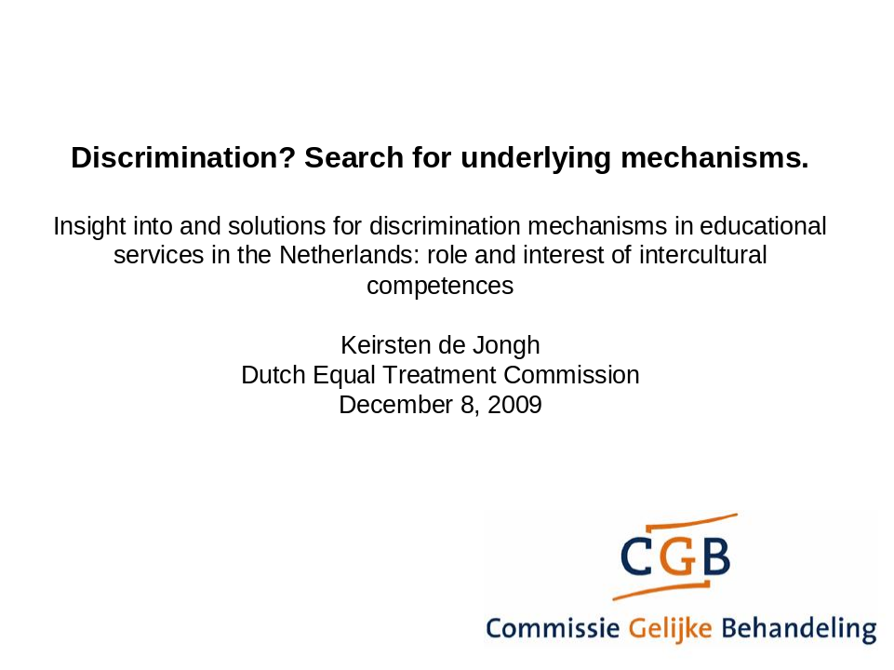

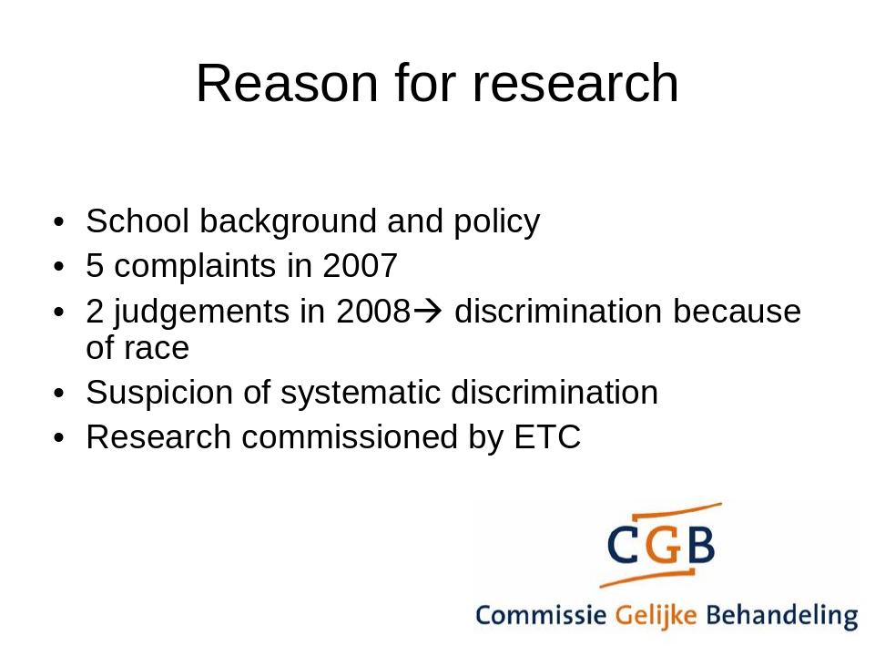

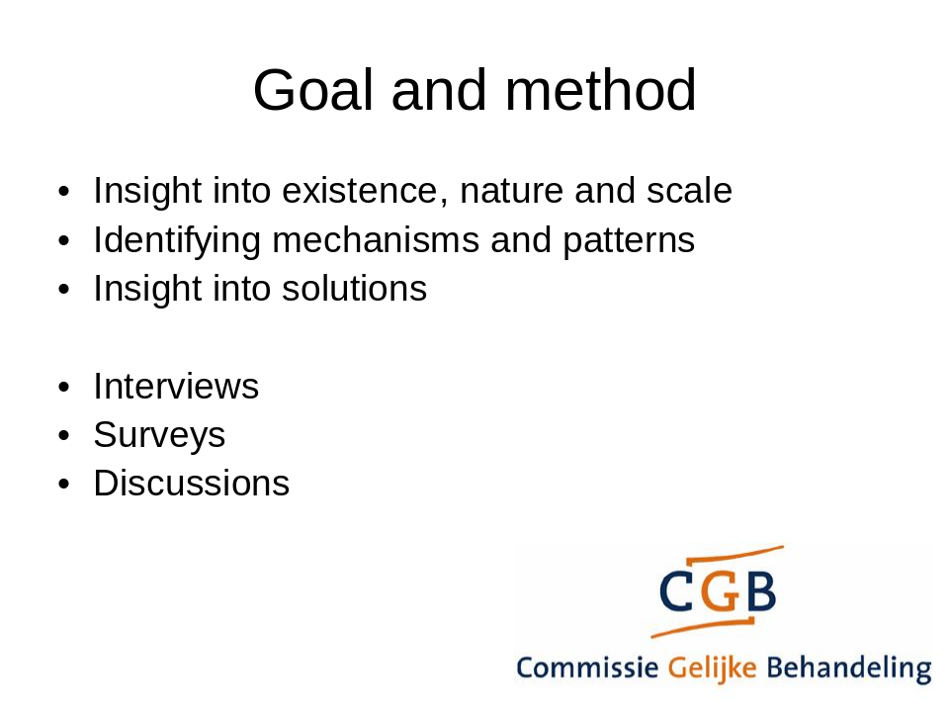

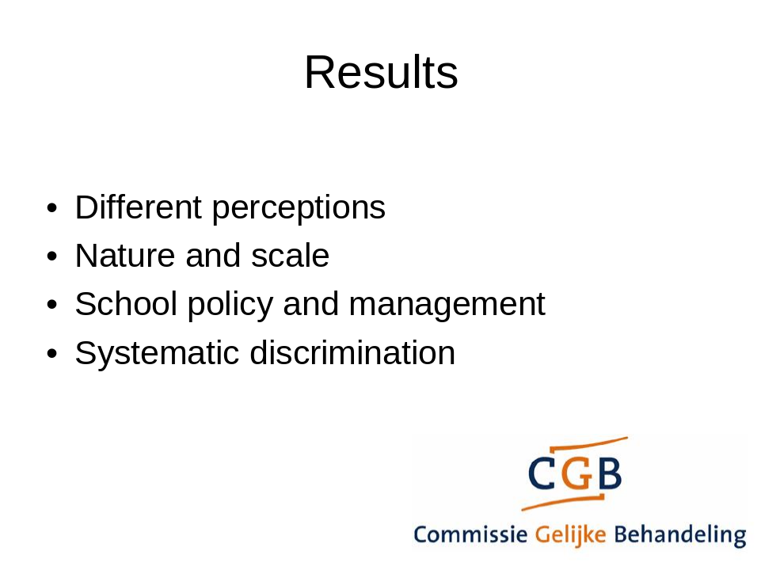

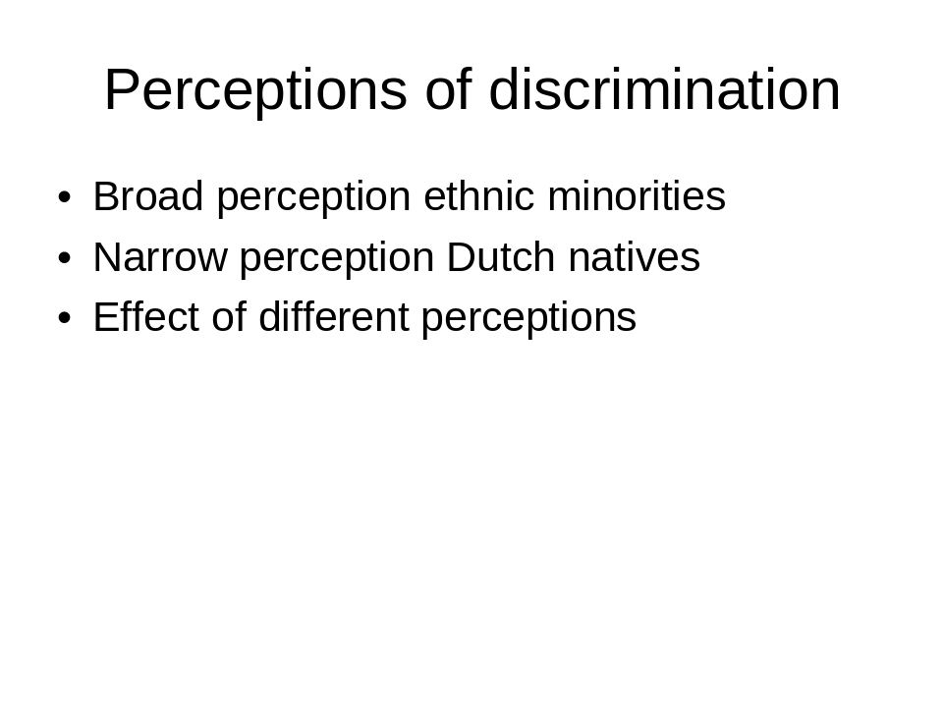

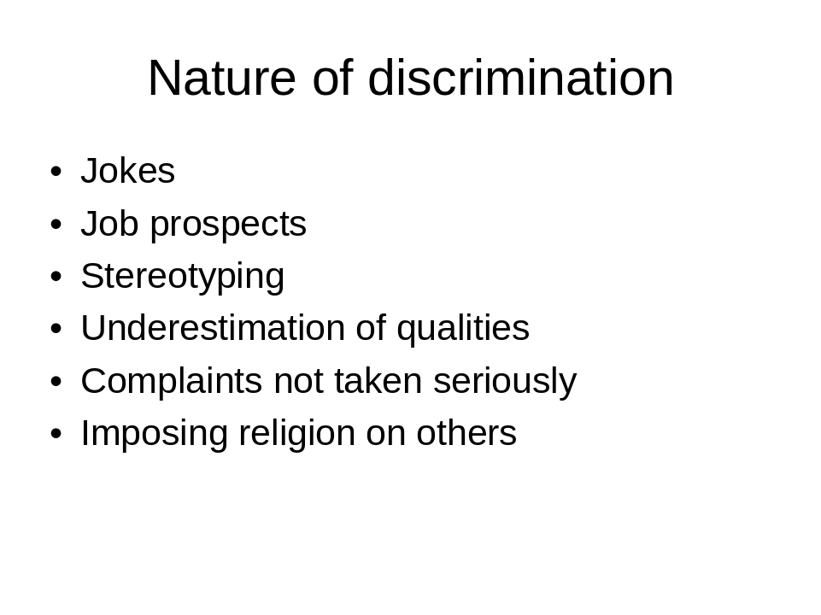

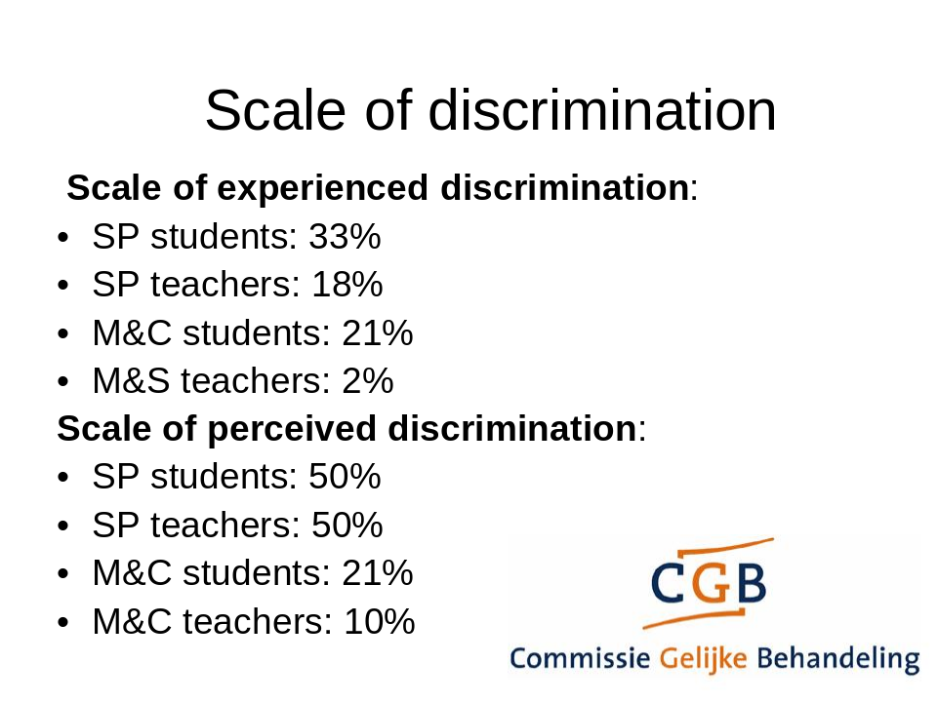

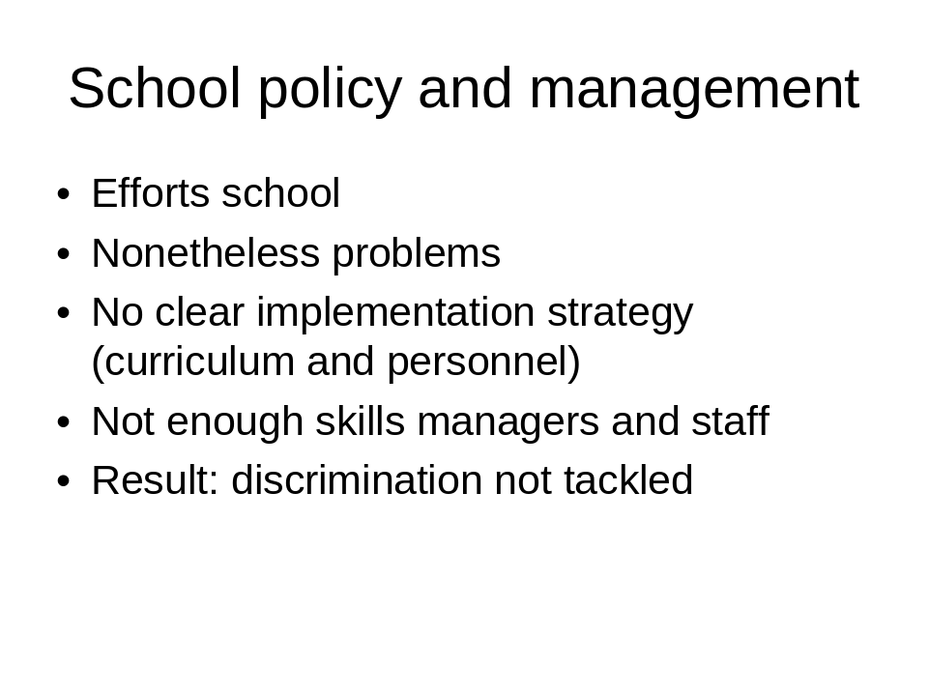

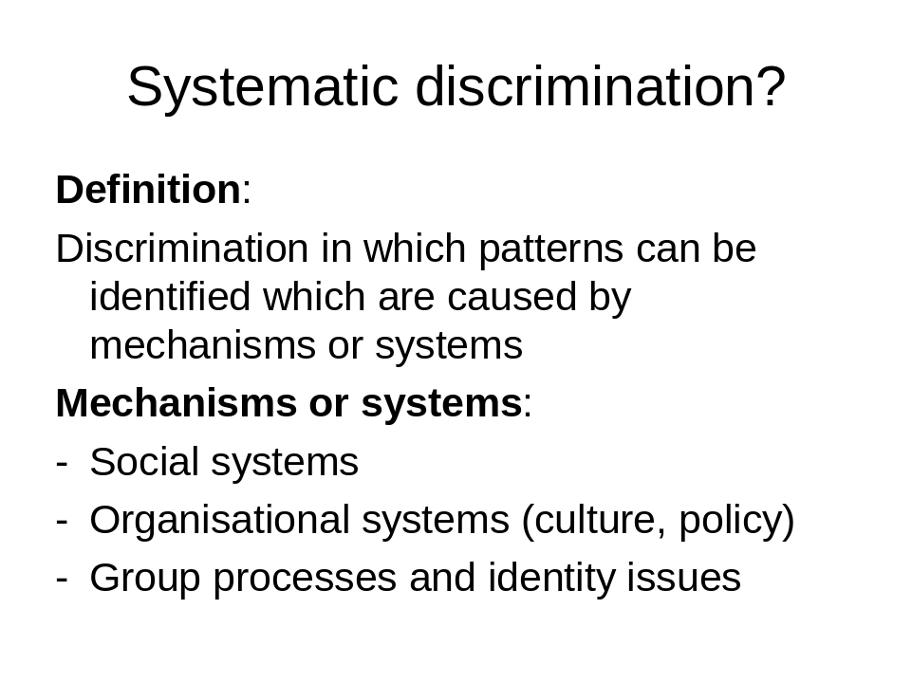

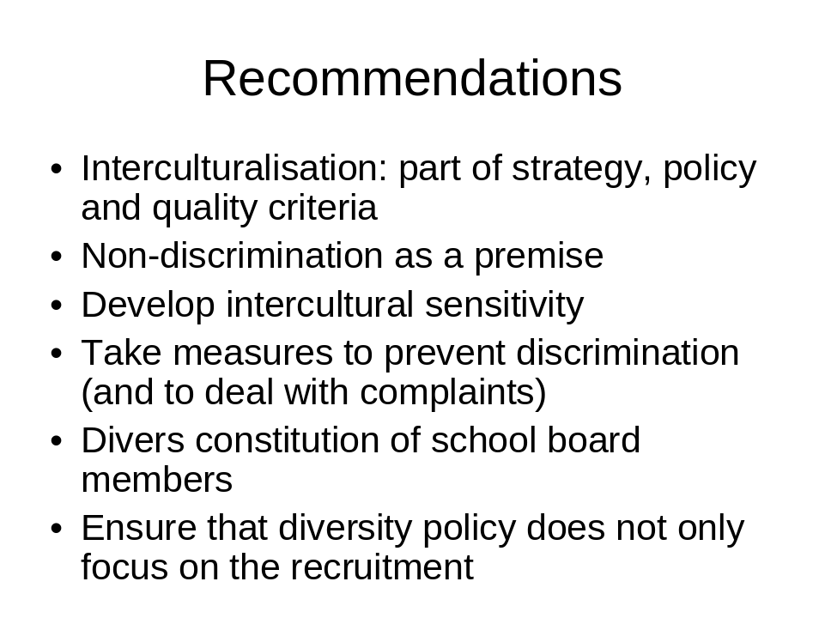

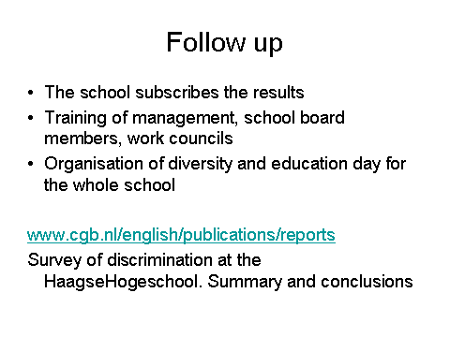
Hans Verrept

Chef de la cellule médiation interculturelle et support de la politique, DG1, Service Public Fédéral Santé Publique, Sécurité de la Chaîne Alimentaire et Environnement (Belgique)

Head of the Intercultural Mediation and Policy Support Unit, DG1, Federal Public Service of Health, Food Chain Safety and Environment (Belgium)

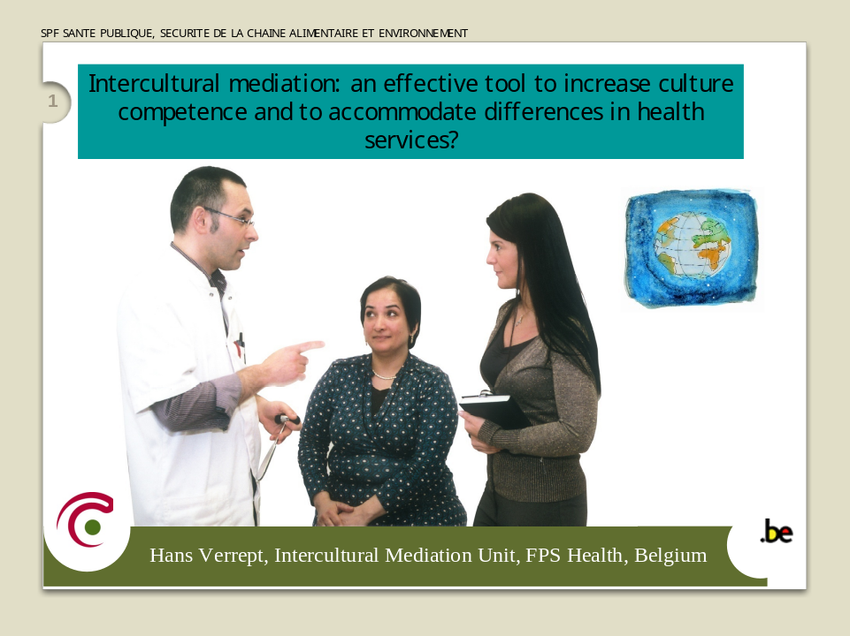
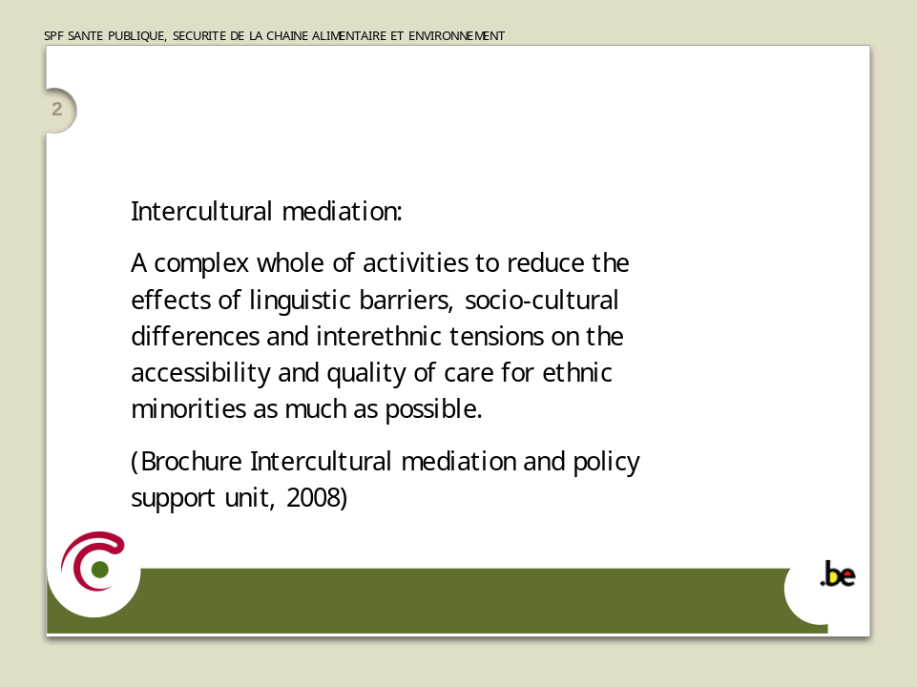

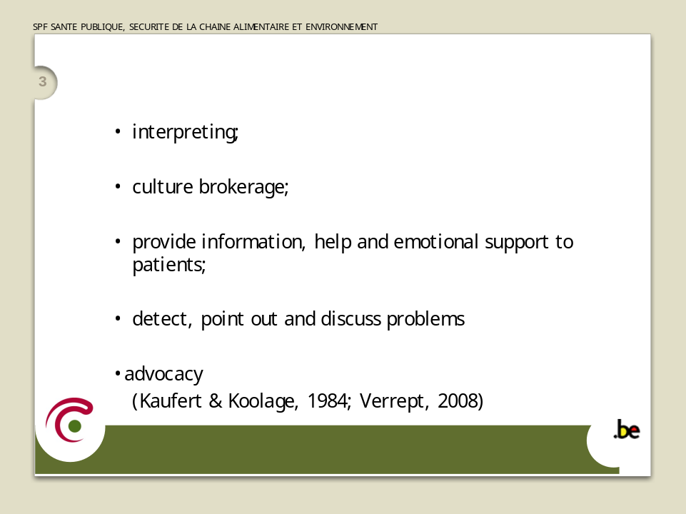

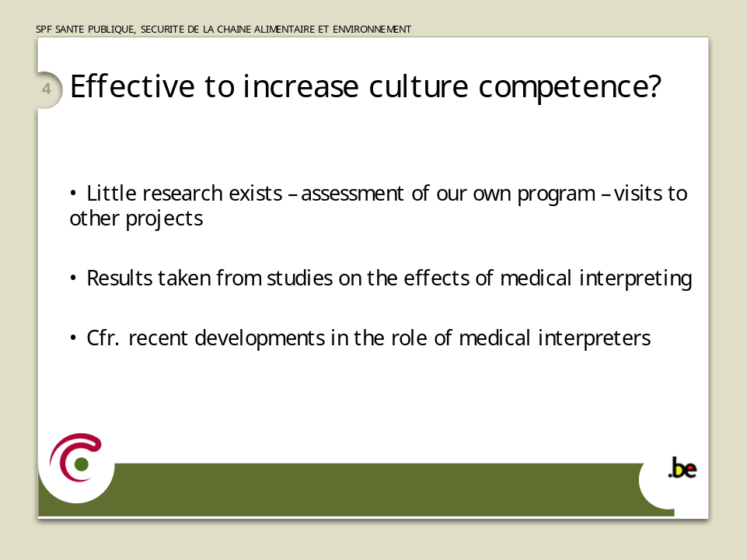

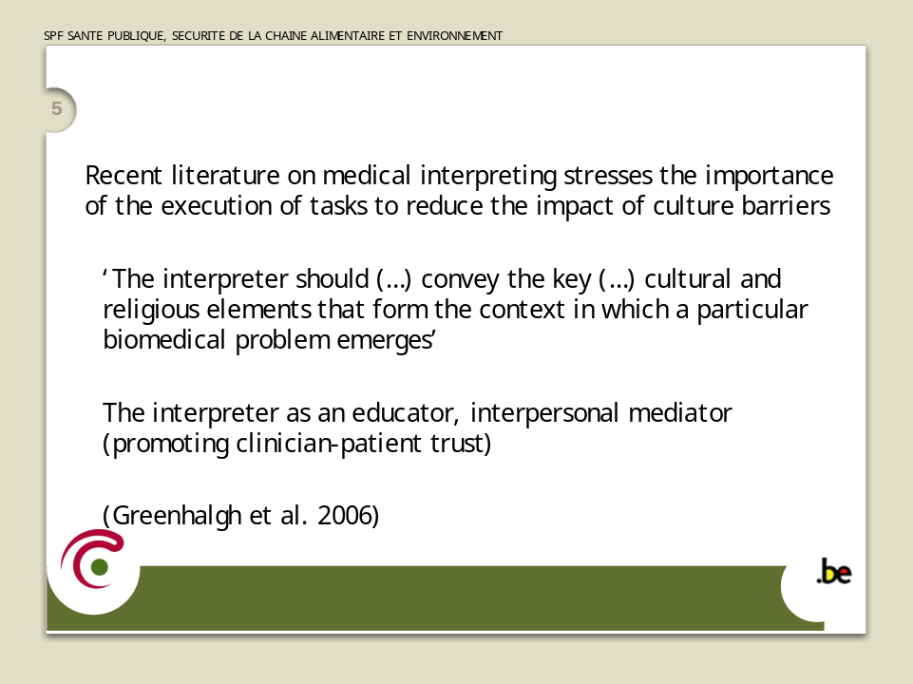

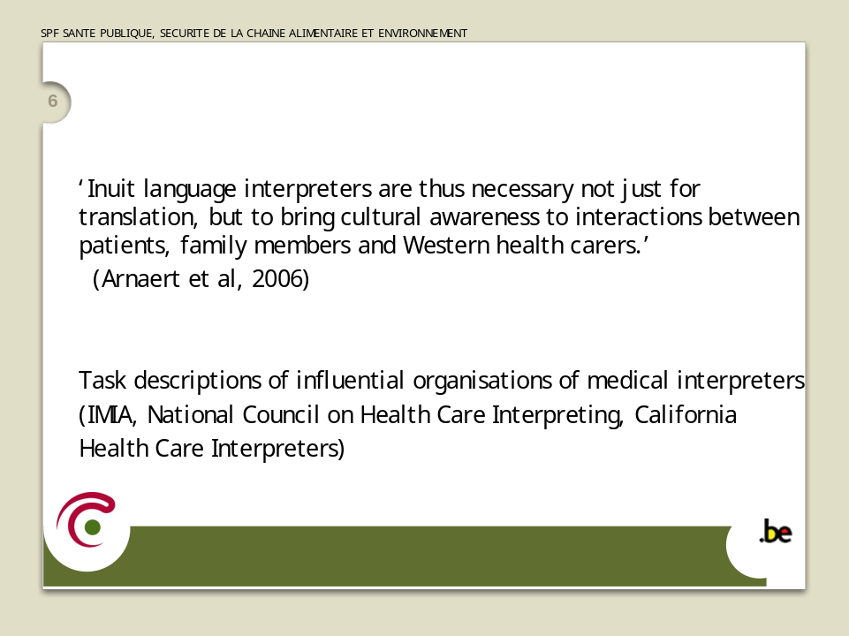

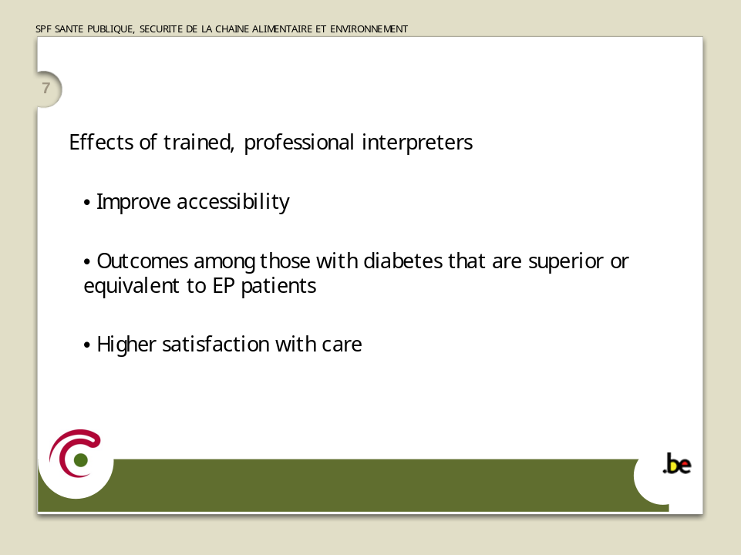

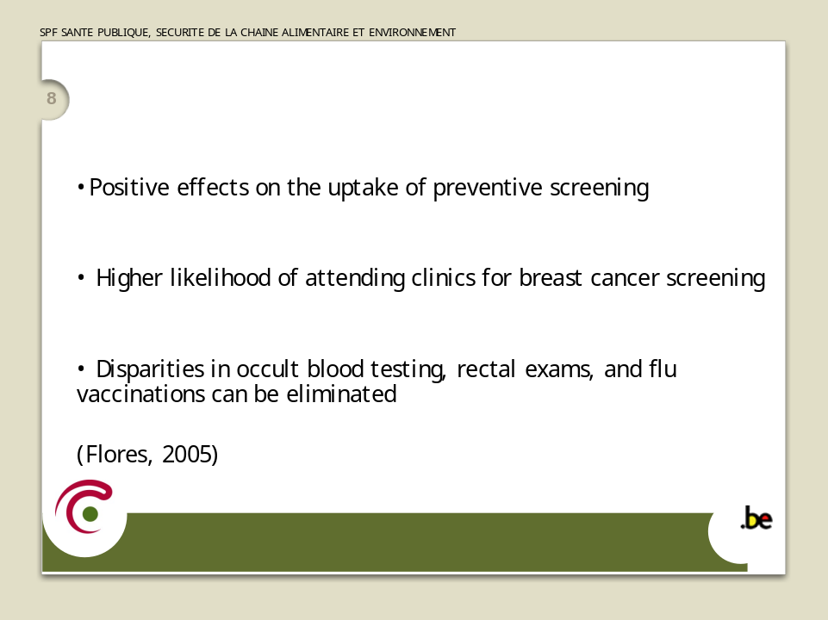

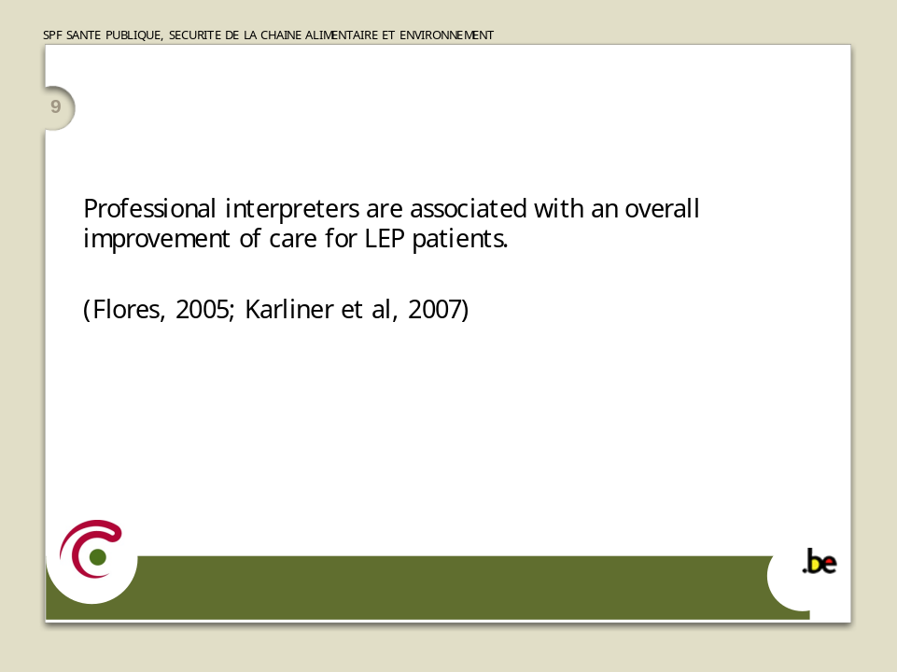

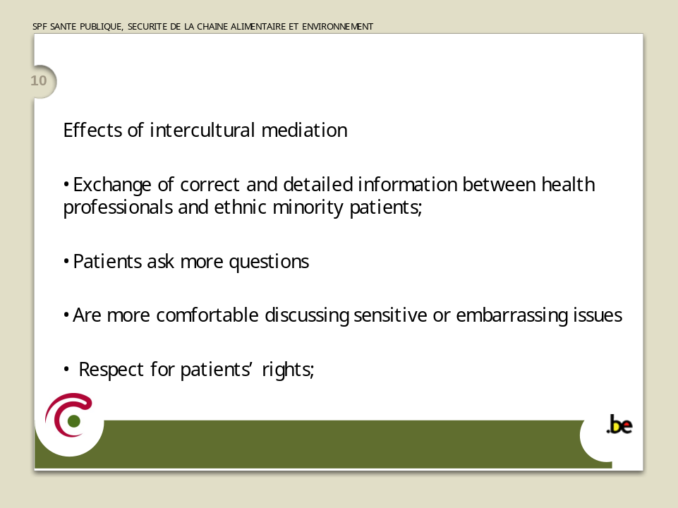

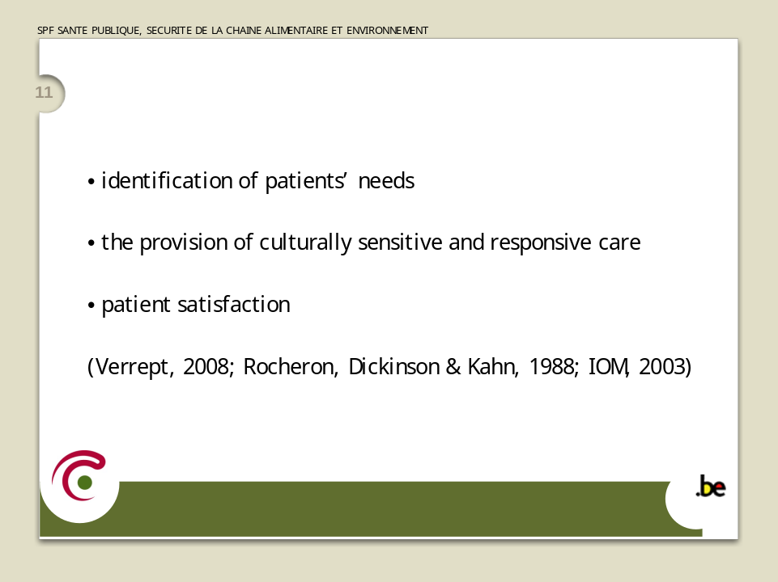

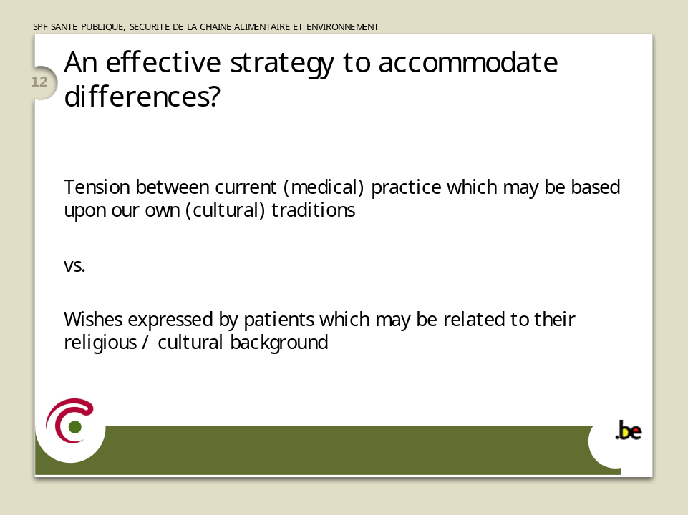

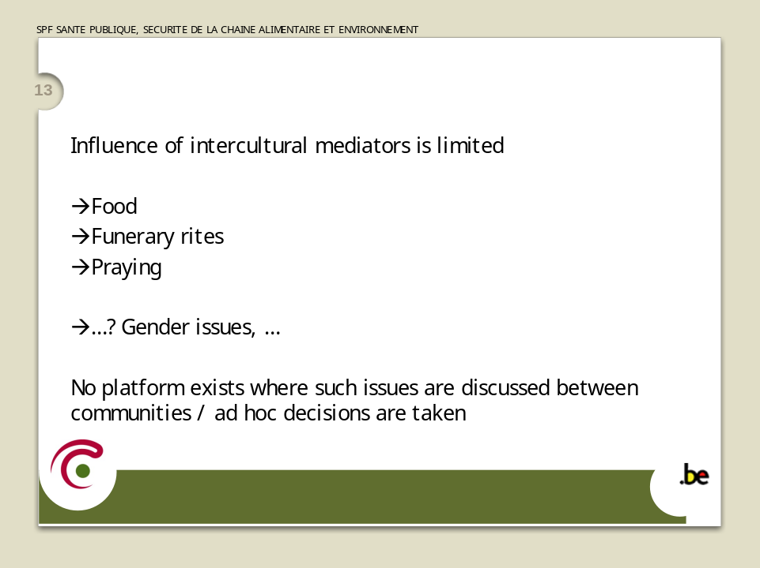

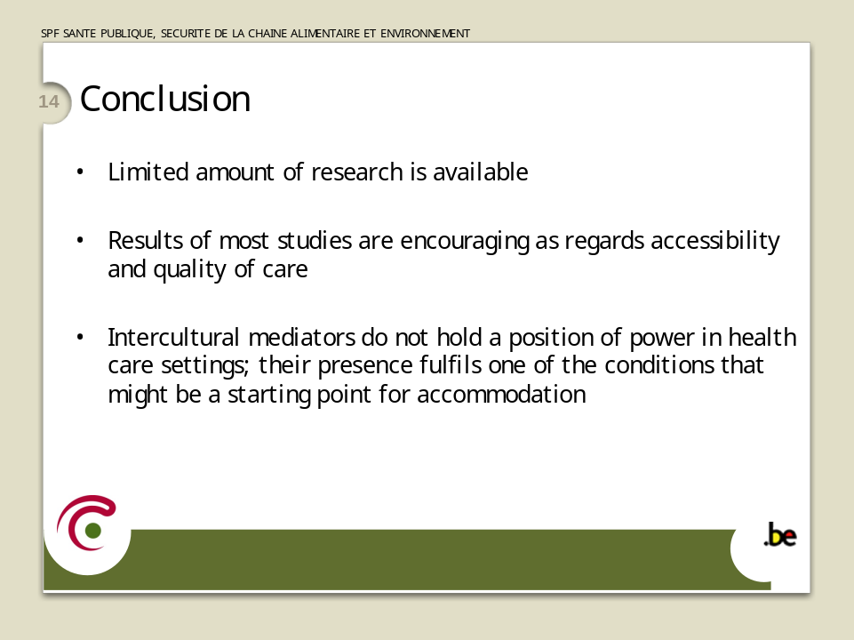

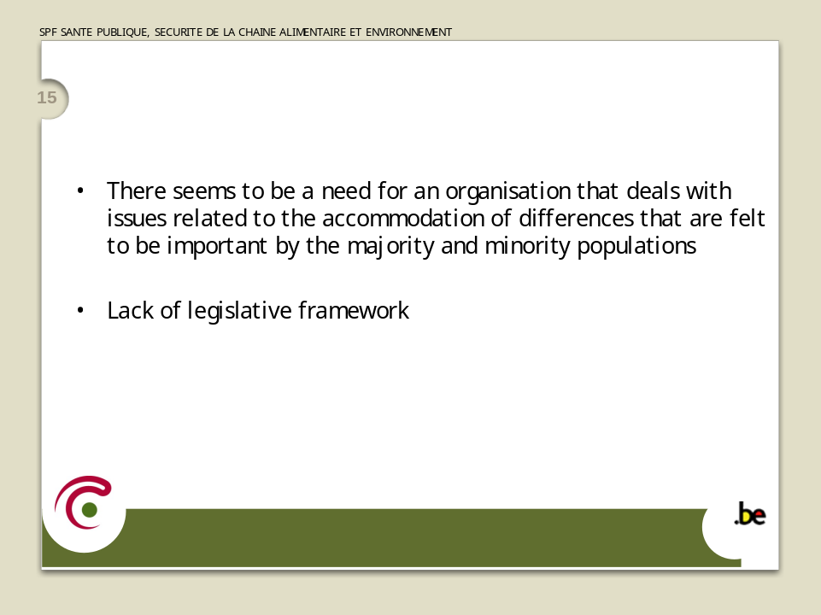

Liliana SABAN

Directrice, Migrations Santé Alsace (France)

Head, Migrations Santé Alsace (France)

Les efforts d’accommodation dans les services
répondent-ils aux besoins et attentes des migrants ?

Une approche déterminée par le cadre constitutionnel

Il est communément reconnu que l'état de santé des populations migrantes est moins bon que celui des français nés en France ; néanmoins les recherches menées dans ce domaine restent encore rares et les politiques publiques se donnant pour objectifs d’apporter des réponses ciblant les besoins des migrants sont pratiquement inexistantes.

Les principes républicains de laïcité et d’égalité devant la loi "de tous les citoyens sans distinction d’origine, de race ou de religion", affirmés à l'article 1er de la Constitution de notre pays déterminent une approche très spécifique de ce qui a trait à l’immigration, et plus généralement à la diversité culturelle et religieuse.
Le modèle d' "intégration à la française" récuse les traitements différenciés, ceux-ci pouvant constituer un risque – réel ou supposé – d' "enclavements ethniques" d’une part (c'est-à-dire produits par la société d'accueil) et de dérives communautaristes de l’autre (c'est-à-dire de repli des migrants eux-mêmes). Ce positionnement a un effet double dans le domaine de la santé des migrants : par crainte d'ouvrir la voie à des discriminations, le recueil par nationalité ou pays d’origine de données objectives d’épidémiologie ou d’utilisation des services est fortement soumis à conditions, et par ailleurs pour parer à d'éventuels glissements, les services publics se prémunissent d'emblée contre les demandes d'accommodements liées à des pratiques religieuses ou culturelles : ainsi, la Charte de la laïcité dans les services publics proposée par le Haut Commissariat à l'Intégration - qui n'a pas valeur normative mais qui est un corpus de grands principes -, spécifie que les usagers "ne peuvent, à raison de leurs convictions, récuser un agent public ou d’autres usagers, ni exiger une adaptation du fonctionnement du service public".

Les observations qui peuvent donc être faites sur les besoins et les attentes des migrants en matière de santé, et les accommodations existantes ou manquantes, reposent d'une part sur les quelques études néanmoins disponibles et d'autre part sur les constats que des associations travaillant dans les domaines de la santé et du social font, sur le terrain même de leurs actions, au contact des publics.
Des besoins spécifiques liés à la migration

Les besoins des migrants en matière de santé sont fortement caractérisés par la migration. Le pays d'origine, les raisons qui les ont poussés à migrer - économiques, familiales ou politiques - et le statut administratif qui légitime ou pas leur présence en France, la durée même de cette présence, les réseaux sociaux qu'ils arrivent, ou pas, à reconstituer, leur vécu de l'immigration, en termes d'exil, de déracinement ou d'enracinement, leur connaissance de la langue pour comprendre et s'exprimer, sont autant d’éléments qui - en se combinant – viennent marquer les besoins des migrants.
Ces combinaisons sont toujours individuelles et c'est bien pourquoi ces besoins ne sont bien évidemment pas uniformes, homogènes et figés, mais tout au contraire variés et évolutifs.

Cependant, les chercheurs et les professionnels de la santé qui sont amenés à accueillir et soigner les migrants font des constats qui se recoupent. Ils relèvent que les migrants ont de vraies difficultés d'identification des services, de décodage du fonctionnement des systèmes, d'expression de leurs attentes, symptômes, plaintes et souffrances, de compréhension des diagnostics et pronostics, d'accès à l'information visant le consentement éclairé… et aussi d'observance des traitements et suivis.
Les médecins, de leur côté, soulignent les risques d'erreurs de diagnostic, la nécessité ressentie de multiplier les examens pour tenter de pallier aux problèmes de communication (sans y parvenir… !) et le rallongement des durées d'hospitalisations qui s'en suit ; ils soulignent aussi les risques de prescription de traitements inadaptés, voire même dangereux lorsqu'ils n'arrivent pas à recueillir des informations capitales comme les allergies et les contre-indications en général (anti-inflammatoire, antécédents d’ulcère ...)...

Ces besoins appellent des accommodations qui ont à agir sur les registres des barrières linguistiques, de l'accueil et des compétences des professionnels, et finalement sur celui des fonctionnements institutionnels.

Les difficultés de langue trouvent des réponses inégales

La question de la "langue" émerge relativement souvent dans les services publics, surtout à l'hôpital, mais essentiellement lorsque les médecins ressentent des difficultés, ou plus globalement le corps soignant. Les réponses trouvées sont très disparates puisqu'à côté de solutions bricolées, certaines pouvant avoir de lourds effets d'ailleurs, il arrive que soient sollicitées des ressources beaucoup plus structurées.
Sans compter les médecins, encore trop nombreux, qui ne voient pas d'utilité à soigner avec un interprète (les arguments généralement avancés sont le doute de l'exactitude de la traduction, les contraintes de l'organisation,...), la très large majorité des professionnels se contentent de solutions improvisées. Ces agents des administrations, infirmiers, médecins, s'adressent à des tiers, habituellement des membres de la famille, souvent des enfants, ou à des amis et voisins ; d'autres encore sollicitent des membres du personnel, de toutes catégories, et bien entendu non formés aux fonctions pour lesquelles ils sont interpellés.
Viennent enfin les acteurs qui recherchent des services d'interprètes ou de médiateurs professionnels parce qu'ils présentent des garanties de qualité et de respect d'une déontologie. Cette forme d'accommodement, qui existe dans certaines grandes villes est toujours portée par des associations. Ce sont elles qui saisissent les directions des établissements hospitaliers. Les hôpitaux qui posent la communication (linguistique et culturelle) avec les migrants et la prise en compte de la diversité comme une affaire interne à l'institution sont rarissimes : l'hôpital Avicenne de Bobigny, qui porte un projet pilote et adhère au réseau Migrant Friendly Hospitals, en est un.
Il me paraît important de noter le caractère inégal des moyens mobilisés et des missions confiées à ces intermédiaires que sont les interprètes ou les médiateurs dans les différents services publics du territoire ; dans notre région, en Alsace, il n'y a pas de cahiers des charges formalisés par les services publics, hormis les modalités techniques d'exécution, et je n'ai pas entendu dire que cela soit différent ailleurs. L'accommodement qui est pratiqué est une variété d'interventions aux profils imprécis : les fonctions assumées par les interprètes fluctuent selon les associations qui les missionnent, au gré de leurs propres représentations des limites du métier et parfois même sans qu'elles soient sérieusement définies.
Ce constat en appelle un autre : les contours de professionnalisation sont eux aussi disparates ; gagner de la clarté sur ces deux points, en codifiant les fonctions d'une part et en établissant des standards de formation partagés d'autre part, assurerait une qualité uniforme et donc une identité. Au-delà du souci de qualité qui n'est pas moindre, il me semble qu'atteindre cette harmonisation peut améliorer l'identification de ces fonctions comme un véritable métier et par conséquent augmenter le recours des professionnels à cet accommodement.

En amont en tout cas, au niveau des politiques et des institutions, le besoin et les enjeux de l'accommodement "interprétariat ou médiation" ne sont pas vraiment problématisés, réfléchis, ni planifiés.

Les représentations des professionnels …

L'accès aux soins des migrants est aussi entravé par leur capacité à utiliser les services, au vu notamment de l'accueil qui leur est réservé. En effet, la question de la communication ne peut être envisagée que par le seul aspect de "carence linguistique" mais doit aussi l'être par celui des représentations culturelles… et clairement, celles qui viennent interférer ne sont pas uniquement les représentations des migrants eux-mêmes, mais largement aussi celles des professionnels à qui ils s'adressent, qu'ils consultent. Des préjugés, des stéréotypes… autant de culturalisme que de discrimination.

La discrimination directe dont les migrants font l'objet est une réalité à prendre en compte et qui constitue "tout le contraire" de l'accommodement ! Une étude récente, menée sous la direction de Didier Fassin, souligne que des agents administratifs qui considèrent que la législation française est trop généreuse et que la bonne qualité de la couverture de soin inciterait des étrangers à se soigner "aux frais de la France" mettent en œuvre des "logiques du soupçon" ; partant des droits des migrants en situation irrégulière qu'en fait elles viseraient, ces logiques atteignent bien entendu toute figure d'étranger.
Ces comportements pointent l'importance et l'urgence de promouvoir chez les professionnels les "dispositions à mettre en œuvre des accommodements". Or la formation des professionnels à l'approche interculturelle est tout à fait occasionnelle et insuffisante en France. Si cette préoccupation trouve une relative place dans les programmes d'études du travail social et des soins infirmiers, les facultés de médecine qui proposent des modules sur la santé des migrants sont encore rares. L'univers médical persiste en France à rester très centré sur lui-même, et son ouverture sur les sciences humaines est encore tout à fait limitée.

Les attentes de personnalisation de soins

Je n'ai pas encore évoqué les attentes spécifiques exprimées par les migrants. Elles sont essentiellement liées à leurs croyances ou traditions : la plus courante concerne les interdits alimentaires qui touchent les repas eux-mêmes mais aussi les traitements prescrits ; viennent ensuite les attentes liées aux modes d'accouchement, aux pratiques accompagnant la naissance ou au respect des rites de la mort. Ces attentes et les réponses d'accommodements apportées ne semblent plus troubler les acteurs de la santé ou du social : dans les villes grandes et moyennes, on y est quotidiennement confronté. Cependant dans les petites communes où les migrants sont plus isolés, l'approche est différente : la mixité culturelle est moins habituelle, les accommodements sont moins envisagés, plus difficilement accessibles aussi, et la marge de négociation se trouve être d'autant plus étroite.
Enfin, il y a également les attentes de personnalisation des soins, venant d'hommes et de femmes qui, au nom de leur croyance religieuse ou de leurs codes culturels, refusent d’être examinés, à l’hôpital public, par des médecins du sexe opposé. Généralement, ces demandes d'accommodement qui "sexualisent" les professionnels sont rejetées, et prennent appui sur les cadres de laïcité et d'égalité homme – femme, affirmés comme des valeurs fondamentales de la république.

Les dysfonctionnements systémiques

Je ne pourrai pas conclure sans avoir dit que les difficultés à appliquer des accommodations naissent des dysfonctionnements structurels, systémiques, des services publics de santé. Le plus souvent ce sont des logiques institutionnelles qui agissent sur les comportements des professionnels, qui accueillent et soignent les migrants, indépendamment de leur propre intentionnalité.
En France depuis quelques années sont votées des lois que les spécialistes de santé publique jugent d'inquiétantes en ce qu'elles favorisent les inégalités de santé au lieu de les combattre ; ainsi se mettent à l'œuvre des politiques publiques qui dissocient le champ du sanitaire de celui du social. Cette logique est très présente à l'hôpital. Dès lors, puisque les besoins des migrants relèvent des déterminants sociaux de la santé, des directions hospitalières estiment que la planification d'accommodements n'est pas de leur ressort, même si les besoins se manifestent dans les établissements, dans des espaces de soins, et touchent le soin.

Il faut se référer en outre à la récente réforme hospitalière qui impose une gestion de l'hôpital public sur le modèle de celle de l'entreprise et vise la rentabilité. La pratique de "la tarification à l’activité" qui est à l'œuvre au sein de l'hôpital "standardise" les situations de soins là où la prise en charge de façon pertinente des patients et tout particulièrement des plus vulnérables de la société, requiert nécessairement, pour les soins comme pour l’accompagnement, une mobilisation complexe d’acteurs, et plus de temps. Or, les soignants sont soumis à la pression d'une double injonction, imposant la satisfaction d'un impératif de "quantité" avec celui d'une "démarche qualité" autour de la garantie des droits des usagers.

Le temps est un élément récurrent : lorsque l'insuffisance d'effectifs contraint les agents, infirmières ou médecins à écourter le temps qu'ils passent avec chacun des usagers et / ou patients, les premières victimes de cette limitation sont ceux, parmi les publics, qui ne maîtrisent pas la langue française.
Dans ce contexte, la recherche d'accommodations est un effort de plus à faire, un fardeau plus qu'autre chose.

… un triple levier

A ce jour les accommodements apportés dans les services de santé sont insuffisants, autant dans leur forme que dans le mode de recours qu'en font les services publics (manque de réflexion sur l'objet, moment de recours tardif,…) ou encore dans leur inégale distribution sur le territoire.

La meilleure adéquation des accommodements et leur développement nécessitent l'interaction, autour d'une volonté partagée, des différents acteurs et registres de responsabilités concernés. Tout d'abord, et obligatoirement, les politiques publiques d'intégration des populations, et de santé publique, doivent être les initiateurs et les promoteurs d'un large "esprit d'inter-culturalisme" ; seul cet investissement premier des pouvoirs publics permettra l'appropriation durable d'une telle disposition par les professionnels du social et du soin, comme enfin par les migrants eux-mêmes, et ce de leur place d'acteurs à part entière.

Roberta di Rosa

Professor of Sociology in Ethnic Relationships, Corso di Laurea in Servizio Sociale, Faculty of Arts & Philosophy, University of Palermo (Italy)

Professeure de Sociologie des relations ethniques, Corso di Laurea in Servizio Sociale, Faculté de Lettres et Philosophie, Université de Palerme (Italie)

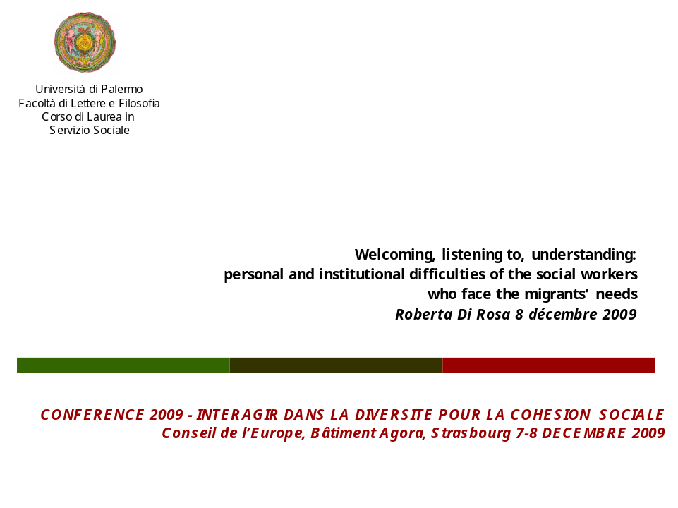
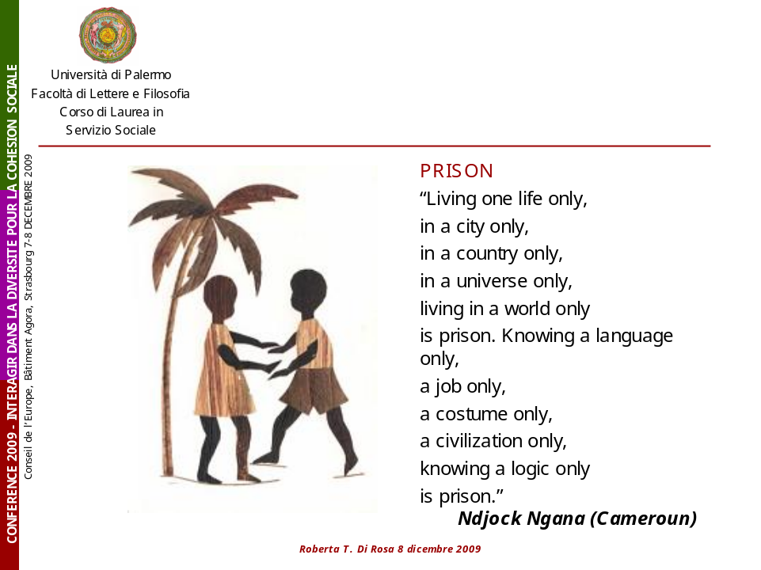

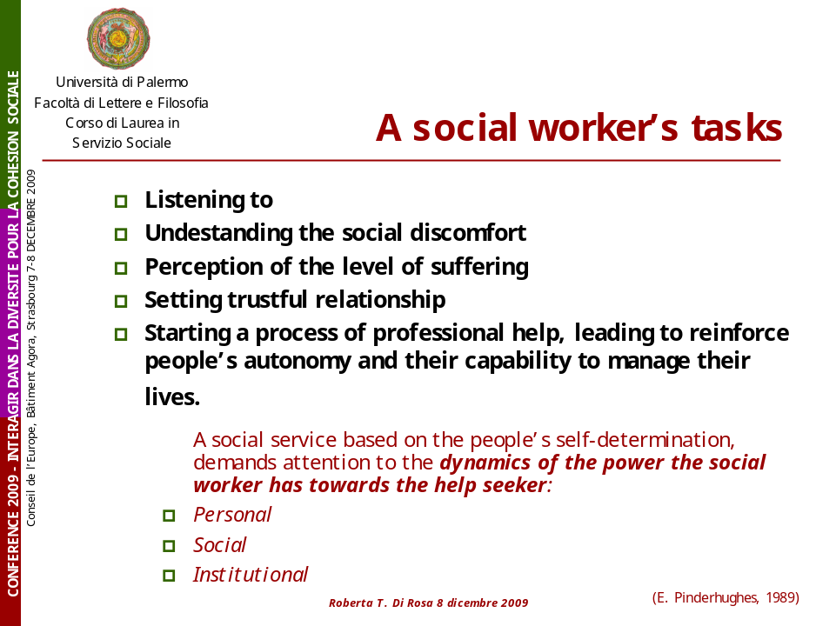

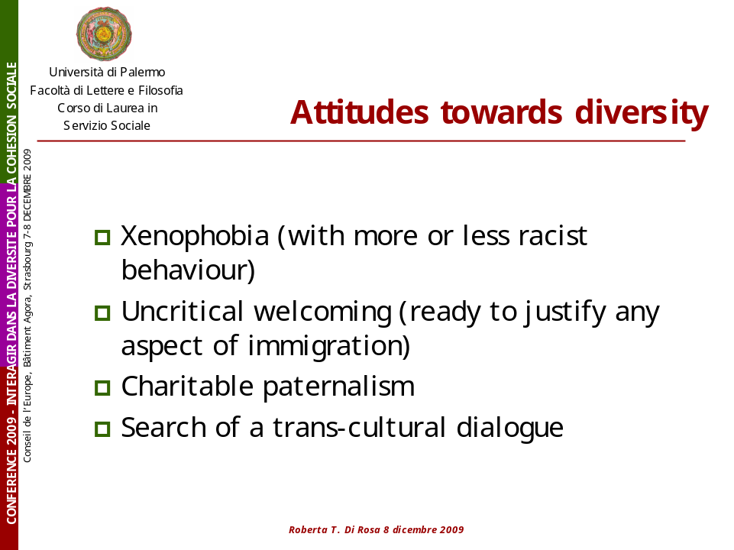

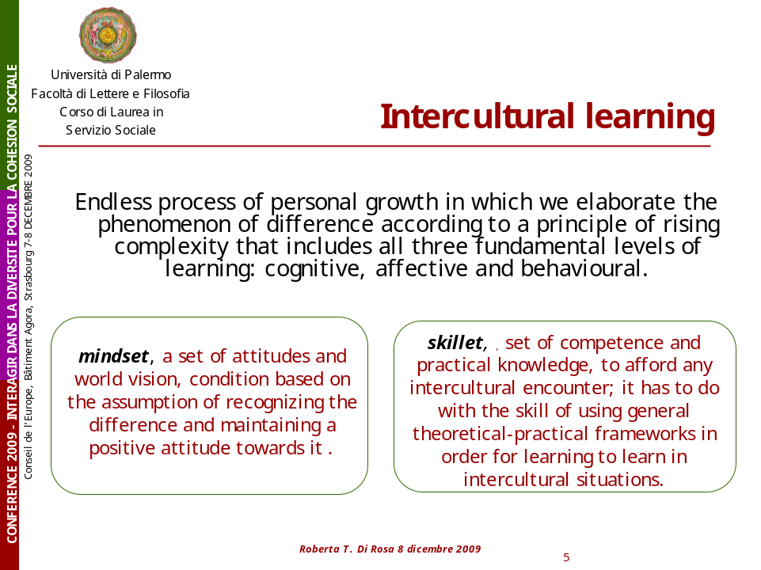

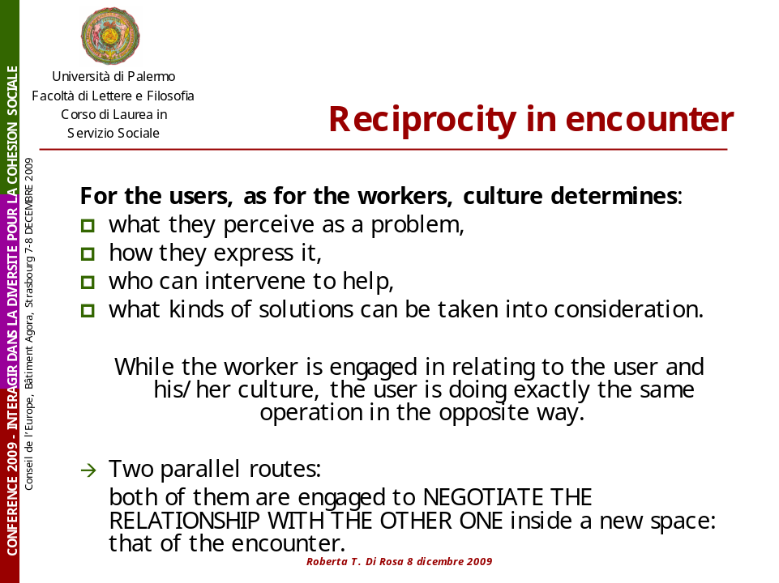

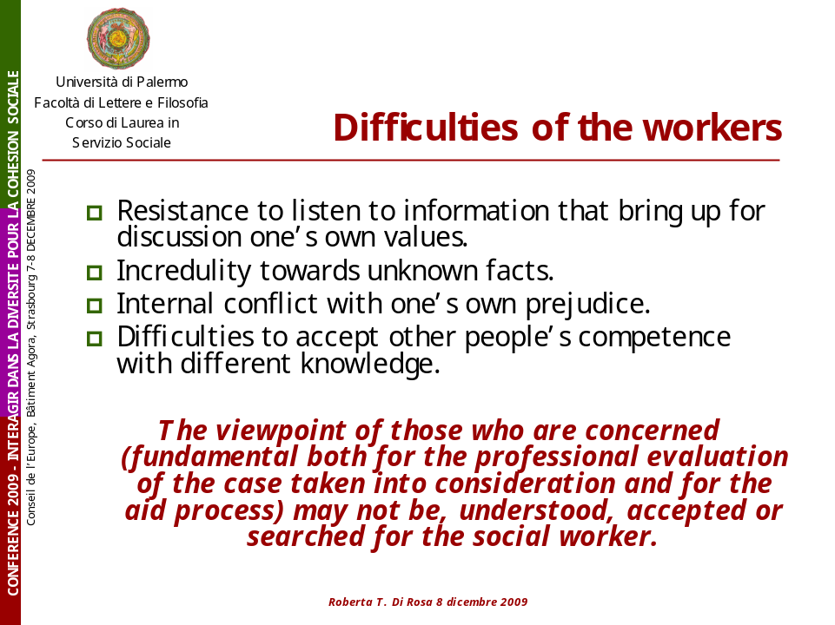

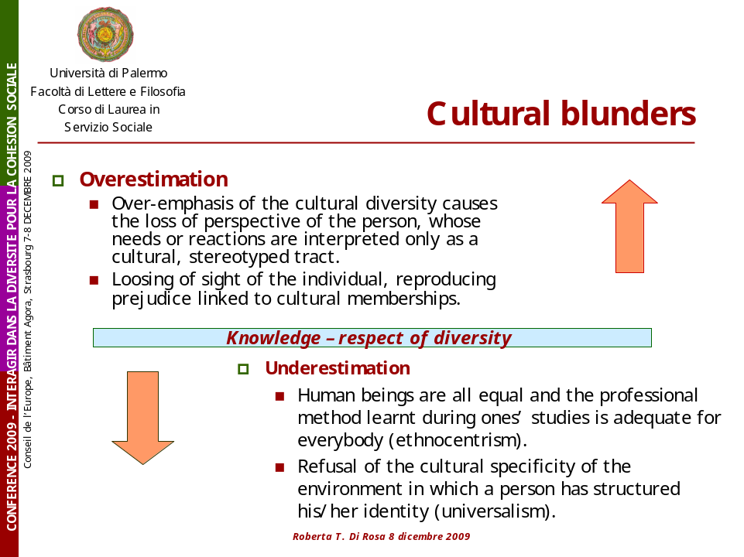

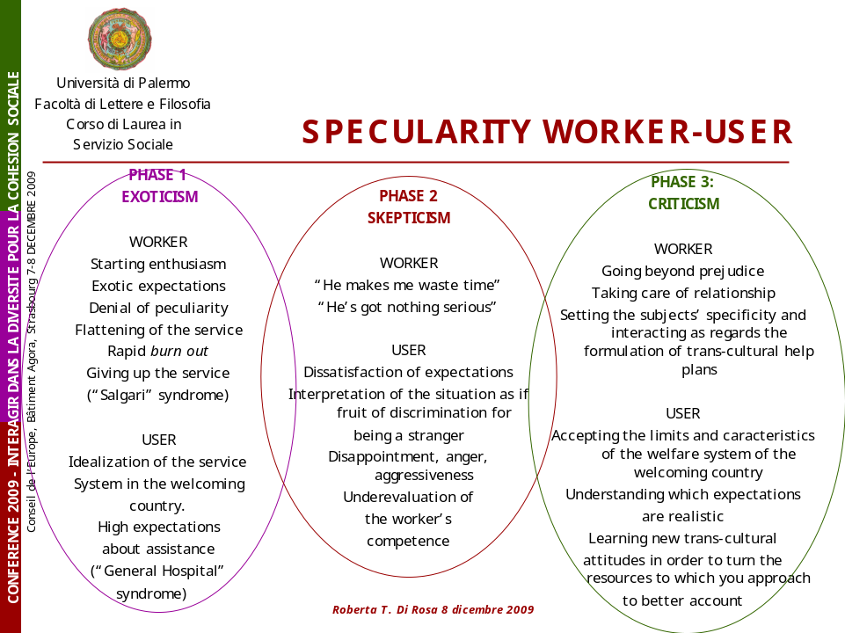

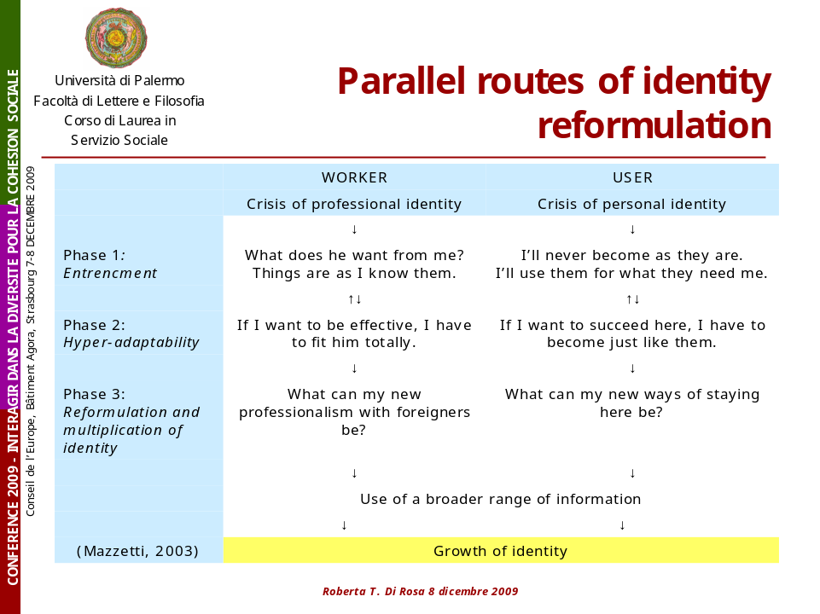

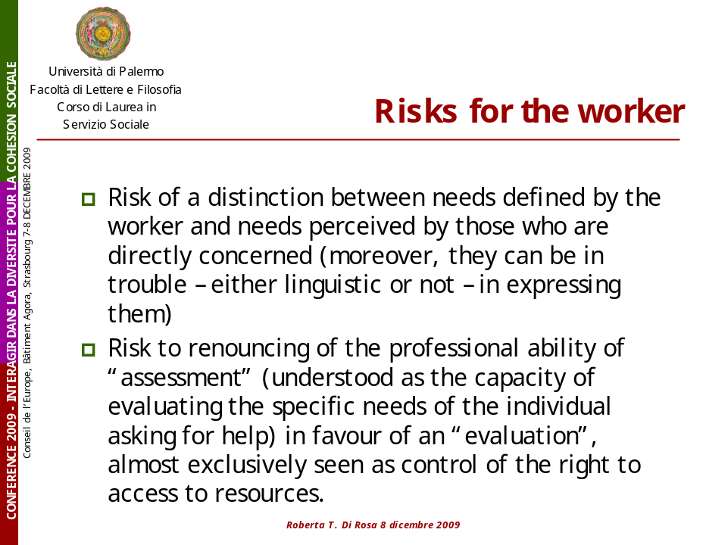

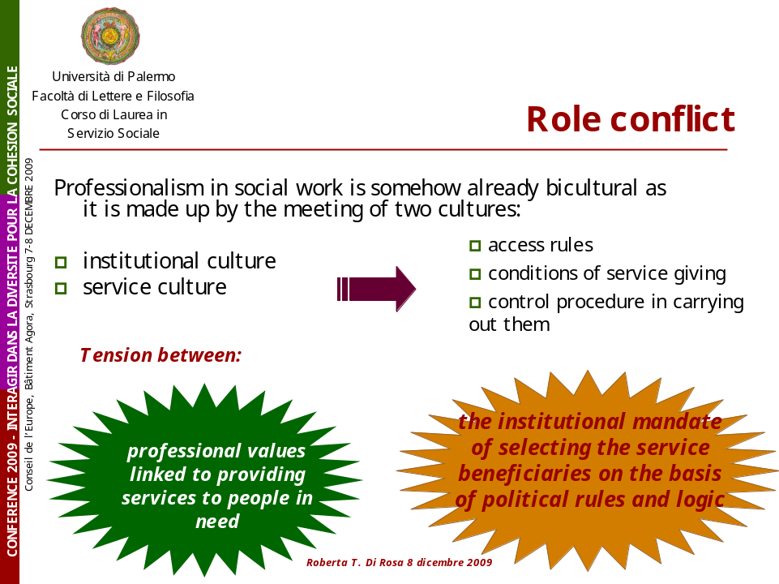

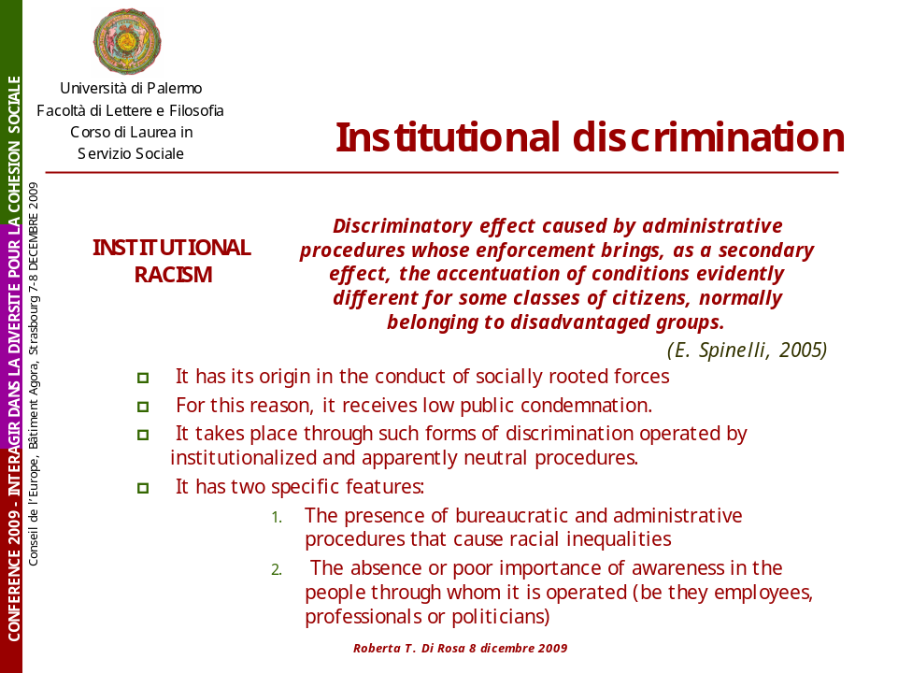

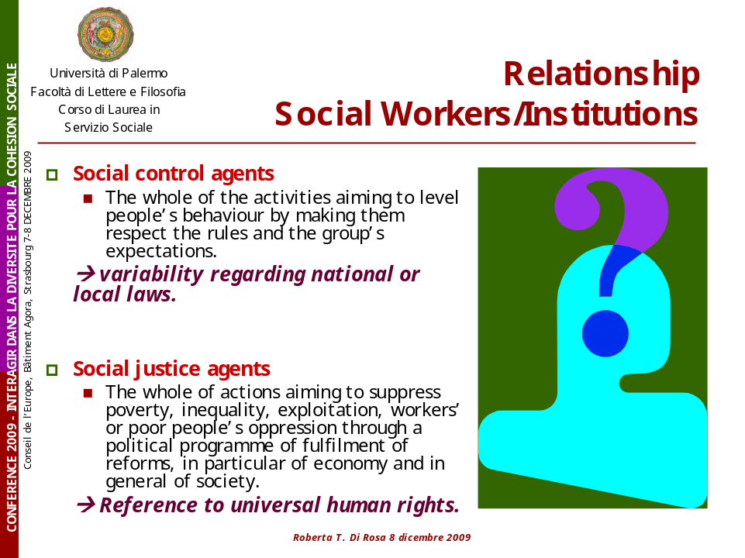

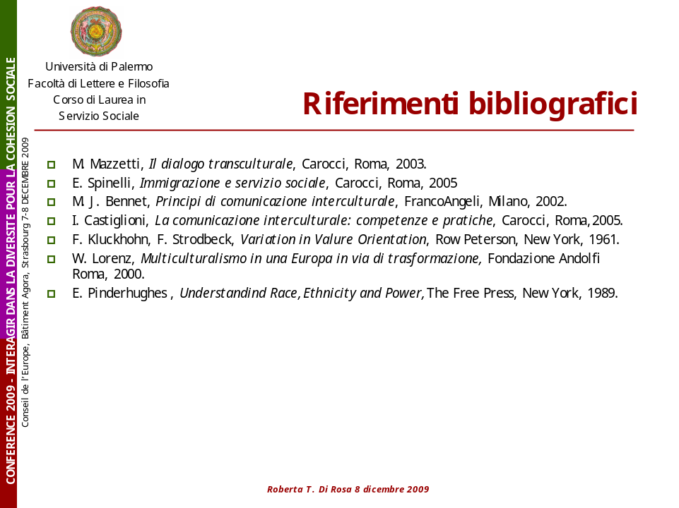

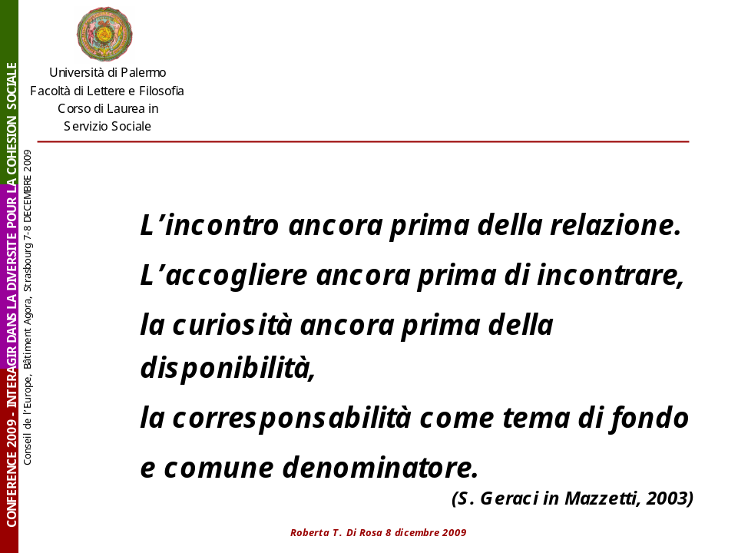

Introduit par le titre de l'intervention, le concept d' "accommodation" vient à la suite de celui d'accommodement, et d'aménagement, évoqués tout au long de cette conférence. Dans mes propos, ils n'ont pas de résonnance juridique : j'entends par accommodation et/ou accommodements des "réponses pratiques" apportées dans les services publics de santé aux besoins des personnes.
Hormis l'Aide Médicale d'État (AME) – dispositif d'accès aux droits - permettant la prise en charge des frais de santé des personnes qui ne peuvent pas bénéficier de l'assurance maladie (article L 251-1 du Code de l'action sociale et des familles), c'est à dire des étrangers en résidence non régulière, autrement dit les "sans-papiers".
Plus particulièrement : Fassin D., "La santé des immigrés et des étrangers : méconnaissance de l'objet et objet de reconnaissance", Précarisation, risque et santé, Paris, Inserm, coll. Questions en santé publique, 2001, pp. 187-96 ; Carde E. "Les discriminations selon l'origine dans l'accès aux soins", Santé Publique, 2007, 2, pp. 99-110 ; Mizrahi A. & A., "Morbidité et soins médicaux aux personnes nées à l'étranger", Journal d’Economie Médicale, 2008, Vol. 26.3. pp. 159-176 ; Dourgnon P., Jusot F., Sermet C., Silva J, "La santé perçue des immigrés en France", Questions d’économie de la Santé, n°133, juillet 2008, IRDES ; Dourgnon P., Jusot F., Sermet C., Silva J, "Le recours aux soins de ville des immigrés en France", Questions d’économie de la Santé, n°146, septembre 2009, IRDES ; Attias-Donfut C., Vieillesse et migrations, Retraite et société, n° 55, octobre 2008, Caisse nationale d'assurance vieillesse (CNAV) ; COMEDE, Guide de prise en charge médico-psycho-sociale des migrants/étrangers en situation précaire, Paris 2008.
Les fonctions sont distinctes, mais ne sont pas ici approfondies.
Paris, Marseille, Lyon, Strasbourg, Nantes, Grenoble, Metz…
Nous entendons un document de référence définissant les enjeux, et établissant les spécifications des missions attendues.
E. Carde, op.cit.
Cette suspicion trouve appui dans des discours et mesures politiques concernant les "fraudes généralisées à l’identité" (F. Fillon, Ministre des affaires sociales, du travail et de la solidarité, Assemblée nationale, 28 octobre 2003) ou tout récemment la "nécessité de lutter contre les mariages gris" (E. Besson, Ministre de l'Immigration : une "escroquerie sentimentale à but migratoire" et dont l'ampleur serait "préoccupante", sans qu'aucun chiffre ne soit fourni).
Cf. Loi n° 2002-2 du 2 janvier 2002 rénovant l'action sociale et médico-sociale ; Loi n° 2002-303 du 4 mars 2002 relative aux droits des malades et à la qualité du système de santé ; textes d'applications de la réforme hospitalière : http://www.sante.gouv.fr/htm/dossiers/t2a/textes/applicatifs.htm
E. Carde, op.cit.

