DGIII / DCS (2006) 16

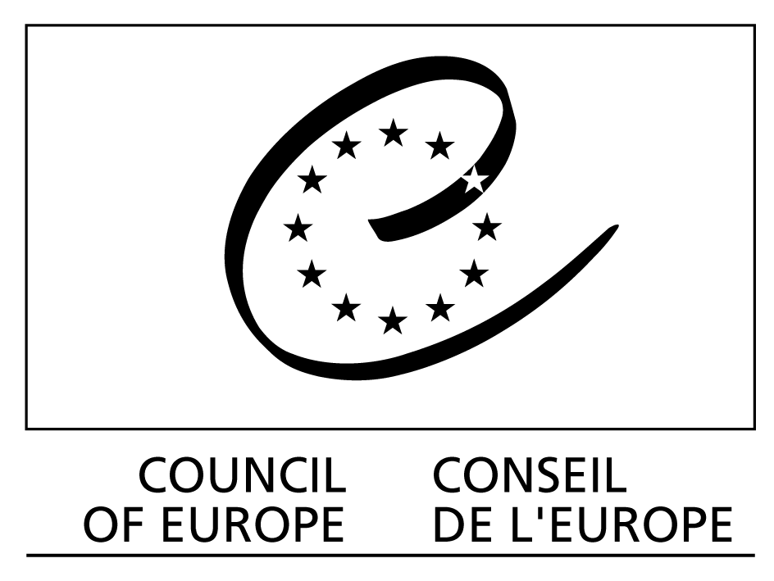

European Dialogue Platform on Ethical and Solidarity-based Initiatives of citizens to combat poverty and social exclusion

Report of the meetings held on 4 and 5 May 2006
__________

On 4 and 5 May 2006, as part of the work of the Dialogue Platform on Ethical and Solidarity-based Initiatives, the Council of Europe organised three meetings with the various relevant players:

- the second meeting of the Steering Committee for the Platform in order to discuss a three-year Platform Action Plan (2006-2008);
- a general meeting on the four themes for 2006 in order to draw up a work programme on each of them;
- a meeting of the Internetwork with a view to finalising its Statutes and official inauguration and laying the foundations of a work programme for 2006 and 2007.

There follows a report on each of these meetings.

1. Second meeting of the Steering Committee for the Platform (morning of 4 May)

The Steering Committee embraces the following representatives of the various bodies involved in the Platform:
- the Committee of Ministers is represented by Ambassador Alexei Tulbure, Chair of the GR-SOC;
- the Congress of Local and Regional Authorities is represented by Ms Pauline Dee;
- the Parliamentary Assembly is represented by Ms Gratiela Iordache;
- the European Committee for Social Cohesion (CDCS) is represented by Ms Assia Cholashka;
- the INGO Liaison Committee is represented by Mr Jean-Marie Heydt;
- the emerging Internetwork represented at this meeting by the various participant networks, including Giovanni Acquati, INAISE Chair and INAISE and FEBEA representative, Christine Gent representing IFAT and the Fair Trade networks, Daniel Vuillon representing the AMAP/CSA URGENCI network, Klaus Melvin Jensen representing the ASECO network, Salvatore Vetro representing the ENSIE network and Erdmuthe Klaer representing the REVES network.

The Steering Committee meets once or twice a year in order to decide on the major thrusts for the Platform’s work.

The Steering Committee decided at its first meeting on 24 May 2005 to adopt the theme of “combating poverty and social exclusion” as the Platform’s overall policy theme. This theme, which has taken on great importance today at both European and world level, is a matter of concern for all the different players involved in the platform, namely public authorities and citizen initiative networks, and can be tailored to a variety of problems bound up with more specific contexts.

Drawing on this general policy thrust and the activities conducted in 2005, the Secretariat has drawn up a three-year strategy and activity plan (covering 2006-2008). The purpose of this second meeting of the Steering Committee for the Platform was therefore to take stock of the activities conducted over the previous year and also to analyse the activity plan proposed in order to flesh out the Platform’s three-year strategy.

The various partners generally approved the relevance of the work performed and the plan proposed. However, Ambassador Alexei Tulbure, Chair of the GR-SOC, suggested establishing monitoring/assessment indicators for the implementation of the strategy over the next three years.

Further to this suggestion, the Secretariat prepared a proposal, which was then discussed late that afternoon. Appended hereto is the revised version of this proposal incorporating the comments made during the course of the day. Nevertheless, this is no final cut-and-dried version, and any proposed amendments or refinements will be welcomed.

2. General meeting: final assessment, analysis and fleshing out of the 2006 themes

On the afternoon following this meeting, the partners resumed consideration of the themes planned for 2006 in the three-year strategy with a view to taking stock of the work conducted on each theme, analysing them in greater detail and identifying a work programme to be implemented up to the end of the year and in the run-up to the Trento seminar. The group had been supplied for the purpose with various documents and proposals prepared by the Secretariat. Outside experts had also been invited to take part in the debates, using their specific know-how and expertise to help pinpoint new lines of work on these themes.

a) Themes at the implementation stage: responsible food consumption and ethical and solidarity finance

Discussions on the theme of responsible food consumption centred on information on the process that was under way with a view to preparing a Parliamentary Assembly Recommendation on the subject as transmitted by the Secretariat of the Committee on the Environment, Agriculture and Local and Regional Affairs. A hearing held on 28 February had been attended by several representatives of responsible consumption and fair trade networks participating in the Platform. In the wake of this hearing the Recommendation had been formulated and should be tabled, discussed and approved by the end of the year. The exchanges will continue with the Platform partners in order to complete the said process.

Another recommendation is currently being prepared on the subject of ethical and solidarity finance. Ms Gratiela Iordache, MP and Parliamentary Assembly representative within the Platform, has co-operated with the Secretariat in producing the requisite information and a timetable for drawing up preparatory documents to this recommendation.

b) Theme at the dialogue and decision-making stage: household over-indebtedness

The process that was launched at the Conference of Ministers of Justice on 5 April 2005 and the Resolution adopted on that occasion has led to a pan-European comparative study, the main results of which were presented at the meeting. At the same time, the solidarity finance and responsible consumption networks have, since last year, been actively discussing the possible forms of intervention in tandem with the civic organisations specialising in this topic, such as CRESUS in France.

A recommendation is now being prepared to follow up the 5 April 2005 Resolution. Drafting commenced in May and will continue until November, before the text is adopted by the Committee of Ministers at the beginning of 2007.

The Platform might provide inputs into this process at two levels:

- firstly, contributions to the recommendation under preparation. These contributions might concern distributing responsibilities between the public authorities and the citizens, in accordance with the expectations expressed in the Resolution adopted by the Ministers of Justice on 5 April 2005;

- secondly, identifying and developing good practices to be included in the monitoring and implementation process for the recommendation, once approved. One idea that has emerged and been discussed in this context is a multipartite social contract to be concluded by a variety of players, linking up actual support for the families affected (with such organisations as CRESUS), rehabilitating household financial situations by means of social loans, which are a matter for solidarity finance networks, and (re)learning responsible consumption with networks specialising in this approach, as well as the public authorities for the purposes of official recognition of such forms of partnership. This multipartite social contract must therefore be seen from the angle of joint responsibility and protection of the dignity of over-indebted individuals and families. Over the year an effort will be made to flesh out and finalise the idea with an eye to presentation at the Trento seminar.

c) Theme at the proposal-drafting stage: public awareness, information and incentive for responsible consumption and solidarity finance geared to combating social exclusion and poverty

We should recall that this theme was analysed in 2005, a summary of which was presented at the Trento seminar on 1 and 2 December 2005. This summary highlighted the various levels of information, awareness-raising and incentive provision at stake in responsible consumption and solidarity saving, as well as the more glaring deficits and challenges facing each of these levels.

In 2006, therefore, we are entering a phase involving the preparation of proposals by the various Platform partners (networks and public bodies). Some lines of work have already been suggested, such as the importance of the new communication technologies and the need for joint action by the different networks in order to secure a scale effect. The idea of developing the concept of responsible towns and cities has also been put forward, drawing on the example of “fair trade cities” in the United Kingdom. An informal working group has been set up on the subject. Contributions are to be submitted by June 2006.

Moreover, the Secretariat has proposed four main lines of work:

- heightening awareness among children (especially at school);
- providing the poorer sections of the population with access to consumption;
- forging links between solidarity and responsible consumption;
- providing different modes of information on products.

The meeting was an opportunity for discussing the advantages of each proposal and identify possible areas of complementarity. The debate must continue after the meeting so that choices can be made fairly quickly, particularly on solutions incorporating several dimensions within the proposed lines of work.

d) Theme at the analysis stage: dialogue methods between public bodies and ethical and solidarity initiative networks

This new theme for 2006 is extremely important to the Platform because dialogue between public bodies and the ethical and solidarity initiative networks is not a matter solely for the European level, with the European Platform itself. It also concerns the local, regional and national levels, where various forms of dialogue are conducted, some of them having been in place for several years now. Pinpointing, analysing and systematising dialogue methods at these various levels would therefore present the twofold advantage of, firstly, capitalising on this experience and enhancing good practices vis-à-vis dialogue at the European level, thus helping consolidate the Platform itself and disseminate the learning of consultation and democracy in the various countries, and secondly, building bridges and Platform relays in European countries, regions and towns in which consultation platforms have been or are being established.

During this first year, therefore, this theme is at the analytical stage, which began with gathering information on existing facilities before the effort at systematisation. We already have some initial results from 2004 and 2005 in the form of a compilation of good practices which has been published in Alternatives Economiques and Altreconomia, and a preliminary systematisation exercise comprising four levels of dialogue.

Other lines of work were proposed during the meeting, eg preparation of a list of fields in which to build up dialogue. Some partners also voiced a desire to take part in this work, including the REVES Network, which is itself a local-level dialogue network.

3. Meeting of the Internetwork of Ethical and Solidarity-based Initiatives

Pro memoriam: the various networks of civic ethical and solidarity-based networks operating at the European level are involved in a process of setting up a European Internetwork, one of whose aims is to interface with the public authorities within the Platform.

After several meetings had been held on the setting up of this Internetwork, the representatives of the networks in question met once again on the evening of 4 May in order to finalise the Statutes and prepare for the official registration of the Internetwork. Agreement was also reached on an annual contribution of € 200 for full membership and € 50 for associate membership.

4. Conclusion and follow-up

In conclusion, the meeting on 4 and 5 May was particularly important in terms of consolidating the Platform’s three-year strategy and action plan in order to secure the support of all the players involved, and also in conducting the activities planned for 2006 on the basis of the relevant themes.

In order to complete the work by December 2007, the prospective date of the second Trento seminar, two further working meetings are being programmed:

- a meeting on 22 and 23 June with a select group of members of the future Internetwork geared to specifying its involvement in these various activities and proposing a work programme for 2006 and 2007;
- a meeting in the week from 11 to 15 September with a view to finalising the processes under way on each of the themes, for presentation in Trento at the end of the year. This meeting will be held in tandem with the second meeting of the experts working on the recommendation on household over-indebtedness, with a view to combining the two initiatives.

The structure of the Trento seminar itself will be designed in such a way as to optimise the work conducted on the various themes over the year. The Secretariat will shortly be sending out a proposal to that effect.

Appendix: MONITORING-EVALUATION CRITERIA FOR THE PLATFORM

1- POLITICAL IMPACT:

General
- Better understanding of citizenship through responsible consumption and solidarity-based finance
- Better understanding of democracy
- Better knowledge of the different themes thanks to the completed studies

International recognition
- Recognition of the importance of responsible consumption and solidarity-based finance as a tool to fight poverty and social exclusion by the European Commission
- Recognition of its importance for the millennium goals by the international bodies such as United Nations, Work Bank, FAO, etc.

Specific to Council of Europe
- Resolution and/or recommendations launched thanks to the platform
- Resolution and/or recommendations to which the platform contributes

2- PRACTICAL IMPACT

Impact in terms of dissemination and transfer
- dissemination and transfer of existing practices in other countries
- dissemination and transfer of innovations launched thanks to the Platform
- dissemination and transfer of policies to support responsible consumption and solidarity-based finance (laws, labels, financial support, etc.)

Results in terms of innovations and best practices
- New kinds of actions realized thanks to the Platform
- Impact of these actions in terms of fighting poverty and social exclusion

Results in terms of tools and references
- new tools for responsible consumption and solidarity-based finance: guidebooks, proposals of labels, etc.

3- IMPACT FOR THE NETWORK

- creating and launching the European Inter-network of Ethical and Solidarity-based Initiatives
- Added value and multiplying effects for the different networks thanks to the inter-network activities

