DGIII / DCS (2006) 05

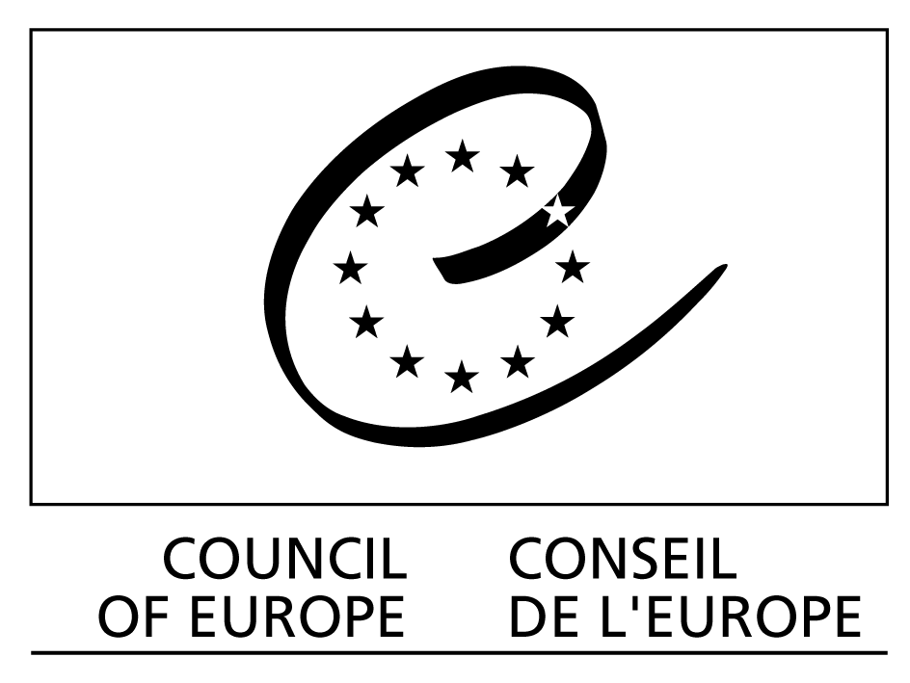

European dialogue platform on ethical and solidarity-based initiatives
to combat poverty and exclusion

Provisional programme for the meetings of 4 and 5 May 2006

Palais de l’Europe, Room 8
__________

Thursday 4 May 2006

9h00-9h30 Welcome and presentation

9h30-12h30 Meeting of the Management Committee
Agenda :
- Outcomes of the activities achieved in 2005
- Presentation of the proposal of the Master plan and three-year activity programme (Secretariat of the Council of Europe)
- Discussion in two parts:
- Proposed general methodology
- Choice of themes
- Amendments
- Approval

12h30-14h00 Lunch

14h00–18h00 Analysis of 4 themes for the year 2006

14h00- 14h30 Recommendation on responsible foodstuffs consumption – situation after the hearing of 28 February 2006 of the Committee on the Environment, Agriculture and Local and Regional Affairs of the Parliamentary Assembly

14h30 – 16h00 Information and awareness activities for responsible consumption and ethical and solidarity-based saving to combat poverty and exclusion :
- Reminder of the studies carried out in 2005 : inventory of what already exists and what is missing ;
- Round table/brainstorming on proposals for possible works (« identity cards» for products, norms of reference, labels, guide to responsible consumption, promotional tools, etc.)
- Perspective for the year 2006

16h00 – 16h15 Coffee break

16h15 – 16h45 Methodes of dialogue between public authorities and citizen initiatives: studies foreseen for 2006

16h45- 18h00 Over-indebted families:
- Synthesis of completed studies and information on the process of preparation for a recommendation of the Council of Europe and the follow-up. Role of the platform in this process, particularly for the link between public policies and citizen initiatives
- Round table of the proposals from partners (responsible consumption – ethical and solidarity-based finance, other approaches)
- Perspective for 2006

18h00 – 19h30 Meeting of the Internetwork for the approval of status and amendment for the modalities of the constitution (without interpretation )

Friday 5 May 2006

9h00-12h00 Work structuring and work programme of the platform

9h00 - 9h30 Conclusions of the work of the previous day and constitution of working groups on each of the four themes

9h30 – 11h15 Working groups on each theme to define objectives, work and responsibilities

11h15 – 11h30 Coffee break

11h30 – 13h00 Synthesis and programme – first draft for the second seminar in Trento

13h00-14h30 Lunch

14h30-17h00 Building of transversal projects

17h00 End of meeting

