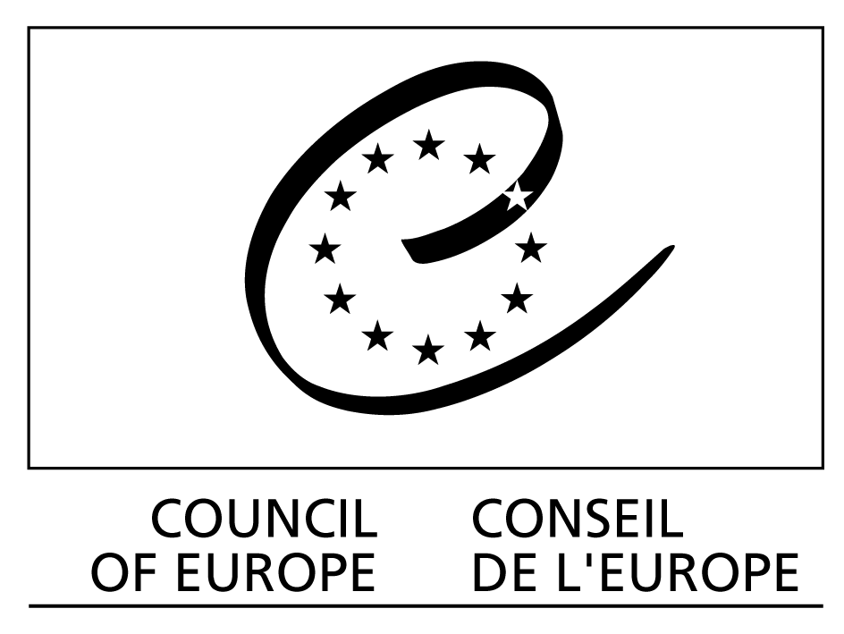

Strasbourg, 22 June 2005
CDCS (2005) 19
DGIII/DCS (2005) 37

BUREAU OF THE EUROPEAN COMMITTEE
FOR SOCIAL COHESION
(CDCS)

16th Meeting

Strasbourg, 30 June – 1 July 2005
_________________________

Item VII of the draft Agenda

European dialogue platform on ethical and solidarity-based initiatives

Report of the meetings held on 23 and 24 May 2005
__________

ACTION : DISCUSS AND MAKE PROPOSALS
TO THE CDCS

DGIII / DCS (2005) 37

European dialogue platform on ethical and solidarity-based initiatives

Report of the meetings held on 23 and 24 May 2005

__________

As part of the activities of the Dialogue platform on ethical and solidarity-based initiatives, the Council of Europe organised three meetings on 23 and 24 May 2005 with the different players involved:

- the first meeting of the Platform's Management Committee
- the second meeting of the Working group on setting up the Internetwork
- a general meeting to analyse work completed and in progress and to prepare future activities, particularly the seminar to be held in Trento on 1 and 2 December 2005.

Each of these meetings is reported on below:

1- First meeting of the Platform's Management Committee

The Management Committee brings together the different bodies participating in the platform, namely:
- the Committee of Ministers, represented by Ambassador Tulbure, Chair of the GR-SOC;
- the Congress of Local and Regional Authorities, represented by Mrs Pauline Dee;
- the Parliamentary Assembly, to be represented by Mrs Gratiela Iordache, who was unable to attend owing to a last-minute problem;
- the European Committee for Social Cohesion (CDCS) represented by Mrs Assia Tcholashka
- the internetwork now being constructed, represented by Jean-Paul Vigier (president of the FEBEA) and Christine Gent (representing the Fair Trade networks)
- the INGO Liaison Committee, represented by Mr Jean-Marie Heydt.

Also in attendance was the Council of Europe secretariat, represented by Mrs Gilda Farrell, Head of the Social Cohesion Development Division.

The Management Committee will meet once or twice a year and its role is to determine the main thrusts of the platform.

As this was the first meeting, the agenda focused on:
- the political interest of the platform and the functioning of the Committee
- the main orientations of the platform for the coming years
- the platform's links with the different bodies represented

In view of the interests and concerns of the different partners and the differences in context between countries, particularly between western and eastern Europe, it was decided to take "combating poverty and social exclusion" as the platform's first guiding theme. This theme, of great topical importance at both European and world level, is a concern cutting across the spheres of interest of the different players involved in the platform, public authorities and networks of citizen initiatives, and may be tackled from different angles linked to more specific contexts.

2- Second meeting of the Working group on setting up the Internetwork

By way of a reminder: the different networks of citizen-led ethical and solidarity-based initiatives existing at European level became involved in a drive to set up a European internetwork with the objective, among others, of establishing it as a talking partner for public authorities within the platform. An initial meeting organised with different network representatives on 3 November 2004 during the Council of Europe forum resulted in the creation of a working group of 7 individuals tasked with preparing the setting-up of the internetwork itself.

At an initial meeting of the group in February 2004, a joint declaration had been drawn up and then proposed to the different networks, to serve as a basis of shared recognition for establishing the internetwork.

The second meeting specified the arrangements for setting up the internetwork and work orientations for 2005 with the aim of presenting a shared position at the Trento seminar. The idea is to focus on the cross-sectoral issues of interest to the different groups to be represented in the internetwork and arrive at proposals integrating different approaches. The innovation fund should provide one incentive for working along these lines.

It was also decided to invite the different networks present at the meeting of 3 November 2004 and all those signing up to the joint declaration to attend the Trento seminar so that a constitutive assembly setting up the internetwork could be held.

3- General meeting: review of activities, the theme of over-indebtedness and preparation of the Trento seminar

A general meeting was held over the two days to review platform activities and discuss how work should be continued, particularly in connection with the Trento seminar. There was also specific discussion on the theme of "over-indebtedness of families", seen today as a priority by the governments.

3.1 – General presentation of the platform

The meeting began with a general presentation of the platform by the Council of Europe Secretariat. The presentation document screened at the meeting is appended.

Since the forum in November 2004 the platform activities have essentially entailed carrying out studies and gathering practical examples of dialogue between the public authorities and citizen initiatives at different levels (local, regional, national) and in different European countries. Some of these initiatives have been featured in a publication currently available in French (co-published with Alternatives Economiques) and soon to be available in Italian (co-published with AltrEconomia).

On the basis of that work, two approaches were proposed:

1. an analytical approach geared to the question: what is the added-value gained from dialogue between the public authorities and citizen initiatives on the basis of existing experiences?
2. a forward-looking approach geared to the question: what is the potential added-value in relation to key issues facing society?

For the first approach, a study highlighted four levels for further pursuit of dialogue between the public authorities and citizen initiatives (see the document presenting these four levels on the platform's internet site: www.coe.int/platform/en). A conceptual document was also available and was presented at the meeting.

The second approach entails identifying issues facing society today and therefore calls for the setting of priorities. It also introduces an aspect of experimentation, hence the importance of the innovation and experimentation fund for which implementation procedures are being considered.

In addition, the forward-looking approach emphasises the cross-sectoral aspect, in that many issues facing society require dialogue between the public authorities and networks of citizen initiatives if they are to be dealt with effectively and receive an adequate response. These issues concern different DGs and departments of the Council of Europe, and the platform on ethical and solidarity-based initiatives could therefore become a cross-sectoral instrument at the Council of Europe, of interest to DGs other than DG III – Social Cohesion. This would apply, for example, to the theme of over-indebtedness of households, on which DG I is currently working (see below). Other themes more specifically of interest to DG IV such as managing heritage and environment are also involved.

As a "test-run", the Secretariat proposed to begin work on the question of over-indebtedness of households, which is a crucial problem today and fits in with the general line of action determined by the Management Committee revolving around combating exclusion and poverty (combating new forms of exclusion).

3.2- The theme of over-indebtedness of families

Over-indebtedness was the subject of a conference of Ministers of Justice organised by the Council of Europe in April 2005, resulting in a final recommendation asking the Council of Europe's Secretariat to come up with responses to a number of questions raised, some of which specifically related to the division of roles between public institutions and civil society.

This brief from the Justice Ministers prompted the Secretariat to envisage dialogue between public authorities and citizen initiatives as one of the best means of identifying solutions to this problem of society. The meeting held on 23 and 24 May with the Secretariat of DG III and DG I was a first step in this direction, aided by the participation, alongside socially responsible economy networks (ethical financing, fair trade, responsible consumption), of Mr Constans, inspector general of finance and Chair of the Advisory Committee for the Financial Sector in France, and Mr Michel Knoel and Ms Natalia Reu of the CRESUS association (Regional Chamber of Social Over-indebtedness). The participation of Paul Maréchal, expert and former director of the Observatory for over-indebtedness in Belgium, further enriched the discussion.

The theme-based meeting began with a presentation by Mr Constans on the situation in France and French policy followed for some twenty years, to both overcome and prevent the problem, particularly through the involvement of département committees on over-indebtedness. He described the latest developments in identifying new solutions, which allowed greater flexibility in processing case-files, particularly through the Borloo law. He stressed the importance of dialogue with citizens' organisations involved in this area directly (such as CRESUS) or indirectly (such as the cooperative credit bank).

The CRESUS association also presented its work in assisting over-indebted individuals and the useful information this generated. Other experiences were described, including that of CREDAL and classes for consumers in Belgium (presented by Paul Maréchal) and others less directly linked to over-indebtedness but opening up possibilities for a broader approach to the question; these included experiments aimed at developing responsible consumption (examples of Cambiaresti in Venice and Global Action Plan in the Basque country, described in the guide to citizen initiatives in Europe and passed on by the secretariat).

Where socially responsible and solidarity-based economy networks were concerned, the FEBEA, represented by its president, Jean-Paul Vigier, said that this issue had never been tackled as such within the federation and that, apart from the CREDAL, none of its members had really worked on it. Nevertheless Jean-Paul Vigier thought that it was an important theme, which opened up possibilities for other forms of micro-loan (so far limited essentially to micro-loans for economic activities) and proposed to put it on the agenda of the FEBEA's next meeting in June. The fair trade networks were not directly concerned by the theme either, but their representative, Christine Gent, suggested linkage with responsible consumption through proposing solutions enabling indebted individuals (and those who were excluded and in an overall situation of poverty) to have access to fair trade products and other responsible consumption products at affordable prices. Pascale Delille and Giovanni Acquati referred to a project that they had devised along these lines within the framework of the I.C. Equal initiative.

In conclusion the platform had to be allowed to continue working on this theme, while integrating it into the overall theme defined by the Management Committee, namely combating exclusion and poverty, which would make it possible to open up the debate and identify new solutions and prospects for innovation going beyond immediate action to tackle the problem. Within that process close links would be established with DG I so that work carried out within the platform on this theme would be built into the solutions to be proposed in response to the Justice Ministers' recommendation.

3.3- Preparation of the Trento seminar

The Trento seminar to be held on 1 and 2 December 2005 will be a milestone in the promotion of dialogue between public authorities and citizen networks, capitalising on the work carried out in 2005 and launching the debate on follow-up to that process. In particular, it will be time to discuss the innovation fund, which should be set up in 2005 so that it can start up its activities in late 2005 or early 2006.

Given the sheer volume of questions to be tackled on 23 and 24 May it was not possible to complete preparatory work on the seminar, and the participants left it to the Secretariat to finalise the planning of the event. For that reason, the conclusions presented here take account of the work carried out after the meeting.

The core information is as follows:

1- in response to the overall thrust of work defined by the Management Committee for the first few years of the platform, the seminar theme will be "Involving citizens in combating poverty and exclusion";
2- the seminar is to be organised in 4 half-days: one morning spent introducing the theme, followed by an afternoon of workshops revolving around the question "how can citizens be involved in combating poverty and exclusion?" in terms of: (1) information; (2) education/awareness-raising and (3) possibilities for action. The morning of day two will focus on new challenges in combating social exclusion and poverty, with consideration of two topics (over-indebtedness and access to credit), followed by an afternoon devoted to conclusions and prospects for the year 2006;
3- a provisional programme is appended to the present report.

