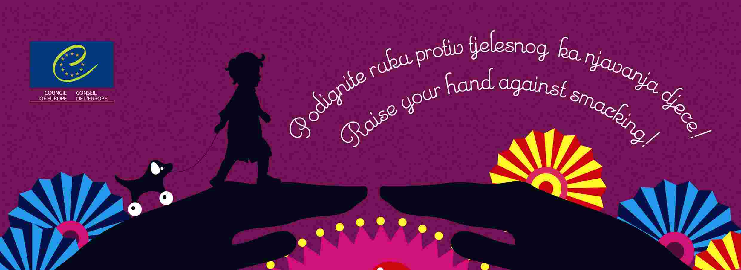

Raise your hand against smacking!

A Council of Europe initiative against
corporal punishment of children

International launch in Zagreb, 15 June 2008

in co-operation with
the Ministry of Family, Veterans’ Affairs and
Intergenerational Solidarity of Croatia

Draft Programme

Saturday, 14 June 2008

8 p.m. Dinner hosted by Ms Jadranka Kosor, Deputy Prime Minister of the Government of the Republic of Croatia and Minister of Family, Veterans’ Affairs and Intergenerational Solidarity at the Westin Zagreb Hotel (upon invitation only).

Sunday, 15 June 2008

Venue: The Zagreb Puppet Theatre (Address: Ulica baruna Trenka 3, Zagreb)

8.30 a.m. Registration of participants

9.00 a.m. Official welcome
- Ms Maud de Boer-Buquicchio, Deputy Secretary General of the Council of Europe
- Ms Jadranka Kosor, Deputy Prime Minister of the Government of the Republic of Croatia and Minister of Family, Veterans’ Affairs and Intergenerational Solidarity

9.10 a.m. Debate: Eliminating corporal punishment of children: Questions and answers.
Moderator: Georgios Moschos, Deputy Ombudsman, Head of Department of Children’s rights (Greece)

Question 1. What is corporal punishment of children? Is it a form of violence?
- Ms Yanghee Lee, Chair of the UN Committee on the Rights of the Child
- Ms Maria Calivis, Director of Unicef Regional Office for CEE/CIS/Baltics
- Ms Lorriann Robinson, Policy Adviser, the National Society for the Prevention of Cruelty to Children (United Kingdom)

Question 2: Why should we abolish corporal punishment?
- Video message from Mr Thomas Hammarberg, Council of Europe Commissioner for Human Rights
- Ms Paivi Hirvela, Judge at the European Court of Human Rights
- Ms Džamila Stehlíková, Minister for Human Rights and Minorities (Czech Republic)
- Ms Mila Jelavić, Ombudsperson for Children (Croatia)

Question 3: How can we abolish corporal punishment?

- Through legal reform
- Mr Peter Newell, Global Initiative to End All Corporal Punishment of Children
- Ms Minodora Cliveti (Romania), member of the Parliamentary Assembly of the Council of Europe
- Ms Marija Pavilioniene (Lithuania), Member of Parliament

- Through positive parenting policies
- Ms Idalia Moniz, Secretary of State for Disability and Assistant to the Minister of Labour and Social Solidarity (Portugal)
- Ms Ninoslava Pećnik (Croatia), Council of Europe Working Party on Parental Skills
- Ms Adreia Marques (Portugal), the Council of Europe Disabilities Action Plan

- Through awareness raising on children’s rights
- Ms Marie-Josée Jacobs, Minister of Family and Integration (Luxembourg)
- Mr Pavle Kornhauser, Slovenian Association of Friends of Youth

Question 4: What are we doing and what are we going to do?
- Ms Amparo Valcarce, Secretary of State for Social Policy (Spain)
- Ms Ivanka Hristova, Deputy Minister of Labour and Social Policy (Bulgaria)
- Ms Irma Ertmann (Finland), Thematic Coordinator on children’s rights (Council of Europe Committee of Ministers)
- Ms Mieke Shuurman, Secretary General of the European Children’s Network (Euronet)

11.15 a.m. Coffee and sandwich break
Press conference

12.00 Launching ceremony
Facilitator: Mr Goran Grgić, actor (Croatia)
(includes a presentation of the corporal punishment initiative and a screening of the TV spot “Raise your hand against smacking!”)

1 p.m. Puppet Show: W. A. Mozart The Magic Flute

2.15 p.m. Closing of the event

2.30 p.m. Luncheon hosted by the Deputy Secretary General of the Council of Europe at the Sheraton Zagreb Hotel (upon invitation only).

