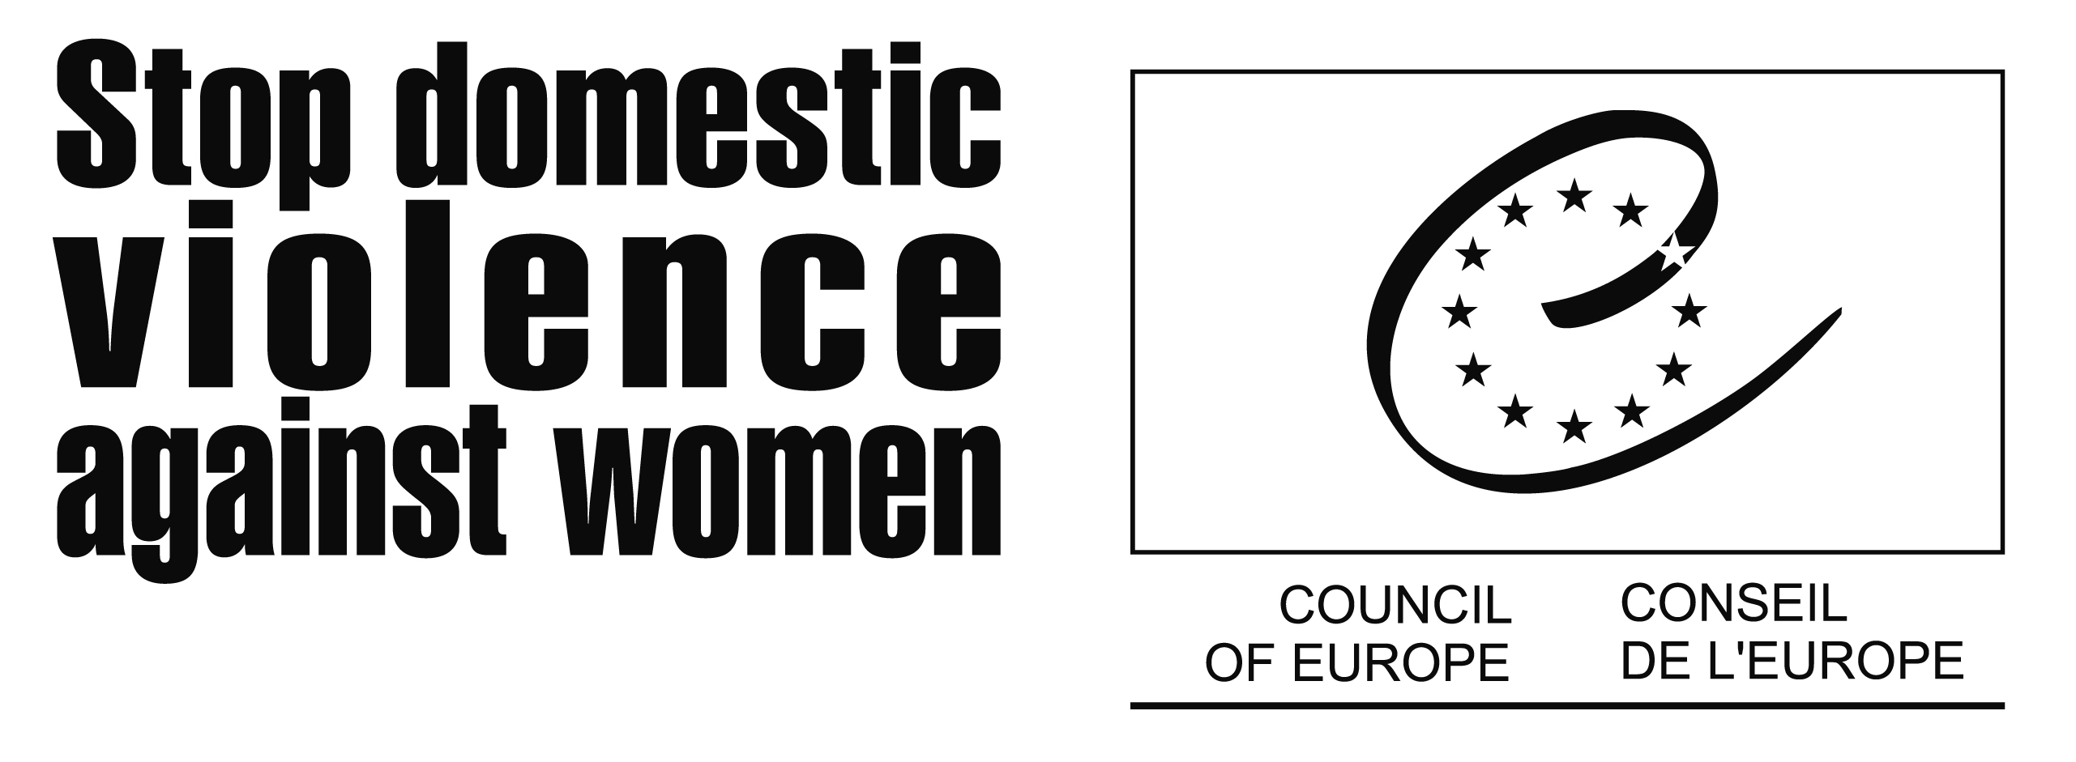

On 27 November 2006, the Council of Europe launched a Campaign to Combat Violence against Women, including Domestic Violence during a high-level conference in Madrid. The Campaign aims at raising awareness that violence against women is a human rights violation. It promotes effective implementation of measures through legislation and national action plans. Member states are urged to provide adequate resources and to deliver concrete results in this field. Campaign activities will be carried out by different bodies of the Council and by its member states.

Why a Council of Europe Campaign

Despite positive developments in law, policies and practices, domestic violence occurs at all levels of society in all Council of Europe member states. Analyses indicate (according to the stocktaking study prepared by Prof. Dr. Carol Hagemann-White for the Council of Europe in 2006) that in most instances women are the ones affected: 12% to 15% of European women over 16 suffer domestic abuse in a relationship – many continue to suffer physical and sexual violence from former partners even after the break-up. Too many have died.

Violence against women is a human rights violation. It deprives women of their fundamental rights and freedoms and represents a serious obstacle to equality between women and men.

To find a way out of this situation, the Heads of State and Government of the Council of Europe decided at the 3rd Summit of the Council of Europe (Warsaw, 16-17 May 2005) to carry out a Campaign to Combat Violence against Women, including Domestic Violence, which was launched on 27 November 2006 in Madrid. The Campaign aims at the following:

- to raise awareness across Council of Europe member states that violence against women is a human rights violation to be challenged by every citizen
- to urge member states to demonstrate political will by providing adequate resources to deliver concrete results in ending violence against women
- to promote the implementation of the Council of Europe’s Recommendation Rec(2002)5 on the protection of women against violence, through legislation and national action plans and to monitor progress achieved.

What do we know about Domestic Violence

Domestic violence is not a private matter. Council of Europe member states have a responsibility to respect, protect and fulfil the human rights of all citizens. Therefore, they must ensure reasonable measures to prevent, investigate and punish all forms of violence against women, including domestic violence. If the police, criminal justice system and governmental services do not respond to women seeking help, states have failed to fulfil this obligation.

In recent years, several large-scale surveys and studies to measure the extent of violence against women have been commissioned by member states. An overview suggests that across countries, figures for all forms of violence – including stalking – are as high as 45%.

The health consequences of violence are serious and reach far beyond the immediate injuries, such as bruises or fractures. According to the stocktaking study prepared for the Council of Europe by Prof. Dr. Carol Hagemann-White, women who have been physically, sexually or emotionally abused need psychiatric care four to five times more often than others. They have attempted suicide five times more often than others. Furthermore, children are negatively affected by domestic violence, suffering in respect to their emotional, behavioural and mental health. As a result, violent behaviour is often perpetuated from one generation to another.

Apart from personal and social consequences, violence against women has a high economic cost. Notwithstanding studies carried out in some member states on the overall cost of domestic violence for society, comprehensive research on this issue is scant – both at European and national level. Results of the recent stocktaking study show that the estimated total annual cost of violence against women in Council of Europe member states could be as high as 34 billion Euros (S. Walby, 2004, United Kingdom).

What are the objectives of the Campaign

The Stocktaking Study on the measures and actions taken in Council of Europe member States to combat violence against women (2006) also shows that a large proportion of member states have recognised domestic violence as a grave problem requiring a comprehensive response. However, data on the implementation of legislative measures (number of police complaints, court cases and type of sentences) and their evaluation is lacking. Furthermore, the service provision needs to be adequately resourced and developed including immediate (shelters, help lines etc) and long-term (advocacy, financial support, housing) support services for victims.

During this Campaign, member states are urged to assess their national response to combating violence against women, identify any existing gaps and take action to better implement effective measures in the following fields:
- Legal and policy measures (in particular amending national legislation)
- Support and protection of victims (in particular providing well resourced support and improving coordination between different bodies)
- Data collection (in particular on prevalence and incidence of domestic violence, implementation and evaluation of existing legislation as well as exchange of information between member states).

How is the Campaign taking shape

The Campaign has three dimensions: intergovernmental, parliamentary and local and regional. It will be carried out by the Council’s bodies as well as its members, in partnership with inter- governmental organisations and NGOs involved in the protection of women against violence.

Council of Europe intergovernmental activities will focus on regional information and awareness raising seminars, the parliamentary dimension will focus on soliciting parliamentary initiatives in this field and the local and regional dimension will target decision-makers at local and regional level. Member states are requested to appoint a high-level official and national focal point for the purpose of the Council of Europe Campaign and national campaign as well as to carry out national activities and report on them to the Council of Europe. The Campaign will end in March 2008 with final national reports and an activity report evaluating the response of the Council of Europe member states to domestic violence.

Stocktaking study on the measures and actions taken in Council of Europe member states to combat violence against women (Council of Europe, 2006)

