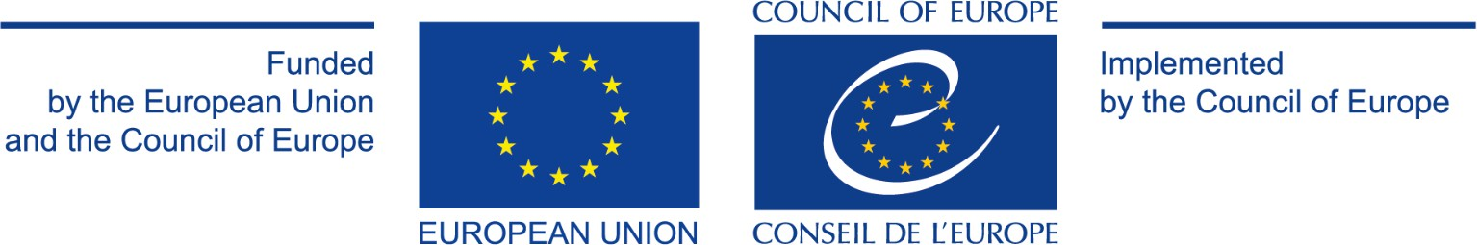

PROJECT SUMMARY

Title of the Project | Support to Council of Europe for EU Network of prison monitoring  bodies (“European NPM Forum”)
Project Financing | EUR 166,667 funded 90% by the European Union and 10% by the  Council of Europe
Donor | European Union (EU)
Duration | 12 months (1 August 2025 – 31 July 2026)
Target | National Preventive Mechanisms bodies (NPM) from EU member  States

- BACKGROUND AND PRIOR COOPERATION
The European NPM Forum is an interactive peer-to-peer network that brings together National Preventive Mechanisms in EU member States and beyond, mandated to conduct regular monitoring visits to all places of deprivation of liberty in their respective jurisdictions.
NPMs are key players in the protection of fundamental human rights of persons deprived of their liberty in prisons, but also in other places of deprivation of liberty (police stations, psychiatric establishments, social care homes, immigration detention centres, etc.). The role of NPMs is to independently visit these places at national and local levels, write reports on their findings, and examine their compliance with fundamental human rights of persons deprived of their liberty. They also issue recommendations to the authorities concerned and suggest improvements.
Since the entry into force of the Optional Protocol to the Convention against Torture and other Cruel, Inhuman or Degrading Treatment or Punishment (OPCAT) in 2006, the Council of Europe has been assisting in setting up NPMs in Europe and providing support to these bodies. In continuation of previous efforts and cooperation, the Forum allowed to establish and maintain a loose network of NPMs. This included support for their establishment, initial training of their members and staff, and the transfer of knowledge and expertise from its expert monitoring body, the European Committee for the Prevention of Torture and Inhuman or Degrading Treatment of Punishment (CPT).
The Forum provides a platform for regular exchange and discussion to assist European NPMs in carrying out their mandate effectively and independently and consequently enhancing mutual trust in detention conditions in EU Member States and beyond. While the project only funds support for European Union NPMs, the participation in the Forum goes beyond the European Union, and NPMs from non-EU member states, as well as states which are not members of Council of Europe, notably countries in the MENA region (Morocco and Tunisia) take active part in the exchanges. This widens the breadth of expertise, experiences and practices that can be enjoyed by the direct beneficiaries of the Project.

OVERALL OBJECTIVE OF THE EUROPEAN NPM FORUM
The joint project aims at steadily harmonising standards of detention in all places of deprivation of liberty, improving the effectiveness of monitoring methodologies and, in the long run, enhancing

detention conditions in the region through independent and objective monitoring and combined action at national, regional and international level, including through enhanced judicial cooperation within the European Union (EU).
The main objective of the project aims at maintaining and supporting the now well established European NPM Forum. The project will continue facilitating the regular exchange aiming at developing NPMs’ capacity and methodology to carry out their mandates effectively and independently through discussing different matters relating to deprivation of liberty and exchanging best practices, lessons learnt and common challenges. The objective is to contribute to the monitoring by regular objective inspections and gradual improvement of detention conditions (both in the pre- and the post-trial stage) in EU member States. This involves reliance on common criteria and methods for monitoring as well as the development of a common understanding of the precise requirements (standards) that govern the treatment of detained persons in the EU, the Council of Europe region, and beyond.
In line with the EU priorities, the project will continue to provide concrete support to assist NPMs in effectively monitoring and reporting on the procedural rights of suspects and accused persons subject to pre-trial detention (PTD), as well as on material detention conditions, as stated in the EU Recommendation adopted on 8 December 2022, laying down minimum standards in an effort to reduce the population in EU detention facilities and tackle the overcrowding problem. Despite obligations under Article 5 of the European Convention on Human Rights (ECHR), significant divergences persist among member States in the application of PTD, particularly concerning its use as a measure of last resort and the review of pre-trial decisions. In some countries, PTD is treated as routine, rather than exceptional, thereby contributing to increased prison density.
Beyond the topic of PTD, this new phase of the project supports efforts to reduce overcrowding and promote alternatives to both pre- and post-trial detention. The project focuses on the continued operation and further development of the European NPM Forum, with the aim of fostering ongoing peer exchange, critical reflection, and the development of common guidance and working methodologies. Dissemination of relevant information and awareness-raising will be ensured through country fiches, publications and the NPMs Forum’s digital platform. Targeted support and capacity building for EU NPMs remains a core component of the project, aiming to further strengthen their ability to carry out their mandate effectively and independently, improve working methods and overall impact, and facilitate exchange of experiences and promising practices in detention monitoring.

