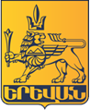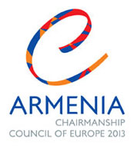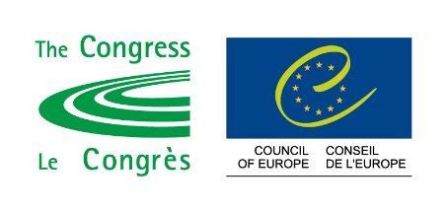

International Conference of capital cities of Council of Europe Member States

“Making the metropolis citizen-friendly: a challenge for public authorities”
Yerevan, Armenia, 11 October 2013
Press release
An international Conference of capital cities of the Council of Europe member States took place in Yerevan on October 11, 2013, under the Armenian Chairmanship of the Committee of Ministers of the Council of Europe and in close cooperation with the Congress of Local and Regional Authorities.
The Conference was opened by Mr. Armen Gevorgyan, Deputy Prime Minister and the Minister of Territorial Administration of Armenia, who read out the address of the President of the Republic, Mr. Serzh Sargsyan to the participants of the Conference. In his address, the President, particularly underlined that grassroots democracy is a pivotal element for the democratic development of the societies.
Mr. Taron Margaryan, the Mayor of Yerevan, also welcomed the participants and said that this is the first time that Armenia holds the Chairmanship of the Committee of Ministers of this pan-European organisation. He also stressed the importance of local democracy, which the Armenian Chairmanship declared one of its priorities. This is why the capital city of Yerevan organised, in cooperation with the Congress of Local and Regional Authorities, this conference to discuss the challenges that capital cities of the Council of Europe member States face today. In his speech, the Mayor of Yerevan also stated that the current global developments create increasing challenges for city authorities, dictating the necessity to be more flexible in order to have a sophisticated system of municipal governing. The Mayor of Yerevan especially underlined the crucial role of citizens’ participation in local self-government as a way to make it more effective and more responsive to the challenges of the day.
Mr. John Warmisham, Vice-President of the Congress, in his opening statement spoke about the governing models of big European cities, common problems that municipal authorities are facing and how to address them.
Mayors of Riga and Tbilisi, Deputy Mayor of Sarajevo, representatives of Moscow Government and Vilnius City Council, as well as members of Yerevan Avagani (Council of Aldermen) also spoke to the participants of the conference, presenting their respective practice and underlining problematic areas. One of the speakers also suggested to consider the possibility of making the meeting of representatives of capital cities a continued process, which will discuss various important issues that are on the agenda of municipalities of almost every metropolis.
The conclusions of the Conference were presented by Mr. Warmisham, who said that: “The metropolis can be our biggest headache; it can also be our greatest hope. Our cities are crucibles, which can offer us a vision of a sustainable, healthy and resilient urban future. The challenge for us is to get our governments, at all levels, to work together with a common purpose to address the challenges of our cities. For this we need new models of collaboration, better decision-making within and between all levels of government, and new and imaginative platforms for citizen engagement.”
Mr. Kamo Areyan, First Deputy Mayor of Yerevan, in his concluding remarks once again stressed the importance of a follow-up meeting of representatives of the capital cities of the Council of Europe member States.

