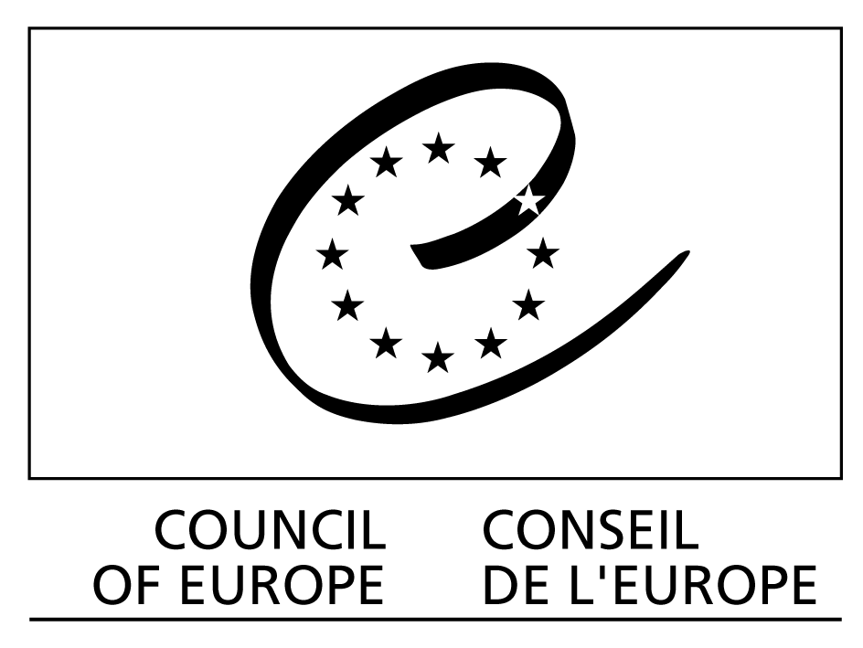
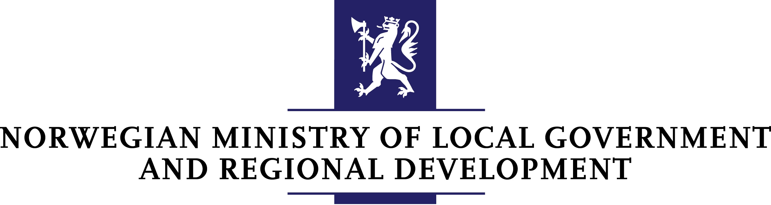

26 March 2010

WORKsHOP on the OBSERVATION

of E-ENABLED ELECTIONS

18-19 March 2010
Oslo, Building R-4, Einar Gerhardsens plass 1

LIST OF PARTICIPANTS/
LISTE DES PARTICIPANTS

REPRESENTATIVES OF MEMBER STATES/

REPRESENTANTS DES ETATS MEMBRES

AUSTRIA/ AUTRICHE

Mr Gregor WENDA
Federal Ministry of the Interior
Republic of Austria
Department III/6- electoral affairs
Deputy Head of Department

Mr Robert KRIMMER
Competence Center for Electronic Voting and Participation (E-Voting.CC)
A - 1190 Vienna/Austria

AZERBAIJAN/ AZERBAïDJAN

Mr Rovzat GASIMOV
Central Electoral Commission
Head of International Relations Departement
Baku AZ1000

BELGIUM/ BELGIQUE

M. Stéphan DE MUL
SPF INTERIEUR
Direction générale des Institutions et de la Population
Chef de Service
B - 1000 Bruxelles

DENMARK/ DANEMARK

Mr Thomas FRANDZEN
Ministry of Science, Technology and Innovation
National IT and Telecom Agency
Coordinator (e-Inclusion and e-Democracy), M.Sc. BA and Philosophy
Division of ICT Skills and eAccessibility

ESTONIA/ ESTONIE

Ms Epp Maaten
Member of the Secretariat
Estonian National Electoral Committee

GERMANY/ ALLEMAGNE

Mr Boris FRANßEN-DE LA CERDA
Division V I 5
Federal Ministry of the Interior

MOLDOVA

Mr Iurie CIOCAN, Ph.D.
Secretary General
Central Electoral Commission of the Republic of Moldova

Mr Frik OLIVIER

Information Technology Specialist

Electoral Support to Moldova Project

MD – 2012 2 012 Chisinau

NORWAY/ NORVEGE

Mr Henrik NORE
Project Manager e-vote 2011
Ministry of Local Government and Regional Development
Norway - 0032 Oslo

PORTUGAL

Mr Domingos Magalhaes
Director of services
DGAI – Electoral Administration
P - 1249-104 Lisbon

RUSSIAN FEDERATION/ FEDERATION DE RUSSIE

Mr Vladislav LUTSENKO
Head of section
Legal Department, CEC of the Russian Federation

Mr Maksim PONOMARENKO
Head of Section
Federal Center of Information Technology under the CEC of the Russian Federation

Mr Konstantin PETRENKO
Interpreter

SWEDEN/ SUEDE

Ms Kristina LEMON
Senior advisor
Election authority
S - 17104 Solna

Mr Henrik HANNEBO
Operation Developer
Election Authority
S - 17104 Solna

SWITZERLAND/ SUISSE

Ms Ardita DRIZA-Maurer
Juriste
Projet de vote électronique
Chancellerie fédrale
Palais fédéral ouest
CH - 3003 Berne

SPEAKERS/ INTERVENANTS

Mr Jonathan STONESTREET
Technical consultant for e-voting systems
F - 75015 Paris

Mr Henrik NORE
Project Manager e-vote 2011
Ministry of Local Government and Regional Development
Norway - 0032 Oslo

Ms Ardita DRIZA-Maurer
Juriste
Projet de vote électronique
Chancellerie fédérale
CH - 3003 Berne

Ms Epp Maaten
Member of the Secretariat
Estonian National Electoral Committee
EE - 15165 Tallinn

Mr Gregor WENDA
Deputy Head of Department
Federal Ministry of the Interior
Republic of Austria

Mr Robert KRIMMER
Competence Center for Electronic Voting and Participation (E-Voting.CC)
Pyrkergasse 33/1/2
A - 1190 Vienna/Austria
Mr Mats LINDBERG
Election Adviser
OSCE Office for Democratic Institutions and Human Rights
PL - 00-557 Warsaw

Ms Betilde MUÑOZ-POGOSSIAN
Coordinator, Electoral Studies and Projects Section
Department for Electoral Cooperation and Observation
Secretariat for Political Affairs
Organization of American States
www.oas.org

OTHER ORGANISATIONS/ AUTRES ORGANISATIONS

OSCE/ODIHR

Mr Mats LINDBERG
Election Adviser
OSCE Office for Democratic Institutions and Human Rights
PL - 00-557 Warsaw

ASSOCIATION OF EUROPEAN ELECTION OFFICIALS (ACEEEO)

Mr Jenő SZEP
Adviser
HU - 1054 - Budapest

ORGANIZATION OF AMERICAN STATES

Ms Betilde MUÑOZ-POGOSSIAN
Coordinator, Electoral Studies and Projects Section
Department for Electoral Cooperation and Observation
Secretariat for Political Affairs

INTERNATIONAL IDEA

Mr Peter WOLF
Technical Manager - Electoral Processes
Design of Democratic Institutions and Processes
Strömsborg

OTHER PARTICIPANTS/AUTRES PARTICIPANTS

Mr Rojan GHARADAGHY
PHD student
Department Secure Data
Center for Advanced Security Research Darmstadt
TU Darmstadt
Germany

Ms Rosa Maria FERNÁNDEZ RIVEIRA
Lecturer In Constitutional Law
Universidad Complutense de Madrid
Parliamentary Law Institute
Ciudad Universitaria
28040 Madrid
Spain

COUNCIL OF EUROPE SECRETARIAT/

SECRETARIAT DU CONSEIL DE L’EUROPE

Directorate General of Democracy and Political Affairs/

Direction Générale de la démocratie et des Affaires Politiques

Mr Michael REMMERT
Project Manager/ Chef de Projet
« Good Governance in the Information Society/
Bonne gouvernance dans la société de l’information »

Mrs Susanne CAARLS
Prorgamme adviser/ Conseiller de programme
« Good Governance in the Information Society/
Bonne gouvernance dans la société de l’information »

OTHER PARTICIPANTS FROM THE MINISTRY OF LOCAL GOVERNMENT AND REGIONAL DEVELOPMENT, NORWAY

Mr Dan SØRENSEN
E-vote 2011 project
Ministry of Local Government and Regional Development
Norway - 0032 Oslo

Ms Kristin SKORPEN
E-vote 2011 project
Ministry of Local Government and Regional Development
Norway - 0032 Oslo

Ms Ragnhild INDREEIDE
E-vote 2011 project
Ministry of Local Government and Regional Development
Norway - 0032 Oslo

Mr Tom Refsum AATLO
Senior Adviser
Ministry of Local Government and Regional Development
Norway - 0032 Oslo

Ms Marianne RIISE
Profession Director
Ministry of Local Government and Regional Development
Norway - 0032 Oslo

Mr Hans Pettr GRAVDAHL
Deputy Director General
Ministry of Local Government and Regional Development
Norway - 0032 Oslo

