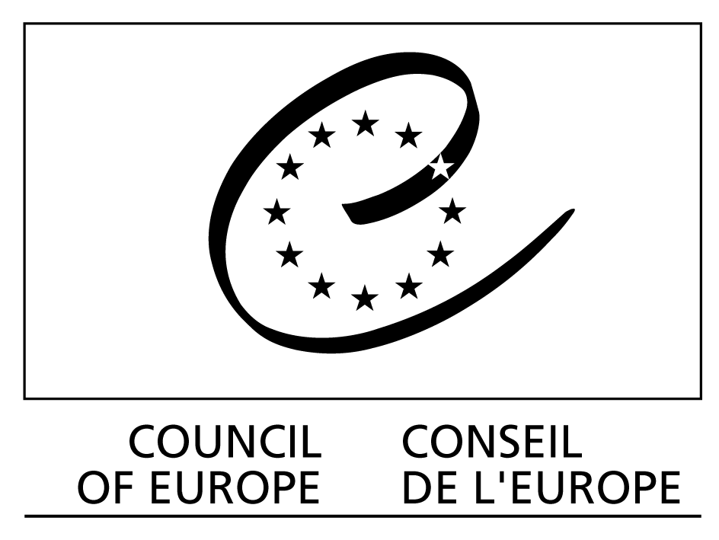

Speech by Maud de Boer-Buquicchio
Deputy Secretary General of the Council of Europe
Meeting on E-Voting Review
Strasbourg, 23 November 2006

Ladies and Gentlemen,
Colleagues,

When I decided to address you on the occasion of this review meeting, e-voting was only an abstract concept to me. Well, today this is no longer the case. As a Dutch citizen living abroad, I had the opportunity to vote through the Internet in the context of the parliamentary election. I found the voting experience encouraging: easy and straightforward, no technical hic-ups. I hope that next time I will also be able to register on-line as an internet voter instead of having to post paper forms.

Voters are not aware of difficulties and uncertainties about e-voting. As a Deputy Secretary General, I am convinced that this is an area which requires continuous attention and serious debate.

While democracy is about much more than a ballot box, clearly there is no democracy without voting. Voting is both one of the most critical and the most vulnerable elements of democratic practice: if something goes wrong at the poll, trust in democracy as a whole is undermined. This is the reason for the Council of Europe – the continent’s democracy watchdog – to pay special attention to e-voting. In principle, there is nothing to prevent the use of e-technologies in political polling – if people watch local council meetings on line, read e-news, contribute to party blogs and sign e-petitions, why should they leave the comfort of their homes to drop a ballot in a box?

It is interesting – and natural – that in e-voting matters (just as in traditional voting) no two countries follow an identical path. Political tradition and culture certainly play a role, as does the results of public debate on the opportunities and risks of e voting. Such a public debate, which is often triggered by civil society, is not only useful but also necessary, as no technological solution solely has advantages. Only a broad dialogue in each country and at the European level can build the trust needed for a successful large-scale introduction of e-voting.

I can assure you that the Council of Europe is taking e-voting seriously. We made a very thorough review of concepts and practice, and threats and opportunities before producing the only internationally agreed benchmark for e-voting systems which exists to date. But in this new and rapidly developing field we cannot consider the job finished. Two years after the adoption of a Recommendation on this subject, we need to take stock of what is actually happening on the ground and address specific concerns such as security, voter verifiability, systems certification, and election observation.

At this meeting, you will take stock of and review developments in the field of e-voting in Council of Europe member states since the adoption of the 2004 Recommendation, and will assess its continuous validity and application. But you will also look ahead to prospects and emerging challenges which still need to be addressed – by states, by the Council of Europe and by the international community.

In the past two years, there have been remarkable and successful experiences with e-voting, Estonia and Switzerland being the best known examples. A significant number of binding and non-binding e-voting pilots have been organised. The Estonian municipal elections in 2005 was the first nationwide binding remote e-voting experience worldwide. Several member states have adopted or are preparing legislation to allow e-voting in elections or referendums or are carrying-out feasibility studies.

In some places, doubts have been raised as to the security of e-enabled elections, particularly with voting machines, and sometimes plans to introduce voting machines have been shelved for an indefinite period.

Experience is mixed and assessment is very complex. The key criteria which will guide you while assessing European experience are contained in the e-voting Recommendation. Central among them is the requirement that e-voting shall be as reliable and secure as conventional voting.
This simple principle has enormous implications in practice, for instance in relation to accreditation of e-voting systems. The Council of Europe Recommendation urges governments to develop certification and accreditation schemes for e-voting systems. First experiences show that it is rather difficult to agree on an “acceptable” security level for e-voting solutions. There is, for instance, an increasing number of critical voices about the use of voting machines, the so-called Direct Recording Equipment. Remote voting has its own – very serious – security issues. Technical answers exist in most cases but the highest security levels which industry could provide are too costly for public authorities to afford and raise the issue of cost effectiveness of e-voting compared with conventional elections.

Determining the cost is the easier side of the cost-effectiveness equation. If e-voting can be demonstrated to increase turnout, higher cost could be justified. However, while e-voting holds the potential to attract some of those who usually vote less – for instance the young, it might have a deterring effect on elderly voters. It is therefore crucial to provide conventional voting channels in parallel for the foreseeable future – which adds to the cost, and complexity of e-voting.

An electronic vote has implications beyond the simple act of voting. If we e-enable this act, we must also make sure that the systems around it have the necessary capacity too. We should ask ourselves whether courts have the necessary technical expertise to deal with election complaints arising from e-enabled elections.

We should also consider what e-voting means for election observation. This question is still largely open and in the past months the Council of Europe and ODIHR have joined forces in order to address it. How can election observers obtain the necessary level of insight into the technical aspects of the e-voting system, such as access to source codes, and how can observers ascertain the proper functioning of the e-voting system as long as the electronic ballot box is open?

E-voting should not be considered in isolation because it is obviously linked to broader democracy and e-democracy issues. E-campaigning is one of them, with the associated concerns for privacy and data protection. There is a case for codes of good practice for e-campaigning, and Estonia where the political parties agreed to adopt one, is an interesting example.

Through your work, the Council of Europe will continue to provide guidance to member states in their endeavour to bring democracy to the information age. Your insights, especially as concerns the implications of e-voting for democratic institutions, democratic culture and democratic reform, will inform our efforts to make democracy more in tune with society in the 21st century – a task for the Forum on the Future of Democracy which will focus on e-democracy at its 2008 session in Spain.

I look forward, with genuine interest, to the answers – and further questions – which will result from your work.

