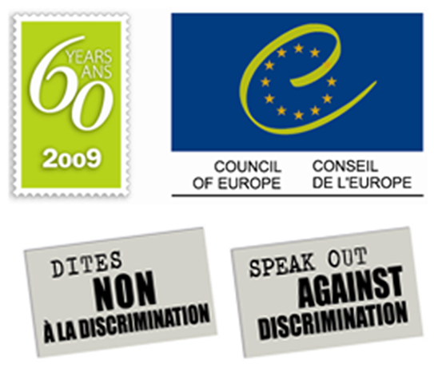

"Speak out against discrimination" Campaign launch in Reggio Emilia on 24 September 2009.

Discrimination is an offence! There should no longer be discrimination against anyone in Europe.

You could be next, victim or witness, so speak out against discrimination!

This is the main message of the Council of Europe’s antidiscrimination Campaign. One of the aims of this Campaign is to tell actual or potential victims of discrimination about the national and European mechanisms which exist to protect and uphold their rights.

The Campaign is also intended to provide backing to media and their staff in their role of raising public support for the fight against discrimination and for intercultural dialogue in Europe.

Following launches in Rome, Milan, Paris, Barcelona, Madrid and Moscow, it is now the turn of Reggio Emilia, where more than 500 copies of the "Speak out against discrimination" campaign poster will be on display in the streets.

Ms Gabriella Battaini-Dragoni, Director General of Education, Culture and Heritage, Youth and Sport and Co-ordinator for intercultural dialogue and for the anti-discrimination campaign, will give a press conference together with Graziano Delrio, Mayor of Reggio Emilia on Thursday 24 September at 9.45 (Sala Rossa, City Hall, Piazza Prampolini, 1). Ms Gabriella Battaini-Dragoni will also present the Council of Europe “White Paper on Intercultural Dialogue”.

