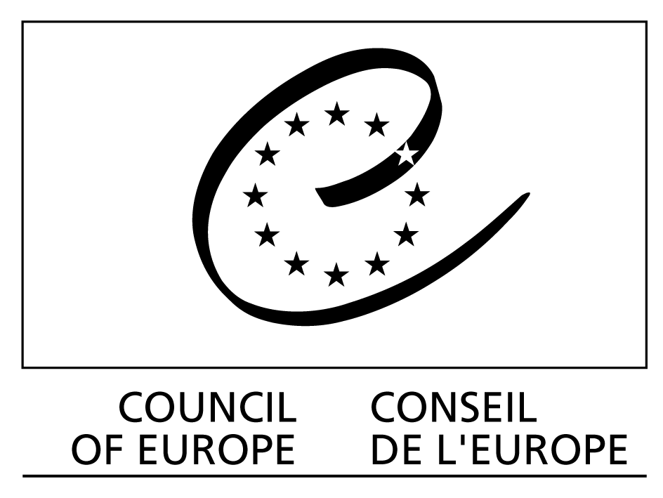
DGIII/DCS (2005)

FORUM 2005

RECONCILING LABOUR FLEXIBILITY WITH SOCIAL COHESION

CONCILIER FLEXIBILITE DU TRAVAIL ET COHESION SOCIALE

17 & 18 November – novembre 2005
Conseil de l’Europe/Council of Europe
Strasbourg, Palais des Droits de l’Homme
___________________________________________________
SESSION III
Measures to accompany labour flexibility of social cohesion
Quelles sont les mesures complémentaires pouvant accompagner la flexibilité du travail dans le cadre de la cohésion sociale ?

Perspectives and proposals
from international organisations

Line Barfod
Member of the Nordic Council and Danish parliamentarian

Resume:

I regard the following as the preconditions of flexicurity in the Nordic countries:
- A high level of advanced tax-based social security systems based on solidarity.
- A highly well-organized labour market. The so called “Nordic model” (labour market) is regulated, not by laws, but by agreements between the enterprises and the trade unions. This system creates a harmonised, consensus oriented labour market with a high flexibility. Most of both the workers and the companies are organised and conflicts are normally solved by the organisations.
- Democracy and a high degree of confidence to the system and the organisations.
- Equality. Almost all women are working and the society provides kindergartens, homes for elderly people and so on.
- Commitment to sustainable development.
- Focus on creating new jobs. We can’t compete with the wages in China neither for the workers in the industry or for the engineers. So we must instead create new jobs.

The Nordic welfare model is not the result of a specific plan but comes from political fights for the last 150 years, fights that are still going on between political parties and between the organisations on the labour market.

The whole speech:

I’m invited to speak on behalf of the Nordic Council which is a partnership between five states and three autonomous territories: Denmark, Finland, Iceland, Norway, Sweden and the autonomous territories of the Åland Islands, Greenland and the Faroe Islands. The Nordic countries are in many ways alike, but also have differences.
Co-operation is based on the unique Nordic political and cultural bonds and on the mutual understanding that ties the 24.6 million people of the Region together. The relatively small Nordic countries make a difference when we work together and combine our strengths. Co-operation makes the Nordic Region more competitive and means Nordic values exert greater influence around the world.

Nordic co-operation is based upon a set of shared values, which enjoy deeply rooted popular support. During the last 50 years a whole raft of joint measures has been introduced to enhance political co-operation and facilitate everyday life for our citizens and businesses. The passport union, the common labour market, joint health and social welfare provision, joint rules for education and research – to name but a few – are all prime examples of the benefits derived from co-operation.

We don’t harmonise the laws like the European Union, instead we find solutions for those problems people have when they cross the borders.

Let me then address what I regard as the preconditions of flexicurity in the Nordic countries:
- A high level of advanced tax-based social security systems based on solidarity.
- A highly well-organized labour market.
- Democracy
- Equality. Almost all women are working and the society provides kindergartens, homes for elderly people and so on.
- Commitment to sustainable development.
- Focus on creating new jobs. We can’t compete with the wages in China neither for the workers in the industry or for the engineers. So we must instead create new jobs.

The latest proposal within the Nordic Council focuses on labour mobility between the Nordic countries, the Baltic countries and Poland. In this context, we must make sure that illegal use of foreign labour does not threaten flexibility and top-down rules could be tempting, but instead we should inform and mobilize in a bottom-up perspective – using the partners of the labour market to inform and prepare persons working abroad and help with the organisation of the labour market.

The so called “Nordic model” (labour market) is regulated, not by laws, but by agreements between the enterprises and the trade unions. This system creates a harmonised, consensus oriented labour market with a high flexibility. Most of both the workers and the companies are organised and conflicts are normally solved by the organisations.

The workforce in the Nordic countries is in general highly skilled and well educated. The welfare system together with the trade unions support and offers re-education to those who loose their jobs. The welfare system should enable an individual who has lost her job to live a normal life and to keep her skills up to date while looking for a new job. I believe this to be one of the key factors for the creation of a stable and solid labour market that supports the social cohesion. But I must also tell you that it is not so in Denmark today. The government has cut down the social welfare and the result is not more people getting a job, but more people getting poor.

Another key factor is the flexibility and the ability of the education system, which must have the ability to foresee the demands both in the near future so that the society is not part of creating a miss-match when it comes to the education and competences of the citizens – to the needs and demands of the labour market. As well as seeing the possibilities for creating new jobs.

Democracy and a high degree of confidence to the system and the organisations are also very important. The citizens feel they influence on political decisions and as workers they have influence in the trade unions and in the companies. Among other things it means that employees come with a lot of ideas of how the companies can improve production, also if it means that some looses their jobs, but in the long run it creates new job. And common solutions are sought of instead of individual solutions to many problems.

A high degree of equality means that a lot more people are on the labour market and that the black market for labour is not very big. It also means that the trade unions fight for rights like parental leave. Island now has a fund that all companies pay to so that workers on parental leave get 80 % of their normal salary. 3 months of the parental leave is only for the father and this means that 90 % of the fathers use their leave.

The commitment to sustainable development means that a lot of creative ideas come forward, that also creates new jobs, for instance the production of windmills in Denmark.

In order to support and finance welfare system like this, all the Nordic countries has a high level of tax. The welfare system is mainly funded by the taxpayer and great emphasis is placed on the redistributive role played by the tax system.

From an overall perspective, the Nordic welfare model enjoys broad political support and agreement on the vast majority of issues. The balance between state and private provision, public and personal responsibility, etc. is open to debate however.

The Nordic welfare model is not the result of a specific plan but comes from political fights for the last 150 years, fights that are still going on between political parties and between the organisations on the labour market.

One of the biggest political problems is the fact that so many people are thrown out from the labour market. In Denmark 2,7 million people work hard, and 900.000 are outside the labour market either unemployed or to ill to work. Many can’t work a whole life because the work is too hard. So we need better working conditions and a different way of organising the labour market in order to make it possible to work a whole life.

