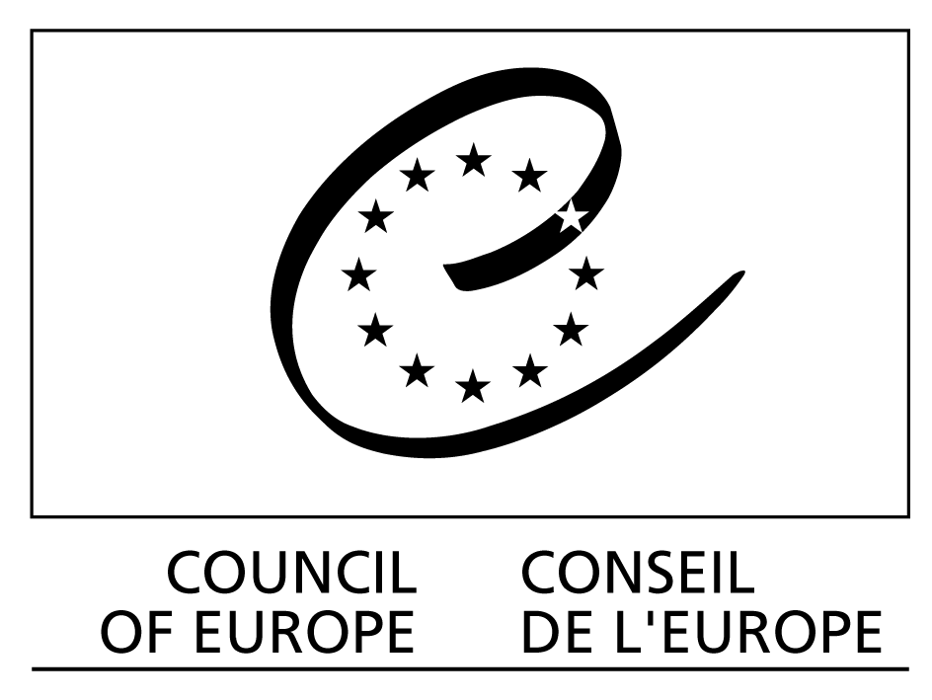

Strasbourg, 30 November 2011 CDCS (2011) 31

EUROPEAN COMMITTEE FOR SOCIAL COHESION
(CDCS)

Terms of Reference :

European Committee for Social Cohesion (CDCS)

Committee of Experts on the rights of people with disabilities (CS-RPD)

1 January 2012 until 31 December 2013

adopted by the Committee of Ministers at the 1127th meeting on 22-24 November 2011

PILLARS: HUMAN RIGHTS and DEMOCRACY

European Committee for Social Cohesion (CDCS)

Set up by the Committee of Ministers under Article 17 of the Statute of the Council of Europe and in accordance with Resolution CM/Res(2011)24 on intergovernmental committees and subordinate bodies, their terms of reference and working methods

Terms of reference valid from 1 January 2012 until 31 December 2013

Main tasks
Under the authority of the Committee of Ministers, the CDCS will oversee all aspects of the Council of Europe’s work in the field of social cohesion and advise the Committee of Ministers on all questions within its area of competence. Taking due account of relevant transversal perspectives, the overall aim is to promote socially cohesive and sustainable societies and to ensure the protection of human dignity. With this purpose, the CDCS is instructed to:

- promote and facilitate implementation of the New Strategy for Social Cohesion and the related Council of Europe Action Plan for Social Cohesion;
- study, analyse and evaluate trends and challenges to social cohesion and hold regular exchanges of views and information on practices related to social cohesion with Council of Europe member states, as well as with relevant international organisations, including in particular the European Union, relevant non-governmental organisations and other stakeholders;
- develop and promote guidelines, tools and cooperation projects for policy implementation and evaluation, particularly in areas relating to social protection including its health dimension, children and families, employment, non-discrimination, migration (in particular from the point of view of integration), the fight against poverty and contribute to the development of national social policies, in connection with relevant Council of Europe standards (and in particular with the European Social Charter, the revised European Social Charter and the European Code of Social Security);
- keep under review the evolution of policies and standards for social cohesion in member states, in the light of relevant legal instruments and tools of the Council of Europe, without pursuing activities relating to monitoring;
- mainstream social cohesion in relevant Council of Europe bodies and activities, in particular on issues related to social inequalities, social responsibilities, social protection and to living together in pluralistic societies;
(vi) oversee the promotion, implementation and follow-up of the “Council of Europe Action Plan to promote the rights and full participation of people with disabilities in society: improving the quality of life of people with disabilities in Europe 2006-2015” (Recommendation Rec(2006)5);
(vii) contribute to the preparation of the Second Council of Europe Conference of Ministers responsible for Social Cohesion (Istanbul, 2012) and, as appropriate, to the follow-up decisions taken by the Committee of Ministers;
(viii) identify opportunities for Council of Europe input and/or complementary Council of Europe action and programmes, taking into account the activities of other international organisations, in particular the European Union, the United Nations and the OSCE;
(ix) conduct a strategic reflection on the ways of increasing impact and effectiveness of the Council of Europe policies and tools for social cohesion in member states.

Pillar/ Sector/ Programme
Pillar: Democracy
Sector: Sustainable Democratic Societies
Programme: Promoting a Socially Cohesive and Sustainable Society

Pillar: Human Rights
Sector: Promoting Human Rights
Programme: Equality and Diversity (People with disabilities)

Expected results
Expected results 2012-2013:
- The Council of Europe Action Plan for Social Cohesion are promoted and implemented in member states, including, as appropriate, through technical assistance projects and cooperation activities;
- member states are provided with a tool to facilitate youth transition to active life taking into account the standards and priorities of European Youth policies;
- member states are guided in developing policies aimed at building a secure future for all;
- a Network of Territories/Pilot projects of Shared Social Responsibilities – aimed at strengthening social cohesion, fighting poverty and any form of discrimination – is set up;
- the 2nd Council of Europe Conference of Ministers responsible for Social Cohesion (Istanbul, October 2012) adopts a political declaration on the theme “Building a secure future for all” to serve as a major guideline for effective and innovative social cohesion policies on this theme;

Composition
Members:
Governments of member states are invited to designate one representative of the highest possible rank in the relevant field, with responsibility at the national level for the planning, development and implementation of policies relevant to the work of the Committee and appointed by their governments to co-ordinate at national level all elements of government policy relevant to the work of the Committee.

The Council of Europe will bear the travel and subsistence expenses of one representative from each member state (two in the case of the state whose representative has been elected Chair).

Member states may send other representatives without defrayal of expenses.

Each member of the committee shall have one vote. Where a government designates more than one member, only one of them is entitled to take part in the voting.

Participants:
The following may send representatives without the right to vote and at the charge of their corresponding administrative budgets:

- Parliamentary Assembly of the Council of Europe;
- Congress of Local and Regional Authorities of the Council of Europe;
- European Court of Human Rights;
- Council of Europe Commissioner for Human Rights;
- Conference of INGOs of the Council of Europe;
- European Committee for Social Rights (ECSR);
- Governmental Committee of the European Social Charter and of the European Code of Social Security;
- European Commission against Racism and Intolerance (ECRI);
- Partial Agreement Co-operation Group to Combat Drug Abuse and Illicit Trafficking in Drugs - (Pompidou Group);
- Enlarged Partial Agreement on Sport (EPAS);
- Council of Europe Development Bank (CEB);
- Steering Committee for Human Rights (CDDH);
- European Committee on Legal Co-operation (CDCJ);
- Steering Committee for Educational Policy and Practice (CDPPE);
- Steering Committee for culture, heritage and landscape (CDCPP);
- Joint Council on Youth (CMJ);
- European Committee on Local and Regional Democracy (CDLR);
- Ad hoc Committee of Experts on Roma Issues (CAHROM);
- Gender Equality Commission (GEC);
- Other Council of Europe intergovernmental committees as relevant.

The following may send representatives without the right to vote and without defrayal of expenses:

- European Union (including, as appropriate, the European Union Agency for Fundamental Rights (FRA) and the European Foundation for the Improvement of Living and Working Conditions (Eurofound));
- Observer States to the Council of Europe: Canada, Holy See, Japan, Mexico, United States of America;

- States Party to the European Cultural Convention that are not member states of the Council of Europe;
- States participating in the Council of Europe Neighbourhood Policies in the Southern Mediterranean, Middle East and Central Asia;
- European Trade Union Confederation (ETUC) and Confederation of European Business (EUROBUSINESS) (“social partners”);
- United Nations and UN agencies: International Labour Organisation (ILO); United Nations Economic Commission for Europe (UNECE); United Nations Educational, Scientific and Cultural Organisation (UNESCO); Office of the High Commissioner for Human Rights (OHCHR), United Nations High Commissioner for Refugees (UNHCR);
- Organisation for Economic Co-operation and Development (OECD);
- European Disability Forum (EDF);
- European Association of Service Providers for Persons with Disabilities (EASPD);
- European Youth Forum (YFJ).

Working methods
Plenary meetings:
48 members, up to 2 meetings in 2012, 3 days, within the budgetary appropriations allocated
48 members, up to 2 meetings in 2013, 3 days, within the budgetary appropriations allocated

Bureau:
11 members, up to 2 meetings in 2012, 3 days, within the budgetary appropriations allocated
11 members, up to 2 meetings in 2013, 3 days, within the budgetary appropriations allocated

The Committee’s work shall include relevant transversal perspectives, inter alia, on gender, children and youth, in all areas of their work.

The Committee will also appoint a Gender Equality Rapporteur from amongst its members.

The rules of procedure of the Committee are governed by Resolution CM/Res(2011)24 on intergovernmental committees and subordinate bodies, their terms of reference and working methods.

Subject to the agenda, the Chair(s) of the subordinate structure(s) to the CDCS may be invited to attend CDCS Bureau meetings.

Subordinate structure
The CDCS provides a coordinating, supervising and monitoring role in the functioning of its subordinate body, the Committee of Experts on the Rights of People with Disabilities (CS-RPD) (see separate Terms of Reference)

PILLAR: HUMAN RIGHTS

Committee of Experts on the rights of people with disabilities (CS-RPD)

Set up by the Committee of Ministers under Article 17 of the Statute of the Council of Europe and in accordance with Resolution CM/Res(2011)24 on intergovernmental committees and subordinate bodies, their terms of reference and working methods

Terms of Reference valid from 1 January 2012 until 31 December 2013

Main tasks
Under the supervision of the European Committee for Social Cohesion, the CS-RPD shall:

- assist member states in the promotion, implementation and follow-up of Committee of Ministers’ Recommendation Rec(2006)5: “Council of Europe Action Plan to promote the rights and full participation of people with disabilities in society: improving the quality of life of people with disabilities in Europe 2006-2015” (‘Council of Europe Disability Action Plan 2006-2015’), Article 15 of the European Social Charter or the European Social Charter (revised) and the UN Convention on the Rights of Persons with Disabilities (UN CRPD), through the development of relevant national legislation, policies and practices, in the following Action Lines and Cross-cutting aspects of the Plan:
- participation of people with disabilities in political and public life (Action Line 1);
- protection and promotion of the rights of women and girls with disabilities (Cross-cutting aspect 4.2 );
- protection of specifically vulnerable groups of children and young people with disabilities (Cross- cutting aspect 4.4);
- participation in cultural life (Action Line 2);
- provide a platform for the exchange of information, experience, knowledge and examples of innovative practices in a structured way, and for the development of co-operation and technical assistance projects;
- effectively co-ordinate relevant intergovernmental and intra-institutional co-operation in this area, as well as co-operation with interested international organisations and observers, including civil society, and in particular organisations of and for people with disabilities;
- identify opportunities for Council of Europe input and/or complementary Council of Europe action and programmes, taking into account the activities of other international organisations, in particular the European Union, the United Nations and the OSCE;

Pillar/ Sector/ Programme
Pillar: Human Rights
Sector: Promoting Human Rights
Programme: Equality and Diversity

Expected results
Expected results 2012:

- Member states are supported in implementing the second 5-year term of the Disability Action Plan 2006-2015 through capacity-building actions (trainings, awareness raising events take place in at least 2 member states) in 5 key action lines identified in the 2010 mid-term review report and conference (i.e. Plan’s action lines No. 4 – Education, No. 5 – Employment, vocational guidance and training, No. 6 – Built environment, No. 7 – Transport and No. 8 – Community living);
- member states are provided with expertise and policy guidelines (identification and dissemination of examples of good practice and a Committee of Ministers’ Recommendation) to protect and promote the rights of the specifically vulnerable groups of children and young people with disabilities;
- a Committee of Ministers’ Recommendation on participation of people with disabilities in political and public life (to be adopted by the Committee of Ministers’ in 2011) is promoted (co-operation activities take place in at least 1 member state);
- a Committee of Ministers’ Recommendation on the human rights of women and girls with disabilities (to be adopted by the Committee of Ministers’ early in 2012) is promoted (co-operation activities take place in at least 1 member state).

Expected results 2013:
- Member states are supported in implementing the second 5-year term of the Disability Action Plan 2006-2015 through capacity-building actions (trainings, awareness raising events take place in at least 2 member states);
- a review report on the implementation of the Plan in 5 key action lines identified in the 2010 mid-term review report and conference (see above) is prepared;
- member states are provided with expertise and policy guidelines (identification and dissemination of examples of good practice and a Committee of Ministers’ Recommendation) to increase the participation of people with disabilities in cultural life, leisure, tourism and sport;
- a Committee of Ministers’ Recommendation on the human rights of the specifically vulnerable groups of children and young people with disabilities (to be adopted by the Committee of Ministers’ in 2012) is promoted (co-operation activities take place in at least 2 member states).

Composition
Members:

Governments of member states are invited to appoint representatives with the relevant qualifications and/or responsibility in the field of protection and promotion for the rights of people with disabilities. The competencies of member states’ representatives to the Committee should correspond to the comprehensive multidisciplinary nature of the Council of Europe Disability Action Plan 2006-2015, and to the objectives to be reached in 2012 and 2013, respectively.

The Council of Europe budget will bear the travelling and subsistence expenses of one representative from each member state (two in the case of the state whose representative has been elected Chair).

Member states may send other representatives without defrayal of expenses.

Each member of the committee shall have one vote. Where a government designates more than one member, only one of them is entitled to take part in the voting.

Participants:

The following may send representatives without the right to vote and at the charge of their corresponding administrative budgets:

- Parliamentary Assembly of the Council of Europe;
- Congress of Local and Regional Authorities of the Council of Europe;
- European Court of Human Rights;
- Council of Europe Commissioner for Human Rights;
- Conference of INGOs of the Council of Europe.
- Governmental Committee of the European Social Charter and of the European Code of Social Security;
- Enlarged Partial Agreement on Sport (EPAS);
- Council of Europe Development Bank (CEB);
- Steering Committee for Human Rights (CDDH);
- European Committee on Legal Cooperation (CDCJ);
- Joint Council on Youth (CMJ);
- Gender Equality Commission (GEC);
- Steering Committee for Education Policy and Practice (CDPPE);
- Steering Committee for Culture, Heritage and Landscape (CDCPP);
- Steering Committee on Media and Information Society (CDMSI);
- Other Council of Europe intergovernmental committees as appropriate.

The following may send representatives without the right to vote and without defrayal of expenses:

- The European Union (including as appropriate the European Union Agency for Fundamental Rights (FRA));
- Observer States to the Council of Europe: Canada, Holy See, Japan, Mexico, United States of America;
- United Nations Organisation (UN);
- United Nations Educational, Scientific and Cultural Organisation (UNESCO);
- United Nations Children’s Fund (UNICEF);
- World Health Organisation (WHO);
- International Labour Organisation (ILO);
- United Nations Development Programme (UNDP);
- Office of the High Commissioner for Human Rights (OHCHR);

- Office of the United Nations High Commissioner for Refugees (UNHCR);
- Organisation for Economic Co-operation and Development (OECD);
- Nordic Centre for Welfare and Social Issues (NVC) under the aegis of the Nordic Council of Ministers.

Observers:
The following organisations may send representatives without the right to vote and without defrayal of expenses:

- European Association of Service Providers for Persons with Disabilities (EASPD);
- European Disability Forum (EDF);
- Rehabilitation International (RI).

Working methods
Meetings:
48 members, 1 meeting in 2012, 3 days
48 members, 1 meeting in 2013, 3 days

The Committee’s work shall include relevant transversal perspectives, inter alia, on gender, children and youth, in all areas of their work.

The Committee will also appoint a Gender Equality Rapporteur from amongst its members.

The rules of procedure of the Committee are governed by Resolution CM/Res(2011)24 on intergovernmental committees and subordinate bodies, their terms of reference and working methods.

This draft recommendation will be submitted to the Ministers’ Deputies for adoption on 16 November 2011.

