DGIII / DCS (2005) 34

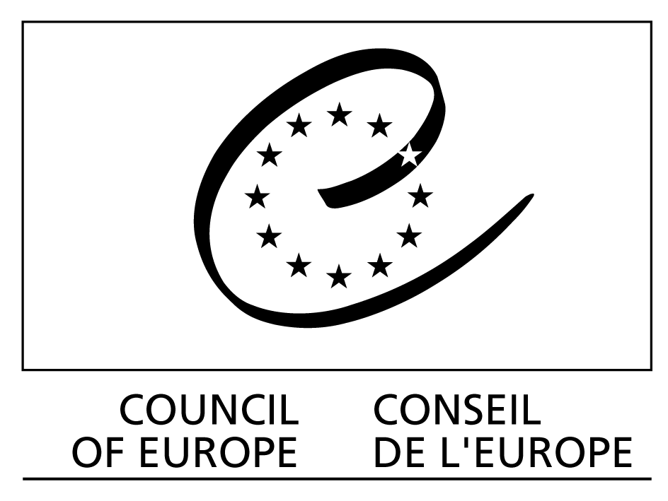

European platform for dialogue on ethical and solidarity-based initiatives

Draft programme of the meetings to be held on 23 and 24 May 2005

Palais de l’Europe, Rooms 6 & 11

__________

Monday 23 May

9h00-9h30 Introduction and presentation of the participants

9h30-10h00 Presentation of the Platform proposals and its different activities (Powerpoint)

10h-11h00 Discussion on the Platform proposal around three aspects :
- its political interest for the Council of Europe: interventions from the Committee of Ministers, the Parliamentary Assembly, the Congress of Local and Regional Authorities, the INGO Liaison Committee and DG IV (Culture and Education) and DG1 (Legal Affairs) on the importance of a platform for dialogue on relevant themes between public authorities and citizens.
- its legal framework ;
- its future and its development.

11h00-11h15 Coffee break

11h15-11h45 Continuation of the discussion and conclusions

11h45–13h00 Activity programme for 2005 on the value-added of dialogue between public authorities and citizen initiatives from two angles :
- Value-added already gained (analysis of existing experiences): review of existing activities and of questions in view of the Trento seminar.
- The potential value-added with a ‘test case’ on the issue of over-indebted households.

13h00-14h30 Lunch

14h30–15h30 Over-indebted households: responses from public powers and responses in terms of responsible consumerism and solidarity-based finance (including responsible micro credits) – technical questions and perspectives on the theme and discussion on the way forward in 2005 in view of the Trento meeting.

15h30–17h00 Two meetings in parallel :
- Meeting of the Platform Management Committee;
- Continuation and conclusion of the morning’s discussions on existing value-added.

17h00-19h00 Meeting of the inter-network

Tuesday 24 May

9h00-9h30 Presentation of the conclusions of the Management Committee meeting and the inter-network meeting and on the discussions on existing value-added.

9h30-10h00 Structure of the Trento meeting – first proposals and discussion

10h00-11h00 Continuation of the issue of over-indebted households with three approaches
a) Financial and legal aspects :
- Intervention from DG1 on the conclusions of the inter-Ministerial conference of Ministers of Justice held in Helsinki and current activities on the issue ;
- Intervention from Mr Emmanuel Constans from the Bank of France to present a
Governmental and Central Bank viewpoint;
- Intervention of the FEBEA and SEFEA on possible responses using micro credits.
- Discussion

11h00-11h15 Coffee break

11h30-13h00 Continuation of the work on over indebted households
b) Addressing the problem via consumerism
- Presentation of good practices : the consumers’ school in Belgium (Paul Maréchal); Stilinfo in Venise (Div Devt CS); AMAP in France (Daniel Vuillon); the possible role of fair-trade (Christine Gent)
- Discussion

c) Addressing the problem from the viewpoint of combatting poverty and new forms of exclusion
- How should the different issues - financial, legal, consumerism and, more generally, the fight against poverty and new forms of social exclusion – be linked?
- Discussion

13h00-14h30 Lunch

14h30-15h30 Conclusions of the morning and follow up to be given for work on over-indebted households and the existing value-added.

15h30–16h30 Programming the Trento meetings and the preparatory work : allocating responsibilities and tasks.

16h30 End of the meeting

