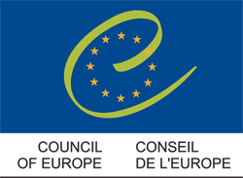

International Scientific Conference
«Ethics Review of Clinical Research in Pharmaceuticals"

Organised by the Council of Europe and the Ministry of Health and Social Development of the Russian Federation

Moscow, 28-29 November 2011

Speaker’s PowerPoint Presentations

Presented in order in which they appear in the Programme

Speaker: Dr Laurence Lwoff, Head of Bioethics Division, Council of Europe

Speaker: Dr Lino Paula, European Research Area – Ethics and Gender Unit, Directorate-General for Research and Innovation, European Commission

Speaker: Ms Isabel de la Mata, Principal Advisor with Special interest in Public Health, Directorate-General for Health and Consumers, European Commission

Speaker: Dr Fergus Sweeney, Head of Sector, Compliance and Inspection, European Medicines Agency

Speaker: Professor Eugenijus Gefenas (Lithuania), Chair of the Steering Committee on Bioethics of the Council of Europe

Speaker: Professor François Lemaire, Department of Clinical Research and Development, Assistance Publique-Hôpitaux de Paris (APHP)

Speaker: Professor Elmar Doppelfeld, Chair of the Group of Specialists on Biomedical Research, Member of the Bureau of the Steering Committee on Bioethics, Council of Europe

