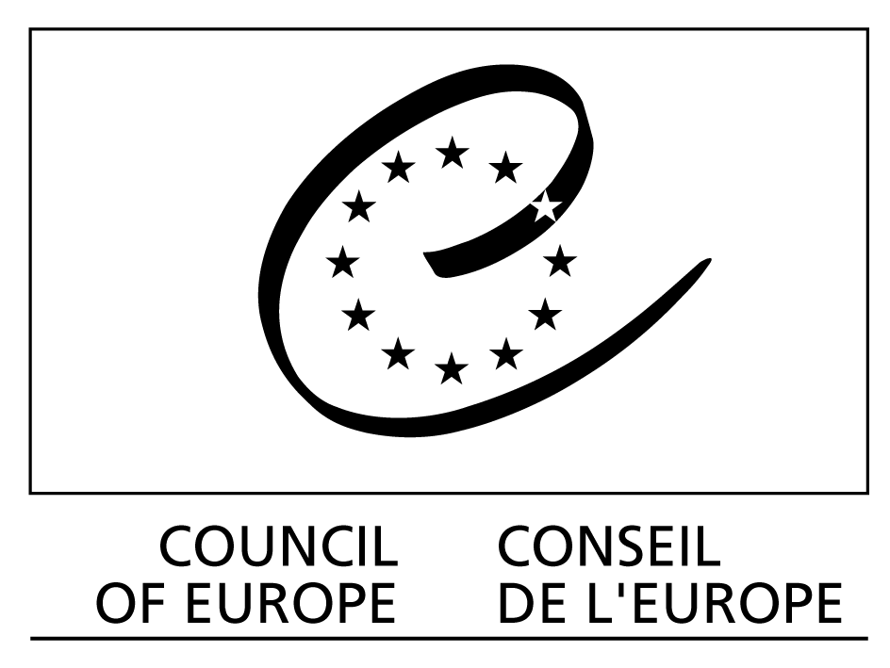

Speech by Maud de Boer-Buquicchio,
Deputy Secretary General of the Council of Europe

Regional Conference Stopping Sexual Violence against Children – ratifying and implementing the Council of Europe Convention on the Protection of Children against Sexual Exploitation and Sexual Abuse (CETS 201)

Zagreb, Croatia, 27-28 October 2011

Ministers,
Excellencies,
Ladies and Gentlemen,

Social progress has many enemies. Denial is one of them.

Denial of problems distorts reality and undermines people’s and society’s capacity to overcome obstacles. Denial keeps making victims, even after the problem has been solved. Denial fuels negative feelings and limits the scope of democratic debate.

In my opinion, the worst case scenario is when denial meets taboo on an issue affecting children. And this is, I am afraid, the scenario set for sexual violence against children.

The widespread nature of sexual violence against children owes much to denial. Denial of its existence, of its extent, of the human and social cost we are paying, and of the usefulness of the measures proposed to eliminate this scourge. Sexual violence against children is indeed the least visible, and the least acknowledged, of all forms of violence against children.

Scientific research suggests that around 20% of children in Europe might be victims of some form of sexual violence. It is estimated that in 70 to 85% of cases, the offender is somebody the child knows, trusts, or even loves.

Sexual violence against children can take many forms, including sexual abuse (usually involving physical contact), child pornography, child prostitution, use of children in pornographic performances, exposure of children to sexual content, solicitation of children for sexual purposes and sexual assault by peers.

Children who are sexually abused often take refuge in silence because they feel shame, guilt and fear. Some child victims are so young that they have no idea what is happening to them, and very often children do not know where, or how, to seek help. Our estimate is that only 10% of cases come to the attention of child protection services. The terrible consequences of sexual abuse can follow children into their adult lives – lives which first person accounts often describe as being lived out in hidden sorrow and pain.

Unfortunately, a child victim's ordeal is not always over when the abuse is disclosed. Far too often, children also fall victim to legal loopholes and social and health care services that lack co-ordination, or which have not undergone adequate training. It is therefore important to secure a comprehensive and coherent legal system to reduce the risk of impunity. It is equally important that the justice system and other professionals dealing with abuse cases protect the child victim and take all the necessary measures to minimise the negative impact that their procedures might have on them. Convicting a perpetrator does not always mean that justice has been done. For instance, in cases where images of a child's abuse are not removed quickly from the Internet, the child's recovery process can be seriously undermined.

Child victims of sexual violence have the right to compensation and to recovery, in particular through adequate psychological and medical treatment.

Ladies and Gentlemen:

It is important to move from denial, to awareness and acceptance of reality. But much more important here is the need to move from acceptance, to the requisite action, in order to make real social progress.

The entry into force on 1 July 2010 of the Council of Europe Convention on the Protection of Children against Sexual Exploitation and Sexual Abuse (the “Lanzarote Convention”) represents a significant advance in preventing sexual violence, protecting children and combating impunity. It is the first international instrument to treat sexual abuse of children as a crime, irrespective of where or by whom it is committed – at home, in a child care institution, through organised crime networks, or the Internet. My colleague, Carlo Chiaromonte, will present this ground-breaking text in more detail later on. Let me just underline that, open to ratification by non-European countries, the Lanzarote Convention is, I am convinced, the best chance we have to effectively combat sexual violence against children worldwide.

For this very reason, In 2010, the Council of Europe launched its
“One in Five” campaign to stop sexual violence against children. The campaign has two main objectives:

- First, to promote signature, ratification and implementation of the Lanzarote Convention;
- Second, to raise awareness of the full extent of sexual violence against children and of the measures that children, parents and professionals working with them can take to prevent and respond to sexual violence.

Activities within the campaign include the organisation of events, the provision of expertise, the promotion of research and networking and the production of awareness raising material. For intance: in view of the difficulties that many countries have in addressing the issue of sexual abuse within the child’s circle of trust, the Council of Europe has developed awareness-raising and information material around a character called “Kiko”, designed to help parents discuss this sensitive issue with their young children. Thanks to the European Economic and Social Committee, it has now been translated into 25 languages.

Both the Parliamentary Assembly and the Congress of Local and Regional Authorities of the Council of Europe have mobilised their respective networks to help us meet the campaign objectives and we can already see the results. More and more countries are joining our campaign, introducing changes in legislations, inproving services for children, training professionals and disseminating our material. You will learn more about our One in Five campaign later this morning.

Ladies and Gentlemen:

To date, the Lanzarote Convention has been ratified by 15 member states of the Council of Europe and 28 additional countries have signed it. Only 4 countries have neither signed, nor ratified. New signatures and ratifications are in the pipeline. The “Lanzarote family” is indeed expanding and has started working together.

I am pleased to inform you that the Committee of the Parties to the Lanzarote Convention met last month for the first time, and has started drafting its Rules of Procedure and discussing the setting up of the future monitoring mechanism. I am fully confident that this Committee will become a dynamic forum for exchange of knowledge and experience, development of expertise and identification of solutions to the most pressing problems.

I am sure that an efficient monitoring mechanism will help governments and their partners to make tangible progress towards the elimination of sexual violence. I trust the Committee will find creative ways to integrate child participation in its work.

Ladies and Gentlemen:

I am deeply grateful to the Croatian authorities for having joined this “Lanzarote family” through the recent ratification of the Lanzarote Convention and for hosting this Conference which, I am sure, will be a source of inspiration and motivation for all of us.

Ministers,
Fifteen years ago, Croatia embraced the European values by becoming a member of the Council of Europe. Since then, we have worked intensively together and the wonderful fruits of your country’s efforts are tangible and widely acknowledged.

Croatia’s contribution to the Council of Europe work is precious to us. Let me just give three examples related to the topic of this conference:

- First, let me remind you that Croatia launched in 2008 the Council of Europe campaign against corporal punishment of children, leading and showing through example that a government cannot afford to be seen to condone any form of violence against children.

- Second, the crucial contribution by prominent Croatian experts to the drafting of our key legal texts and to the illustration through good practices of what needs to be done to protect children victims of sexual violence;

- Last, but not least, the appointment of Ambassador Anica Djamić as Thematic Co-ordinator on Children’s Rights in the Council of Europe Committee of Ministers.

So: Croatia is a much-appreciated and active member of our large European family. We shall be delighted to celebrate soon Croatia’s membership of the European Union.

Ladies and Gentlemen,

Sexual violence is a violation of the child’s human dignity and a serious violation of a child’s rights. It causes irreparable damage to the victim’s physical and mental health and often has life-long negative impact.
It is not by chance that the Lanzarote convention is firmly anchored in the United Nations Convention on the Rights of the Child. The promotion of and respect for children’s rights is a legal imperative, but also a
pre-condition for the effectiveness of any action to eliminate sexual violence. This is particularly important when it comes to preventive measures.

Children all too often grow up in the misguided belief that they have no other rights than those which adults allow them to enjoy. Many children are educated to strictly obey and avoid questioning the deeds and actions of adults. By raising awareness on children’s rights, we build an empowering environment for children, equipping them with the self-confidence, the knowledge and the tools they need to prevent, combat and report abuse.

But eliminating violence against children calls for a strategic approach. This is why the Council of Europe has adopted a set of guidelines to help governments to develop national integrated strategies for the protection of children from violence. The Lanzarote Convention, the Convention on action against trafficking in human beings and the Cybercrime Convention are three key pieces of a larger puzzle.

The guidelines on child-friendly justice, health and social services, and the recommendation on child participation are examples of the many other important pieces that the Council of Europe is shaping to complete the image of a child-friendly Europe.

Today’s regional conference brings together mainly representatives from governments, ministries and agencies, but also representatives from law enforcement, ombudspersons, universities, researchers, NGOs and national branches of international organisations. The involvement and active support of all these actors is essential for the prevention and effective eradication of sexual violence against children. I am very glad to see you all here today and I should like to express a very warm thank you to our Croatian hosts, and in particular to the Prime Minister of Croatia, Mrs Jadranka Kosor, the colleagues in the Croatian Ministry of Family, Veterans’ Affairs and Intergenerational Solidarity and in the Ministry of Justice and, last but not least, Ambassador Anica Djamić.

Ministers, Excellencies, Ladies and Gentlemen,

It takes courage to overcome denial,
It takes vision to go beyond acceptance,
It takes determination to achieve social progress.
Whatever it takes: let’s do it!

Thank you for your attention.

