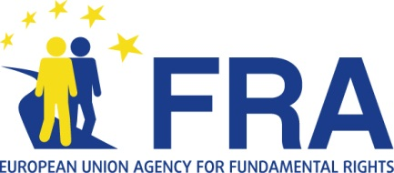 | 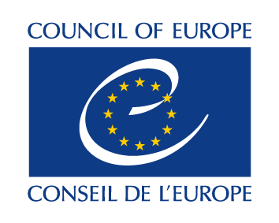

Data Protection Day 2014

Council of Europe and EU Fundamental Rights Agency launch handbook on European data protection law

Strasbourg, 28.01.2014 - The Council of Europe and the European Union Agency for Fundamental Rights (FRA) launched today - on Data Protection Day - a practical guide to European data protection law.

The handbook is the first comprehensive guide to Council of Europe and European Union law on data protection, taking into account the case law from the European Court of Human Rights and the Court of Justice of the European Union. It explains how data protection is regulated under EU law as well as the Council of Europe Convention for the Protection of Individuals with regard to Automatic Processing of Personal Data, and other Council of Europe instruments.

The handbook is aimed at non-specialist legal professionals, judges, national data protection authorities and anyone else that may be confronted with legal questions in the area of data protection. It covers issues such as data protection terminology; key principles and the rules of data protection law; data subjects’ rights and their enforcement; transborder data flow; and data protection in the context of police and criminal justice.

The guide will be launched in English with versions in Bulgarian, Croatian, Danish, Dutch, Estonian, Finnish, French, German, Greek, Hungarian, Italian, Latvian, Lithuanian, Polish, Portuguese, Romanian, Slovak, Slovenian and Spanish to follow later this year.

***

Data Protection Day is celebrated every year on 28 January to mark the anniversary of the opening for signature of the Council of Europe´s Convention for the Protection of individuals with regard to automatic processing of personal data, also known as “Convention 108”. The convention is in force in 46 states. In 2013 Uruguay became the first non-European country to ratify it.

The Convention is the only data protection legally binding international instrument with a worldwide scope of application, open to any country, and with the potential to become a global standard. The treaty is currently being updated to adapt it to new technologies and practice.

Contacts:
Council of Europe: Jaime Rodriguez, Media officer, Tel. +33 3 90 21 47 04
European Union Agency for Fundamental Rights: Blanca Tapia, Spokesperson, Tel. +43 1 580 30 642

